## Multiple Choice

**QUESTION 1**

What are two benefits of network automation? (Choose two)

1. reduced operational costs
2. reduced hardware footprint
3. faster changes with more reliable results
4. fewer network failures
5. increased network security

## Correct Answer: AC

**Section: 6. Automation and Programmability Explanation**

**Explanation/Reference:**

**QUESTION 2**

Which command enables a router to become a DHCP client?

1. ip address dhcp
2. ip helper-address
3. ip dhcp pool
4. ip dhcp client

## Correct Answer: A Section: 4. IP Services Explanation

**Explanation/Reference:**

If we want to get an IP address from the DHCP server on a Cisco device, we can use the command "ip address dhcp".

Note: The command "ip helper-address" enables a router to become a DHCP Relay Agent.

Reference: ht[tps://w](http://www.cisco.com/c/en/us/td/docs/ios-xml/ios/ipaddr_dhcp/configuration/12-4/dhcp-12-4-book/)ww[.cisco.com/c/en/us/td/](http://www.cisco.com/c/en/us/td/docs/ios-xml/ios/ipaddr_dhcp/configuration/12-4/dhcp-12-4-book/)do[cs/ios-x](http://www.cisco.com/c/en/us/td/docs/ios-xml/ios/ipaddr_dhcp/configuration/12-4/dhcp-12-4-book/)m[l/ios/ipaddr_dhcp/configuration/12-4/dhcp-12-4-book/](http://www.cisco.com/c/en/us/td/docs/ios-xml/ios/ipaddr_dhcp/configuration/12-4/dhcp-12-4-book/) config-dhcp-client.html

## QUESTION 3

Which design element is a best practice when deploying an 802.11b wireless infrastructure?

1. disabling TPC so that access points can negotiate signal levels with their attached wireless devices
2. setting the maximum data rate to 54 Mbps on the Cisco Wireless LAN Controller
3. allocating nonoverlapping channels to access points that are in close physical proximity to one another
4. configuring access points to provide clients with a maximum of 5 Mbps

## Correct Answer: C

**Section: 2. Network Access Explanation**

**Explanation/Reference:**

**QUESTION 4**

When configuring IPv6 on an interface, which two IPv6 multicast groups are joined? (Choose two)

A. 2000::/3

B. 2002::5

C. FC00::/7

D. FF02::1

E. FF02::2

## Correct Answer: DE

**Section: 1. Network Fundamentals Explanation**

**Explanation/Reference:**

When an interface is configured with IPv6 address, it automatically joins the all nodes (FF02::1) and solicited- node (FF02::1:FFxx:xxxx) multicast groups. The all-node group is used to communicate with all interfaces on the local link, and the solicited-nodes multicast group is required for link-layer address resolution. Routers also join a third multicast group, the all-routers group (FF02::2).

Reference:

ht[tps://w](http://www.cisco.com/c/en/us/td/docs/ios-xml/ios/ipv6/configuration/xe-3s/ipv6-xe-36s-book/ip6-multicast.html)ww[.cisco.com/c/en/us/td/](http://www.cisco.com/c/en/us/td/docs/ios-xml/ios/ipv6/configuration/xe-3s/ipv6-xe-36s-book/ip6-multicast.html)do[cs/ios-x](http://www.cisco.com/c/en/us/td/docs/ios-xml/ios/ipv6/configuration/xe-3s/ipv6-xe-36s-book/ip6-multicast.html)m[l/ios/ipv6/configuration/xe-3s/ipv6-xe-36s-book/ip6-multicast.html](http://www.cisco.com/c/en/us/td/docs/ios-xml/ios/ipv6/configuration/xe-3s/ipv6-xe-36s-book/ip6-multicast.html)

## QUESTION 5

Which option about JSON is true?

1. uses predefined tags or angle brackets (<>) to delimit markup text
2. used to describe structured data that includes arrays
3. used for storing information
4. similar to HTML, it is more verbose than XML

## Correct Answer: B Section: Not categorized Explanation

**Explanation/Reference:**

JSON data is written as name/value pairs.

A name/value pair consists of a field name (in double quotes), followed by a colon, followed by a value: “name”:”Mark”

JSON can use arrays. Array values must be of type string, number, object, array, boolean or null.. For example:

{

“name”:”John”, “age”:30,

“cars”:[ “Ford”, “BMW”, “Fiat” ]

}

## QUESTION 6

Which IPv6 address type provides communication between subnets and cannot route on the Internet?

1. global unicast
2. unique local
3. link-local
4. multicast

the IPv4 private address. It is not routable on the global Internet.

Note: In the past, Site-local addresses (FEC0::/10) are equivalent to private IP addresses in IPv4 but now they are deprecated.

Link-local addresses only used for communications within the local subnet. It is usually created dynamically using a link-local prefix of FE80::/10 and a 64-bit interface identifier (based on 48-bit MAC address).

## QUESTION 7

Which command prevents passwords from being stored in the configuration as plaintext on a router or switch?

1. enable secret
2. service password-encryption
3. username Cisco password encrypt
4. enable password

## Correct Answer: B

**Section: 5. Security Fundamentals Explanation**

**Explanation/Reference:**

**QUESTION 8**

What are two southbound APIs? (Choose two)

1. OpenFlow
2. NETCONF
3. Thrift
4. CORBA
5. DSC

## Correct Answer: AB

**Section: 6. Automation and Programmability Explanation**

**Explanation/Reference:**

OpenFlow is a well-known southbound API. OpenFlow defines the way the SDN Controller should interact with the forwarding plane to make adjustments to the network, so it can better adapt to changing business requirements.

The Network Configuration Protocol (NetConf) uses Extensible Markup Language (XML) to install, manipulate and delete configuration to network devices.

Other southbound APIs are:

+ onePK: a Cisco proprietary SBI to inspect or modify the network element configuration without hardware upgrades.

+ OpFlex: an open-standard, distributed control system. It send "summary policy" to network elements.

## QUESTION 9

Which set of action satisfy the requirement for multi-factor authentication?

1. The user swipes a key fob, then clicks through an email link.
2. The user enters a user name and password, and then clicks a notification in an authentication app on a

## Explanation

**Explanation/Reference:**

This is an example of how two-factor authentication (2FA) works:

1. The user logs in to the website or service with their username and password.
2. The password is validated by an authentication server and, if correct, the user becomes eligible for the second factor.
3. The authentication server sends a unique code to the user's second-factor method (such as a smartphone app).
4. The user confirms their identity by providing the additional authentication for their second-factor method.

## QUESTION 10

Which two capacities of Cisco DNA Center make it more extensible? (Choose two)

1. adapters that support all families of Cisco IOS software
2. SDKs that support interaction with third-party network equipment
3. customized versions for small, medium, and large enterprises
4. REST APIs that allow for external applications to interact natively with Cisco DNACenter
5. modular design that is upgradable as needed

## Correct Answer: BD

**Section: 6. Automation and Programmability Explanation**

**Explanation/Reference:**

Cisco DNA Center offers 360-degree extensibility through four distinct types of platform capabilities:

+ Intent-based APIs leverage the controller and enable business and IT applications to deliver intent to the network and to reap network analytics and insights for IT and business innovation.

+ Process adapters, built on integration APIs, allow integration with other IT and network systems to streamline IT operations and processes.

+ Domain adapters, built on integration APIs, allow integration with other infrastructure domains such as data center, WAN, and security to deliver a consistent intent-based infrastructure across the entire IT environment.

+ SDKs allow management to be extended to third-party vendor's network devices to offer support for diverse environments.

## QUESTION 11

An email user has been lured into clicking a link in an email sent by their company’s security organization. The webpage that opens reports that it was safe but the link could have contained malicious code. Which type of security program is in place?

1. Physical access control
2. Social engineering attack
3. brute force attack
4. user awareness

## Correct Answer: D

**Section: 5. Security Fundamentals Explanation**

**Explanation/Reference:**

This is a training program which simulates an attack, not a real attack (as it says “The webpage that opens reports that it was safe”) so we believed it should be called a “user awareness” program.

access control means infrastructure locations, such as network closets and data centers, should remain securely locked.

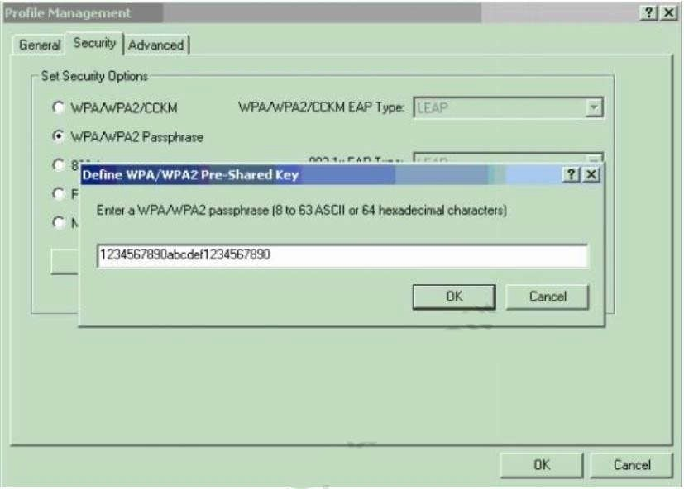

## QUESTION 12

Which type of wireless encryption is used for WPA2 in pre-shared key mode?

1. TKIP with RC4
2. RC4
3. AES-128
4. AES-256

## Correct Answer: D

**Section: 5. Security Fundamentals Explanation**

**Explanation/Reference:**

We can see in this picture we have to type 64 hexadecimal characters (256 bit) for the WPA2 passphrase so we can deduce the encryption is AES-256, not AES-128.

Reference: ht[tps://w](http://www.cisco.com/c/en/us/support/docs/wireless-mobility/wireless-lan-wlan/67134-wpa2-)ww[.cisco.com/c/en/us/support/do](http://www.cisco.com/c/en/us/support/docs/wireless-mobility/wireless-lan-wlan/67134-wpa2-)cs/w[ireless-mobility/wireless-lan-wlan/67134-wpa2-](http://www.cisco.com/c/en/us/support/docs/wireless-mobility/wireless-lan-wlan/67134-wpa2-) config.html

## QUESTION 13

Which two must be met before SSH can operate normally on a Cisco IOS switch? (Choose two)

A. The switch must be running a k9 (crypto) IOS image.

## Correct Answer: AB Section: 2. Network Access Explanation

**Explanation/Reference:**

Reference: ht[tps://w](http://www.cisco.com/c/en/us/support/docs/security-vpn/secure-shell-ssh/4145-ssh.html)ww[.cisco.com/c/en/us/support/do](http://www.cisco.com/c/en/us/support/docs/security-vpn/secure-shell-ssh/4145-ssh.html)cs[/security-vpn/secure-shell-ssh/4145-ssh.html](http://www.cisco.com/c/en/us/support/docs/security-vpn/secure-shell-ssh/4145-ssh.html)

## QUESTION 14

Which type of address is the public IP address of a NAT device?

1. outside global
2. outsdwde local
3. inside global
4. insride local
5. outside public
6. inside public

## Correct Answer: C Section: Not categorized Explanation

**Explanation/Reference:**

NAT use four types of addresses:

* Inside local address - The IP address assigned to a host on the inside network. The address is usually not an IP address assigned bythe Internet Network Information Center (InterNIC) or service provider.

This address is likely to be an RFC 1918 private address.

* Inside global address - A legitimate IP address assigned by the InterNIC or service provider that represents one or more inside local IP addresses to the outside world.
* Outside local address - The IP address of an outside host as it is known to the hosts on the inside network.
* Outside global address - The IP address assigned to a host on the outside network. The owner of the host assigns this address.

## QUESTION 15

Refer to the exhibit. Which prefix does Router 1 use for traffic to Host A?

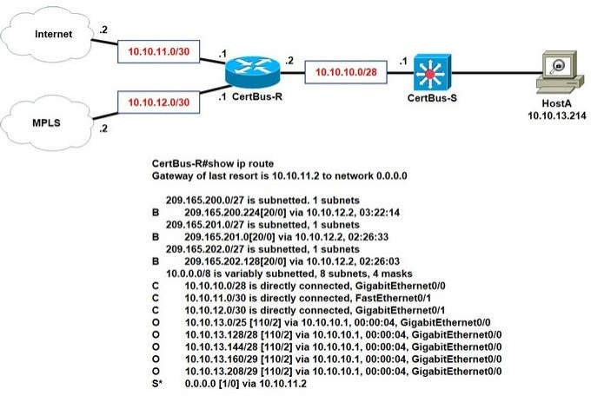

A. 10.10.10.0/28

B. 10.10.13.0/25

C. 10.10.13.144/28

D. 10.10.13.208/29

## Correct Answer: D

**Section: 1. Network Fundamentals Explanation**

**Explanation/Reference:**

Host A address fall within the address range. However, if more than one route to the same subnet exist (router will use the longest stick match, which match more specific route to the subnet). If there are route 10.10.13.192/26 and 10.10.13.208/29, the router will forward the packet to /29 rather than /28.

## QUESTION 16

How does HSRP provide first hop redundancy?

1. It load-balances traffic by assigning the same metric value to more than one route to the same destination m the IP routing table.
2. It load-balances Layer 2 traffic along the path by flooding traffic out all interfaces configured with the same VLAN.
3. It forwards multiple packets to the same destination over different routed links n the datapath.
4. It uses a shared virtual MAC and a virtual IP address to a group of routers that serve as the default gateway

## Explanation/Reference:

Reference: [https://w](http://www.cisco.com/c/en/us/td/docs/ios-xml/ios/ipapp_fhrp/configuration/xe-16/fhp-xe-16-book/)ww[.cisco.com/c/en/us/td/](http://www.cisco.com/c/en/us/td/docs/ios-xml/ios/ipapp_fhrp/configuration/xe-16/fhp-xe-16-book/)docs[/ios-xml/ios/ipapp_fhrp/configuration/xe-16/fhp-xe-16-book/](http://www.cisco.com/c/en/us/td/docs/ios-xml/ios/ipapp_fhrp/configuration/xe-16/fhp-xe-16-book/) fhp- hsrp-mgo.html

## QUESTION 17

In Which way does a spine-and-leaf architecture allow for scalability in a network when additional access ports are required?

1. A spine switch and a leaf switch can be added with redundant connections betweenthem.
2. A spine switch can be added with at least 40 GB uplinks.
3. A leaf switch can be added with a single connection to a core spine switch.
4. A leaf switch can be added with connections to every spine switch.

## Correct Answer: D

**Section: 1. Network Fundamentals Explanation**

**Explanation/Reference:**

Spine-leaf architecture is typically deployed as two layers: spines (such as an aggregation layer), and leaves (such as an access layer). Spine-leaf topologies provide high-bandwidth, low-latency, nonblocking server-to- server connectivity.

Leaf (aggregation) switches are what provide devices access to the fabric (the network of spine and leaf switches) and are typically deployed at the top of the rack. Generally, devices connect to the leaf switches. Devices can include servers, Layer 4-7 services (firewalls and load balancers), and WAN or Internet routers. Leaf switches do not connect to other leaf switches. In spine-and-leaf architecture, every leaf should connect to every spine in a full mesh.

Spine (aggregation) switches are used to connect to all leaf switches and are typically deployed at the end or middle of the row. Spine switches do not connect to other spine switches.

## QUESTION 18

Which two actions are performed by the Weighted Random Early Detection mechanism? (Choose two)

1. It drops lower-priority packets before it drops higher-priority packets.
2. It can identify different flows with a high level of granularity.
3. It guarantees the delivery of high-priority packets.
4. It can mitigate congestion by preventing the queue from filling up.
5. It supports protocol discovery.

## Correct Answer: AD Section: 4. IP Services Explanation

**Explanation/Reference:**

Weighted Random Early Detection (WRED) is just a congestion avoidance mechanism. WRED drops packets selectively based on IP precedence. Edge routers assign IP precedences to packets as they enter the network. When a packet arrives, the following events occur:

1. The average queue size is calculated.
2. If the average is less than the minimum queue threshold, the arriving packet is queued.
3. If the average is between the minimum queue threshold for that type of traffic and the maximum threshold for the interface, the packet is either dropped or queued, depending on the packet drop probability for that type of traffic.

allows the transmission line to be used fully at all times.

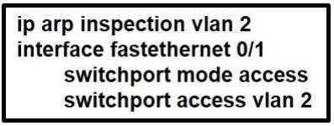

WRED generally drops packets selectively based on IP precedence. Packets with a higher IP precedence are less likely to be dropped than packets with a lower precedence. Thus, the higher the priority of a packet, the higher the probability that the packet will be delivered (-> answer A is correct).

## QUESTION 19

A network engineer must back up 20 network router configurations globally within a customer environment. Which protocol allows the engineer to perform this function using the Cisco IOS MIB?

1. CDP
2. SNMP
3. SMTP
4. ARP

## Correct Answer: B Section: 4. IP Services Explanation

**Explanation/Reference:**

SNMP is an application-layer protocol that provides a message format for communication between SNMP managers and agents. SNMP provides a standardized framework and a common language used for the monitoring and management of devices in a network.

The SNMP framework has three parts:

+ An SNMP manager

+ An SNMP agent

+ A Management Information Base (MIB)

The Management Information Base (MIB) is a virtual information storage area for network management information, which consists of collections of managed objects.

With SNMP, the network administrator can send commands to multiple routers to do the backup.

## QUESTION 20

Refer to the exhibit. What is the effect of this configuration?

1. The switch port interface trust state becomes untrusted.
2. The switch port remains administratively down until the interface is connected to anotherswitch.
3. Dynamic ARP inspection is disabled because the ARP ACL is missing.
4. The switch port remains down until it is configured to trust or untrust incoming packets.

## Correct Answer: A

**Section: 5. Security Fundamentals Explanation**

**Explanation/Reference:**

Dynamic ARP inspection (DAI) is a security feature that validates ARP packets in a network. It intercepts, logs,



1. runts
2. giants
3. frame
4. CRC
5. input errors

## Correct Answer: DE

**Section: 1. Network Fundamentals Explanation**

**Explanation/Reference:**

Whenever the physical transmission has problems, the receiving device might receive a frame whose bits have changed values. These frames do not pass the error detection logic as implemented in the FCS field in the Ethernet trailer. The receiving device discards the frame and counts it as some kind of input error.

Cisco switches list this error as a CRC error. Cyclic redundancy check (CRC) is a term related to how the FCS math detects an error.

The “input errors” includes runts, giants, no buffer, CRC, frame, overrun, and ignored counts. The output below show the interface counters with the “show interface s0/0/0” command:

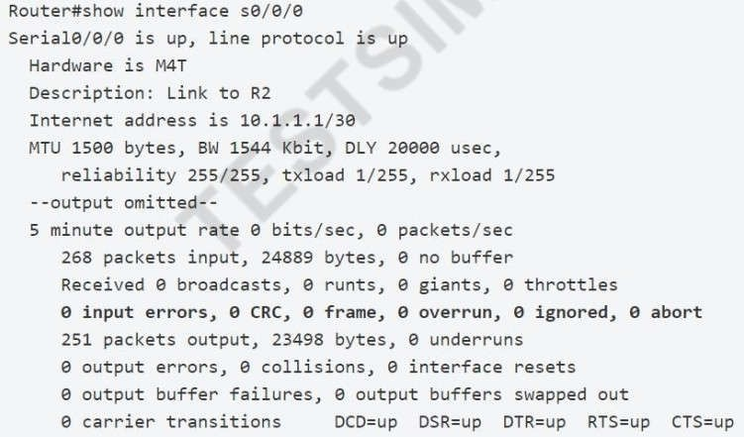

## QUESTION 22

How do TCP and UDP differ in the way that they establish a connection between two endpoints?

1. TCP uses synchronization packets, and UDP uses acknowledgment packets.
2. UDP uses SYN, SYN ACK and FIN bits in the frame header while TCP uses SYN, SYN ACK and ACK bits.
3. UDP provides reliable message transfer and TCP is a connectionless protocol.
4. TCP uses the three-way handshake and UDP does not guarantee messagedelivery.

## Correct Answer: D

**Section: 1. Network Fundamentals Explanation**

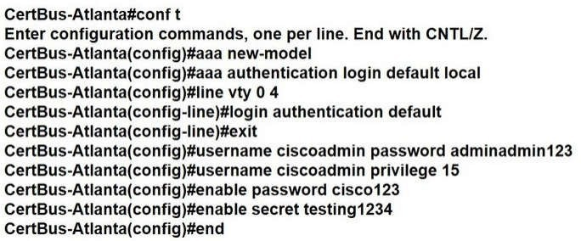

**QUESTION 23**

When OSPF learns multiple paths to a network, how does it select a route?

1. It multiple the active K value by 256 to calculate the route with the lowestmetric.
2. For each existing interface, it adds the metric from the source router to the destination to calculate the route with the lowest bandwidth.
3. It divides a reference bandwidth of 100 Mbps by the actual bandwidth of the existing interface to calculate the router with the lowest cost.
4. It count the number of hops between the source router and the destination to determine the router with the lowest metric.

## Correct Answer: C Section: 3. IP Connectivity Explanation

**Explanation/Reference:**

**QUESTION 24**

Refer to the exhibit. Which password must an engineer use to enter the enable mode?

1. adminadmin123
2. default
3. testing1234
4. cisco123

## Correct Answer: C

**Section: 2. Network Access Explanation**

**Explanation/Reference:**

If neither the enable password command nor the enable secret command is configured, and if there is a line password configured for the console, the console line password serves as the enable password for all VTY sessions -> The "enable secret" will be used first if available, then "enable password" and line password.

Reference: ht[tps://w](http://www.cisco.com/c/en/us/td/docs/optical/cpt/r9_3/configuration/guide/cpt93_configuration/)ww[.cisco.com/c/en/us/td/](http://www.cisco.com/c/en/us/td/docs/optical/cpt/r9_3/configuration/guide/cpt93_configuration/)do[cs/optical/cpt/r9_3/configuration/guide/cpt93_configuration/](http://www.cisco.com/c/en/us/td/docs/optical/cpt/r9_3/configuration/guide/cpt93_configuration/) cpt93_configuration_chapter_0100

## QUESTION 25

Which configuration is needed to generate an RSA key for SSH on a router?

1. Configure VTY access.
2. Create a user with a password.
3. Assign a DNS domain name.

## Correct Answer: D

**Section: 5. Security Fundamentals Explanation**

**Explanation/Reference:**

In order to generate an RSA key for SSH, we need to configure the hostname and a DNS domain name on the router (a username and password is also required). Therefore in fact both answer C and answer D are correct.

## QUESTION 26

Which output displays a JSON data representation?

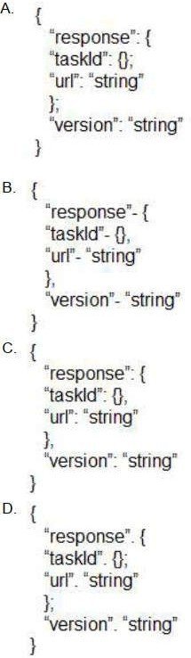

1. Option A
2. Option B

## Explanation

**Explanation/Reference:**

JSON data is written as name/value pairs.

A name/value pair consists of a field name (in double quotes), followed by a colon, followed by a value: “name”:”Mark”

JSON can use arrays. Array values must be of type string, number, object, array, boolean or null. For example:

{

“name”:”John”, “age”:30,

“cars”:[ “Ford”, “BMW”, “Fiat” ]

}

JSON can have empty object like “taskId”:{}

## QUESTION 27

What is the primary different between AAA authentication and authorization?

1. Authentication verifies a username and password, and authorization handles the communication between the authentication agent and the user database.
2. Authentication identifies a user who is attempting to access a system, and authorization validates the users password.
3. Authentication identifies and verifies a user who is attempting to access a system, and authorization controls the tasks the user can perform.
4. Authentication controls the system processes a user can access and authorization logs the activities the user initiates.

## Correct Answer: C

**Section: 5. Security Fundamentals Explanation**

**Explanation/Reference:**

AAA stands for Authentication, Authorization and Accounting.

+ Authentication: Specify who you are (usually via login username & password)

+ Authorization: Specify what actions you can do, what resource you can access

+ Accounting: Monitor what you do, how long you do it (can be used for billing and auditing) An example of AAA is shown below:

+ Authentication: "I am a normal user. My username/password is user_tom/learnforever"

+ Authorization: "user_tom can access LearnCCNA server via HTTP and FTP"

+ Accounting: "user_tom accessed LearnCCNA server for 2 hours". This user only uses "show" commands.

## QUESTION 28

A Cisco IP phone receive untagged data traffic from an attached PC. Which action is taken by the phone?

1. It allows the traffic to pass through unchanged.
2. It drops the traffic.
3. It tags the traffic with the default VLAN.
4. It tags the traffic with the native VLAN.

## Correct Answer: A

**Section: 2. Network Access**

Reference: ht[tps://w](http://www.cisco.com/c/en/us/td/docs/switches/lan/catalyst2960x/software/15-0_2_EX/vlan/)ww[.cisco.com/c/en/us/td/](http://www.cisco.com/c/en/us/td/docs/switches/lan/catalyst2960x/software/15-0_2_EX/vlan/)do[cs/switches/lan/catalyst2960x/software/15-0_2_](http://www.cisco.com/c/en/us/td/docs/switches/lan/catalyst2960x/software/15-0_2_EX/vlan/)E[X/vlan/](http://www.cisco.com/c/en/us/td/docs/switches/lan/catalyst2960x/software/15-0_2_EX/vlan/) configuration_guide/b_vlan_152ex_2960-x_cg/b_vlan_152ex_2960-x_cg_chapter_0110.pdf

## QUESTION 29

An engineer must configure a /30 subnet between two routers. Which usable IP address and subnet mask combination meets this criteria?

1. interface e0/0

description to HQ-A370:98968

ip address 10.2.1.3 255.255.255.252

1. interface e0/0

description to HQ-A370:98968

ip address 192.168.1.1 255.255.255.248

1. interface e0/0

description to HQ-A370:98968

ip address 172.16.1.4 255.255.255.248

1. interface e0/0

description to HQ-A370:98968

ip address 209.165.201.2 255.255.255.252

## Correct Answer: D

**Section: 1. Network Fundamentals Explanation**

**Explanation/Reference:**

A /30 subnet means subnet mask of 255.255.255.252. But 10.2.1.3 255.255.255.252 is a broadcast IP address; only 209.165.201.2/30 is the usable IP address.

## QUESTION 30

What is a benefit of using a Cisco Wireless LAN Controller?

1. Central AP management requires more complex configurations.
2. Unique SSIDs cannot use the same authentication method.
3. It supports autonomous and lightweight APs.
4. It eliminates the need to configure each access point individually.

## Correct Answer: D

**Section: 1. Network Fundamentals Explanation**

**Explanation/Reference:**

**QUESTION 31**

What are two characteristics of a controller-based network? (Choose two)

1. The administrator can make configuration updates from the CLI.
2. It uses northbound and southbound APIs to communicate between architectural layers.
3. It moves the control plane to a central point.
4. It decentralizes the control plane, which allows each device to make its own forwardingdecisions.
5. It uses Telnet to report system issues.

## Explanation/Reference:

**QUESTION 32**

Which attribute does a router use to select the best path when two or more different routes to the same destination exist from two different routing protocols?

1. dual algorithm
2. metric
3. administrative distance
4. hop count

## Correct Answer: C Section: 3. IP Connectivity Explanation

**Explanation/Reference:**

Administrative distance is the feature used by routers to select the best path when there are two or more different routes to the same destination from different routing protocols. Administrative distance defines the reliability of a routing protocol.

## QUESTION 33

Refer to Exhibit. How does SW2 interact with other switches in this VTP domain?

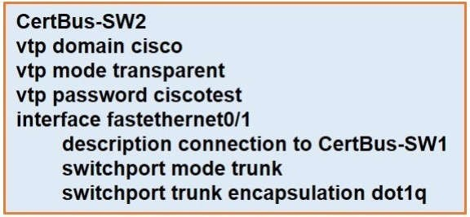

1. It processes VTP updates from any VTP clients on the network on its access ports.
2. It receives updates from all VTP servers and forwards all locally configured VLANs out all trunkports.
3. It forwards only the VTP advertisements that it receives on its trunk ports.
4. It transmits and processes VTP updates from any VTP Clients on the network on its trunk ports.

## Correct Answer: C

**Section: 2. Network Access Explanation**

**Explanation/Reference:**

The VTP mode of SW2 is transparent so it only forwards the VTP updates it receives to its trunk links without

Which unified access point mode continues to serve wireless clients after losing connectivity to the Cisco Wireless LAN Controller?

1. sniffer
2. mesh
3. flexconnect
4. local

## Correct Answer: C

**Section: 2. Network Access Explanation**

**Explanation/Reference:**

Reference: ht[tps://w](http://www.cisco.com/c/en/us/td/docs/wireless/controller/8-5/config-guide/b_cg85/flexconnect.html)ww[.cisco.com/c/en/us/td/](http://www.cisco.com/c/en/us/td/docs/wireless/controller/8-5/config-guide/b_cg85/flexconnect.html)do[cs/wireless/controller/8-5/config-guide/b_cg85/flexconnect.html](http://www.cisco.com/c/en/us/td/docs/wireless/controller/8-5/config-guide/b_cg85/flexconnect.html)

## QUESTION 35

Which two encoding methods are supported by REST APIs? (Choose two)

1. YAML
2. JSON
3. EBCDIC
4. SGML
5. XML

## Correct Answer: BE

**Section: 6. Automation and Programmability Explanation**

**Explanation/Reference:**

The Application Policy Infrastructure Controller (APIC) REST API is a programmatic interface that uses REST architecture. The API accepts and returns HTTP (not enabled by default) or HTTPS messages that contain JavaScript Object Notation (JSON) or Extensible Markup Language (XML) documents.

Reference: ht[tps://w](http://www.cisco.com/c/en/us/td/docs/switches/datacenter/nexus1000/sw/5_x/rest_api_config/)ww[.cisco.com/c/en/us/td/](http://www.cisco.com/c/en/us/td/docs/switches/datacenter/nexus1000/sw/5_x/rest_api_config/)do[cs/switches/datacenter/nexus1000/sw/5_x/rest_api_config/](http://www.cisco.com/c/en/us/td/docs/switches/datacenter/nexus1000/sw/5_x/rest_api_config/) b_Cisco_N1KV_VMware_REST_API_Config_5x/ b_Cisco_N1KV_VMware_REST_API_Config_5x_chapter_010.pdf

## QUESTION 36

What are two reasons that cause late collisions to increment on an Ethernet interface? (Choose two)

1. when the sending device waits 15 seconds before sending the frame again
2. when the cable length limits are exceeded
3. when one side of the connection is configured for half-duplex
4. when Carner Sense Multiple Access/Collision Detection is used
5. when a collision occurs after the 32nd byte of a frame has been transmitted

## Correct Answer: BC

**Section: 1. Network Fundamentals Explanation**

**Explanation/Reference:**

A late collision is defined as any collision that occurs after the first 512 bits (or 64th byte) of the frame have been transmitted. The usual possible causes are full-duplex/half-duplex mismatch, exceeded Ethernet cable length limits, or defective hardware such as incorrect cabling, noncompliant number of hubs in the network, or a

Reference: Click here

## QUESTION 37

Router A learns the same route from two different neighbors, one of the neighbor routers is an OSPF neighbor and the other is an EIGRP neighbor. What is the administrative distance of the route that will be installed in the routing table?

1. 20
2. 90

C. 110

D. 115

## Correct Answer: B Section:

**3. IP Connectivity Explanation**

**Explanation/Reference:**

The Administrative distance (AD) of EIGRP is 90 while the AD of OSPF is 110 so EIGRP route will be chosen to install into the routing table.

## QUESTION 38

What is the primary effect of the spanning-tree portfast command?

1. It enables BPDU messages
2. It minimizes spanning-tree convergence time
3. It immediately puts the port into the forwarding state when the switch is reloaded
4. It immediately enables the port in the listening state

## Correct Answer: B

**Section: 2. Network Access Explanation**

**Explanation/Reference:**

https://itexamanswers.net/ccna-200-301-dumps-full-questions-exam-study-guide-free.html#comment-49349

## QUESTION 39

What is the default behavior of a Layer 2 switch when a frame with an unknown destination MAC address is received?

1. The Layer 2 switch drops the received frame.
2. The Layer 2 switch floods packets to all ports except the receiving port in the given VLAN.
3. The Layer 2 switch sends a copy of a packet to CPU for destination MAC addresslearning.
4. The Layer 2 switch forwards the packet and adds the destination MAC address to its MAC addresstable.

## Correct Answer: B

**Section: 1. Network Fundamentals Explanation**

**Explanation/Reference:**

If the destination MAC address is not in the CAM table (unknown destination MAC address), the switch sends the frame out all other ports that are in the same VLAN as the received frame. This is called flooding. It does not flood the frame out the same port on which the frame was received.

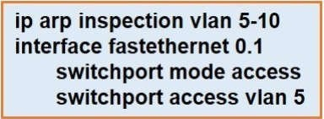

1. All ARP packets are dropped by the switch.
2. Egress traffic is passed only if the destination is a DHCP server.
3. All ingress and egress traffic is dropped because the interface is untrusted.
4. The switch discard all ingress ARP traffic with invalid MAC-to-IP address bindings.

## Correct Answer: D

**Section: 5. Security Fundamentals Explanation**

**Explanation/Reference:**

Dynamic ARP inspection is an ingress security feature; it does not perform any egress checking.

## QUESTION 41

Refer to the exhibit. An engineer configured NAT translations and has verified that the configuration is correct. Which IP address is the source IP?

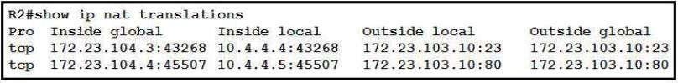

A. 10.4.4.4

B. 10.4.4.5

C. 172.23.103.10

D. 172.23.104.4

## Correct Answer: D Section: 4. IP Services Explanation

**Explanation/Reference:**

**QUESTION 42**

Refer to the exhibit. Which route does R1 select for traffic that is destined to 192 168.16.2?

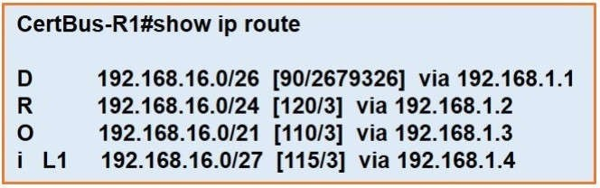

A. 192.168.16.0/21

B. 192.168.16.0/24

C. 192.168 26.0/26

D. 192.168.16.0/27

## Correct Answer: D Section: 3. IP Connectivity Explanation

**Explanation/Reference:**

The destination IP addresses match all four entries in the routing table but the 192.168.16.0/27 has the longest prefix so it will be chosen. This is called the "longest prefix match" rule.

## QUESTION 43

Which IPv6 address block sends packets to a group address rather than a single address?

A. 2000::/3

B. FC00::/7

C. FE80::/10

D. FF00::/8

## Correct Answer: D

**Section: 1. Network Fundamentals Explanation**

**Explanation/Reference:**

FF00::/8 is used for IPv6 multicast and this is the IPv6 type of address the question wants to ask.

FE80::/10 range is used for link-local addresses. Link-local addresses only used for communications within the local subnetwork (automatic address configuration, neighbor discovery, router discovery, and by many routing protocols). It is only valid on the current subnet.

It is usually created dynamically using a link-local prefix of FE80::/10 and a 64-bit interface identifier (based on 48-bit MAC address).

## QUESTION 44

Which two values or settings must be entered when configuring a new WLAN in the Cisco Wireless LAN Controller GUI? (Choose two)

1. management interface settings
2. QoS settings
3. Ip address of one or more access points

E. Profile name

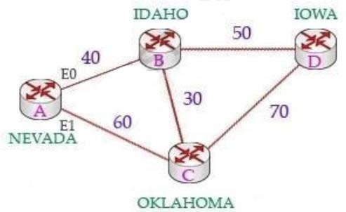

## Correct Answer: DE Section: 2. Network Access Explanation

**Explanation/Reference:**

**QUESTION 45**

Which two actions influence the EIGRP route selection process? (Choose two)

1. The router calculates the reported distance by multiplying the delay on the exiting Interface by 256.
2. The router calculates the best backup path to the destination route and assigns it as the feasible successor.
3. The router calculates the feasible distance of all paths to the destination route.
4. The advertised distance is calculated by a downstream neighbor to inform the local router of the bandwidth on the link.
5. The router must use the advertised distance as the metric for any givenroute.

## Correct Answer: BC Section: 3. IP Connectivity Explanation

**Explanation/Reference:**

The reported distance (or advertised distance) is the cost from the neighbor to the destination. It is calculated from the router advertising the route to the network. For example in the topology below, suppose router A & B are exchanging their routing tables for the first time. Router B says "Hey, the best metric (cost) from me to IOWA is 50 and the metric from you to IOWA is 90" and advertises it to router A.

Router A considers the first metric (50) as the Advertised distance. The second metric (90), which is from NEVADA to IOWA (through IDAHO), is called the Feasible distance.

The reported distance is calculated in the same way of calculating the metric. By default (K1 = 1, K2 = 0, K3 = 1, K4 = 0, K5 = 0), the metric is calculated as follows:

Feasible successor is the backup route. To be a feasible successor, the route must have an Advertised distance (AD) less than the Feasible distance (FD) of the current successor route -> Answer B is correct. Feasible distance (FD): The sum of the AD plus the cost between the local router and the next- hop router. The router must calculate the FD of all paths to choose the best path to put into the routing table.

Note: Although the new CCNA exam does not have EIGRP topic but you should learn the basic knowledge of this routing protocol.

## QUESTION 46

Refer to Exhibit. Which action do the switches take on the trunk link?

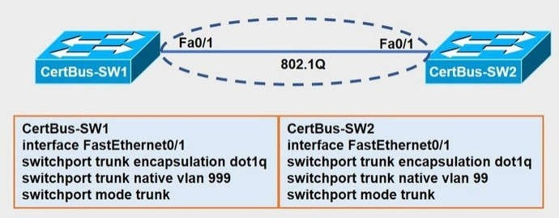

1. The trunk does not form and the ports go into an err-disabled status.
2. The trunk forms but the mismatched native VLANs are merged into a single broadcast domain.
3. The trunk does not form, but VLAN 99 and VLAN 999 are allowed to traverse thelink.
4. The trunk forms but VLAN 99 and VLAN 999 are in a shutdown state.

## Correct Answer: B

**Section: 2. Network Access Explanation**

**Explanation/Reference:**

The trunk still forms with mismatched native VLANs and the traffic can actually flow between mismatched switches. But it is absolutely necessary that the native VLANs on both ends of a trunk link match; otherwise a native VLAN mismatch occurs, causing the two VLANs to effectively merge.

For example with the above configuration, SW1 would send untagged frames for VLAN 999. SW2 receives them but would think they are for VLAN 99 so we can say these two VLANs are merged.

## QUESTION 47

Which command is used to specify the delay time in seconds for LLDP to initialize on any interface?

1. lldp timer
2. lldo holdtimt
3. lldp reinit
4. lldp tlv-select

## Correct Answer: C

**Section: 2. Network Access Explanation**

+ lldp holdtime seconds: Specify the amount of time a receiving device should hold the information from your device before discarding it

+ lldp reinit delay: Specify the delay time in seconds for LLDP to initialize on an interface

+ lldp timer rate: Set the sending frequency of LLDP updates in seconds Reference: Click here

## QUESTION 48

An engineer configured an OSPF neighbor as a designated router. Which state verifies the designated router is in the proper mode?

1. Exchange
2. 2-way
3. Full
4. Init

## Correct Answer: C Section: 3. IP Connectivity Explanation

**Explanation/Reference:**

**QUESTION 49**

Refer to the exhibit. The show ip ospf interface command has been executed on R1. How is OSPF configured?

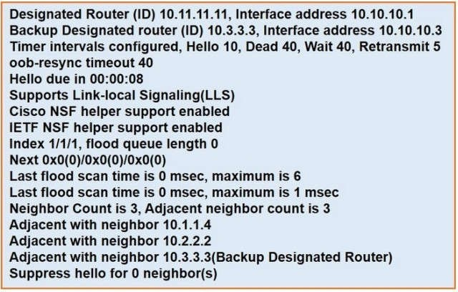

## Correct Answer: C Section: 3. IP Connectivity Explanation

**Explanation/Reference:**

Explanation:

From the output we can see there are Designated Router & Backup Designated Router for this OSPF domain so this is a broadcast network (point-to-point and point-to multipoint networks do not elect DR & BDR) -> Answer B is not correct.

By default, the timers on a broadcast network (Ethernet, point-to-point and point-to-multipoint) are 10 seconds hello and 40 seconds dead (therefore answer C is correct). The timers on a non- broadcast network are 30 seconds hello 120 seconds dead.

From the line “Neighbor Count is 3”, we learn there are four OSPF routers in this OSPF domain -> Answer D is not correct.

Reference: ht[tps://w](http://www.cisco.com/c/en/us/support/docs/ip/open-shortest-path-first-ospf/13689-17.html)ww[.cisco.com/c/en/us/support/do](http://www.cisco.com/c/en/us/support/docs/ip/open-shortest-path-first-ospf/13689-17.html)cs[/ip/open-shortest-path-first-ospf/13689-17.ht](http://www.cisco.com/c/en/us/support/docs/ip/open-shortest-path-first-ospf/13689-17.html)m[l](http://www.cisco.com/c/en/us/support/docs/ip/open-shortest-path-first-ospf/13689-17.html)

## QUESTION 50

An engineer is asked to protect unused ports that are configured in the default VLAN on a switch. Which two steps will fulfill the request? (Choose two)

1. Configure the ports in an EtherChannel.
2. Administratively shut down the ports.
3. Configure the port type as access and place in VLAN 99.
4. Configure the ports as trunk ports.
5. Enable the Cisco Discovery Protocol.

## Correct Answer: BC

**Section: 5. Security Fundamentals Explanation**

**Explanation/Reference:**

**QUESTION 51**

Which QoS Profile is selected in the GUI when configuring a voice over WLAN deployment?

1. Bronze
2. Platinum
3. Silver
4. Gold

## Correct Answer: B

**Section: 2. Network Access Explanation**

**Explanation/Reference:**

Cisco Unified Wireless Network solution WLANs support four levels of QoS: Platinum/Voice, Gold/Video, Silver/ Best Effort (default), and Bronze/Background.

Reference: [https://w](http://www.cisco.com/c/en/us/td/docs/wireless/controller/7-4/configuration/guides/consolidated/)ww[.cisco.com/c/en/us/td/](http://www.cisco.com/c/en/us/td/docs/wireless/controller/7-4/configuration/guides/consolidated/)docs[/wireless/controller/7-4/configuration/guides/consolidated/](http://www.cisco.com/c/en/us/td/docs/wireless/controller/7-4/configuration/guides/consolidated/) b_cg74_CONSOLIDATED/b_cg74_CONSOLIDATED_chapter_01010111.html

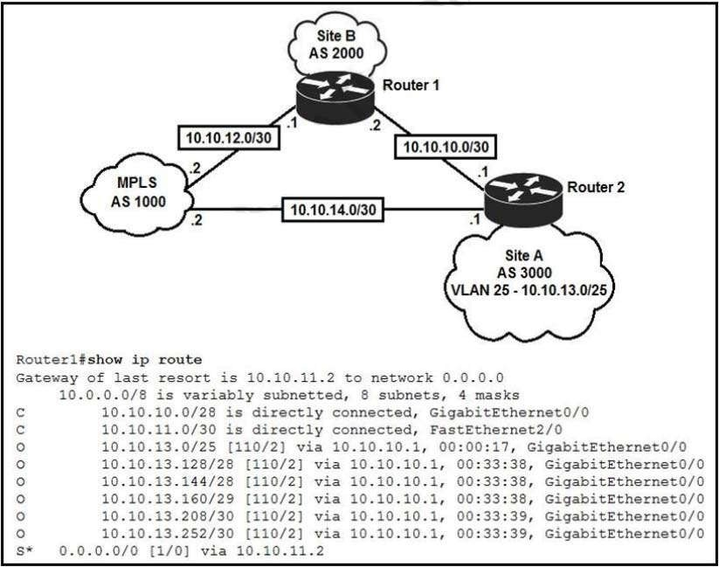

1. Traffic to 10.10.13.0.25 is load balanced out of multiple interfaces.
2. Route 10.10.13.0/25 is updated in the routing table as being learned from interface Gio/1.
3. Traffic to 10.10.13.0/25 is asymmeteical.
4. Route 10.10.13.0/25 learned via the Gi0/0 interface remains in the routing table.

## Correct Answer: D Section: 3. IP Connectivity Explanation

1. The hypervisor can virtualize physical components including CPU, memory, and storage.
2. Each hypervisor can support a single virtual machine and a single software switch.
3. The hypervisor communicates on Layer 3 without the need for additional resources.

## Correct Answer: B

**Section: 1. Network Fundamentals Explanation**

**Explanation/Reference:**

**QUESTION 54**

Refer to the exhibit. Which type of route does R1 use to reach host 10.10.13.10/32?

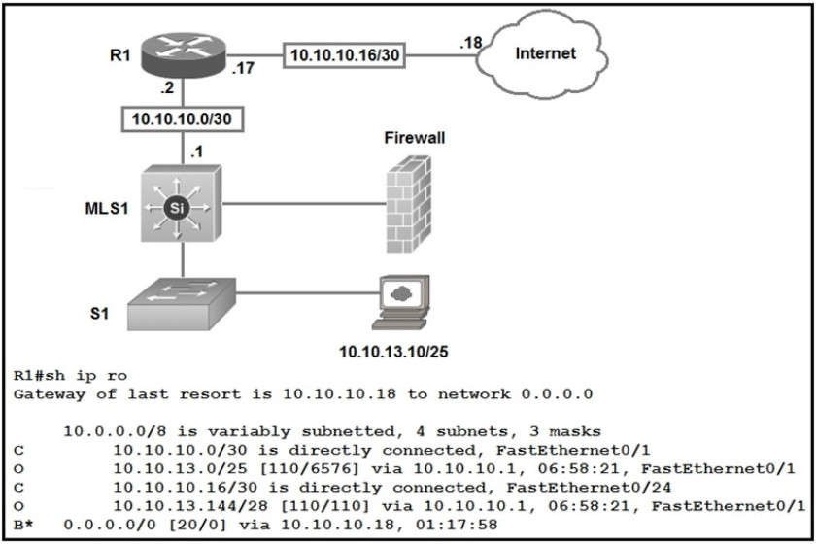

1. floating static route
2. host route
3. default route
4. network route

## Correct Answer: D

**Section: 1. Network Fundamentals Explanation**

**QUESTION 55**

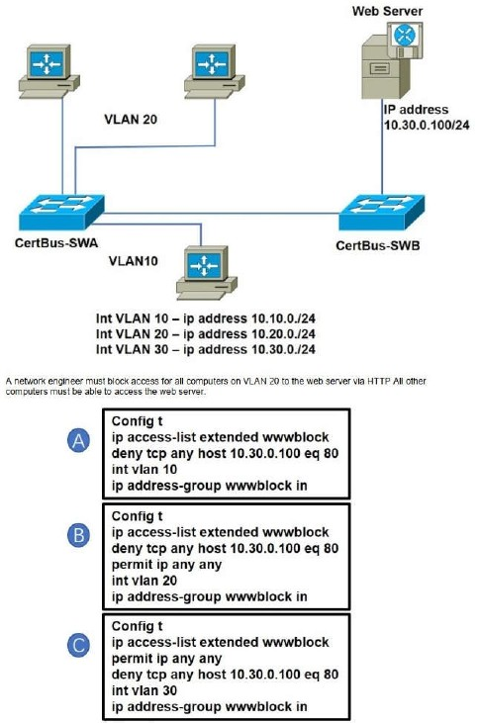

Refer to the exhibit. Which configuration when applied to switch A accomplishes this task?



1. Option A
2. Option B
3. Option C
4. Option D

## Correct Answer: B

**Section: 5. Security Fundamentals Explanation**

**Explanation/Reference:**

**QUESTION 56**

Two switches are connected and using Cisco Dynamic Trunking Protocol SW1 is set to Dynamic Desirable. What is the result of this configuration?

1. The link is in a down state.
2. The link is in an error disables state
3. The link is becomes an access port.
4. The link becomes a trunk port.

## Correct Answer: D

**Section: 2. Network Access Explanation**

**Explanation/Reference:**

**QUESTION 57**

Which feature on the Cisco Wireless LAN Controller when enabled restricts management access from specific networks?

1. CPU ACL
2. TACACS
3. Flex ACL
4. RADIUS

## Correct Answer: A

**Section: 5. Security Fundamentals Explanation**

**Explanation/Reference:**

Whenever you want to control which devices can talk to the main CPU, a CPU ACL is used.

Note: CPU ACLs only filter traffic towards the CPU, and not any traffic exiting or generated by the CPU. Reference: ht[tps://w](http://www.cisco.com/c/en/us/support/docs/wireless-mobility/wlan-security/71978-acl-wlc.html)ww[.cisco.com/c/en/us/support/do](http://www.cisco.com/c/en/us/support/docs/wireless-mobility/wlan-security/71978-acl-wlc.html)cs[/wireless-](http://www.cisco.com/c/en/us/support/docs/wireless-mobility/wlan-security/71978-acl-wlc.html)m[obility/wlan-security/71978-acl-wlc.html](http://www.cisco.com/c/en/us/support/docs/wireless-mobility/wlan-security/71978-acl-wlc.html)

## QUESTION 58

A user configured OSPF in a single area between two routers A serial interface connecting R1 and R2 is running encapsulation PPP, by default, which OSPF network type is seen on this interface when the user types show ip ospf interface on R1 or R2?

D. nonbroadcast

## Correct Answer: C Section: 3. IP Connectivity Explanation

**Explanation/Reference:**

The default OSPF network type for HDLC and PPP on Serial link is point-to-point (while the default OSPF network type for Ethernet link is Broadcast).

## QUESTION 59

Refer to the exhibit. Based on the LACP neighbor status, in which mode is the SW1 port channel configured?

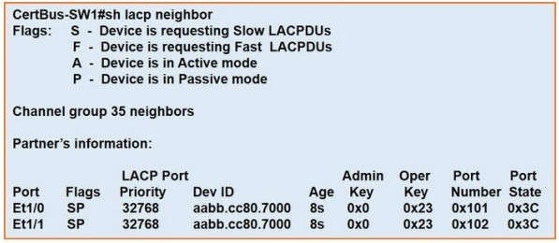

1. passive
2. mode on
3. auto
4. active

## Correct Answer: D

**Section: 2. Network Access Explanation**

**Explanation/Reference:**

From the neighbor status, we notice the “Flags” are SP. “P” here means the neighbor is in Passive mode. In order to create an Etherchannel interface, the (local) SW1 ports should be in Active mode.

Moreover, the “Port State” in the exhibit is “0x3c” (which equals to “00111100 in binary format).

Bit 3 is “1” which means the ports are synchronizing -> the ports are working so the local ports should be in Active mode.

## QUESTION 60

A user configured OSPF and advertised the Gigabit Ethernet interface in OSPF by default, which type of OSPF network does this interface belong to?

1. point-to-multipoint
2. point-to-point

## Section: 3. IP Connectivity Explanation

**Explanation/Reference:**

The Broadcast network type is the default for an OSPF enabled ethernet interface (while Point-toPoint is the default OSPF network type for Serial interface with HDLC and PPP encapsulation).

Reference: ht[tps://w](http://www.oreilly.com/library/view/cisco-ios-cookbook/0596527225/ch08s15.html)ww[.oreil](http://www.oreilly.com/library/view/cisco-ios-cookbook/0596527225/ch08s15.html)ly[.com/library/vie](http://www.oreilly.com/library/view/cisco-ios-cookbook/0596527225/ch08s15.html)w[/cisco-ios-cookbook/0596527225/ch08s15.html](http://www.oreilly.com/library/view/cisco-ios-cookbook/0596527225/ch08s15.html)

## QUESTION 61

An organization has decided to start using cloud-provided services.

Which cloud service allows the organization to install its own operating system on a virtual machine?

1. platform-as-a-service
2. software-as-a-service
3. network-as-a-service
4. infrastructure-as-a-service

## Correct Answer: D

**Section: 6. Automation and Programmability Explanation**

**Explanation/Reference:**

Below are the 3 cloud supporting services cloud providers provide to customer:

+ SaaS (Software as a Service): SaaS uses the web to deliver applications that are managed by a thirdparty vendor and whose interface is accessed on the clients' side. Most SaaS applications can be run directly from a web browser without any downloads or installations required, although some require plugins.

+ PaaS (Platform as a Service): are used for applications, and other development, while providing cloud components to software. What developers gain with PaaS is a framework they can build upon to develop or customize applications. PaaS makes the development, testing, and deployment of applications quick, simple, and cost-effective. With this technology, enterprise operations, or a thirdparty provider, can manage OSes, virtualization, servers, storage, networking, and the PaaS software itself. Developers, however, manage the applications.

+ IaaS (Infrastructure as a Service): self-service models for accessing, monitoring, and managing remote datacenter infrastructures, such as compute (virtualized or bare metal), storage, networking, and networking services (e.g. firewalls). Instead of having to purchase hardware outright, users can purchase IaaS based on consumption, similar to electricity or other utility billing.

In general, IaaS provides hardware so that an organization can install their own operating system.

## QUESTION 62

Which mode allows access points to be managed by Cisco Wireless LAN Controllers?

1. autonomous
2. lightweight
3. bridge
4. mobility express

## Correct Answer: B

**Section: 2. Network Access Explanation**

**Explanation/Reference:**

A Lightweight Access Point (LAP) is an AP that is designed to be connected to a wireless LAN (WLAN)

## QUESTION 63

Which command automatically generates an IPv6 address from a specified IPvô prefix and MAC address of an interface?

A. ipv6 address dhcp

B. ipv6 address 2001:DB8:5:112::/64 eui-64

1. ipv6 address autoconfig
2. ipv6 address 2001:DB8:5:112::2/64 link-local

## Correct Answer: C

**Section: 1. Network Fundamentals Explanation**

**Explanation/Reference:**

The “ipv6 address autoconfig” command causes the device to perform IPv6 stateless address autoconfiguration to discover prefixes on the link and then to add the EUI-64 based addresses to the interface.

Addresses are configured depending on the prefixes received in Router Advertisement (RA) messages.

The device will listen for RA messages which are transmitted periodically from the router (DHCP Server).

This RA message allows a host to create a global IPv6 address from:

+ Its interface identifier (EUI-64 address)

+ Link Prefix (obtained via RA)

Note: Global address is the combination of Link Prefix and EUI-64 address

## QUESTION 64

Refer to Exhibit. An engineer is configuring the NEW York router to reach the Lot interface of the Atlanta router using interface Se0/0/0 as the primary path.

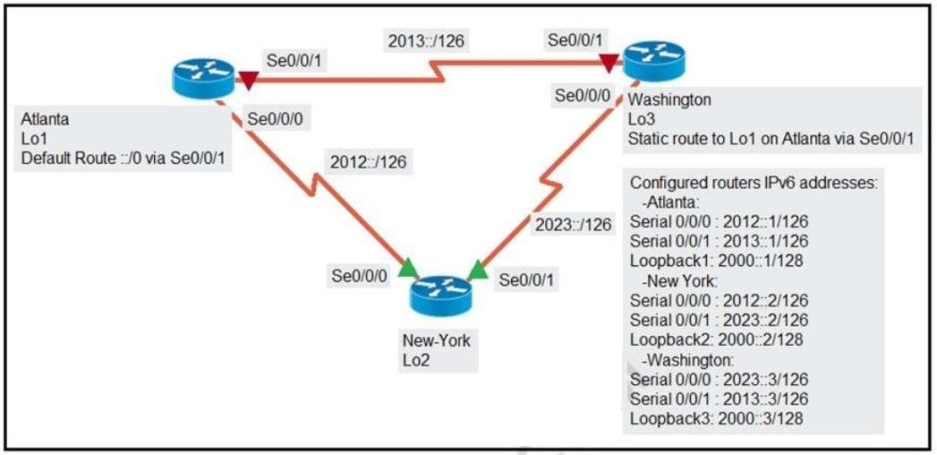

C. ipv6 router 2000::1/128 2012::2

D. ipv6 router 2000::1/128 2023:2 5

E. ipv6 router 2000::1/128 2023::3 5

## Correct Answer: AE Section: 3. IP Connectivity Explanation

**Explanation/Reference:**

Floating static routes are static routes that have an administrative distance greater than the administrative distance (AD) of another static route or dynamic routes. By default a static route has an AD of 1 then floating static route must have the AD greater than 1. Floating static route has a manually configured administrative distance greater than that of the primary route and therefore would not be in the routing table until the primary route fails.

## QUESTION 65

Refer to the exhibit. Which command provides this output?

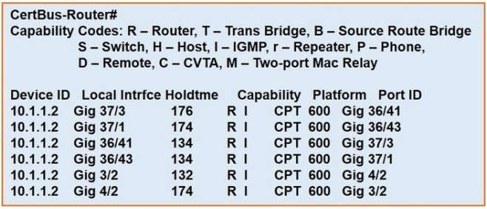

1. show ip route
2. show ip interface
3. show interface
4. show cdp neighbor

## Correct Answer: D

**Section: 2. Network Access Explanation**

**Explanation/Reference:**

**QUESTION 66**

Which two outcomes are predictable behaviors for HSRP? (Choose two)

1. The two routers synchronize configurations to provide consistent packet forwarding.
2. The two routed share the same IP address, and default gateway traffic is load-balanced between them.

## Correct Answer: AB Section: 3. IP Connectivity Explanation

**Explanation/Reference:**

**QUESTION 67**

Which action is taken by a switch port enabled for PoE power classification override?

1. When a powered device begins drawing power from a PoE switch port a syslog message is generated.
2. As power usage on a PoE switch port is checked data flow to the connected device is temporarily paused.
3. If a switch determines that a device is using less than the minimum configured power it assumes the device has failed and disconnects.
4. If a monitored port exceeds the maximum administrative value for power, the port is shutdown and err- disabled.

## Correct Answer: D

**Section: 1. Network Fundamentals Explanation**

**Explanation/Reference:**

Explanation: PoE monitoring and policing compares the power consumption on ports with the administrative maximum value (either a configured maximum value or the port’s default value). If the power consumption on a monitored port exceeds the administrative maximum value, the following actions occur:

* A syslog message is issued.
* The monitored port is shut down and error-disabled.
* The allocated power is freed.

Reference: ht[tps://w](http://www.cisco.com/c/en/us/td/docs/switches/lan/catalyst6500/ios/12-2SX/configuration/guide/)ww[.cisco.com/c/en/us/td/](http://www.cisco.com/c/en/us/td/docs/switches/lan/catalyst6500/ios/12-2SX/configuration/guide/)do[cs/switches/lan/catalyst6500/ios/12-2SX/configuration/guide/](http://www.cisco.com/c/en/us/td/docs/switches/lan/catalyst6500/ios/12-2SX/configuration/guide/) book/power_over_ethernet.pdf

## QUESTION 68

Which 802.11 frame type is association response?

1. management
2. protected frame
3. control
4. action

## Correct Answer: A

**Section: 1. Network Fundamentals Explanation**

**Explanation/Reference:**

There are three main types of 802.11 frames: the Data Frame, the Management Frame and the Control Frame. Association Response belongs to Management Frame. Association response is sent in response to an association request.

Reference: https://en.wikipedia.org/wiki/802.11_Frame_Types

1. Enable NTP authentication.
2. Verify the time zone.
3. Disable NTP broadcasts.
4. Specify the IP address of the NTP server.
5. Set the NTP server private key.

## Correct Answer: AD Section: 4. IP Services Explanation

**Explanation/Reference:**

To configure authentication, perform this task in privileged mode:

Step 1: Configure an authentication key pair for NTP and specify whether the key will be trusted or untrusted. Step 2: Set the IP address of the NTP server and the public key.

Step 3: Enable NTP client mode. Step 4: Enable NTP authentication. Step 5: Verify the NTP configuration. Reference: Click here

## QUESTION 70

Refer to the exhibit. The New York router is configured with static routes pointing to the Atlanta and Washington sites.

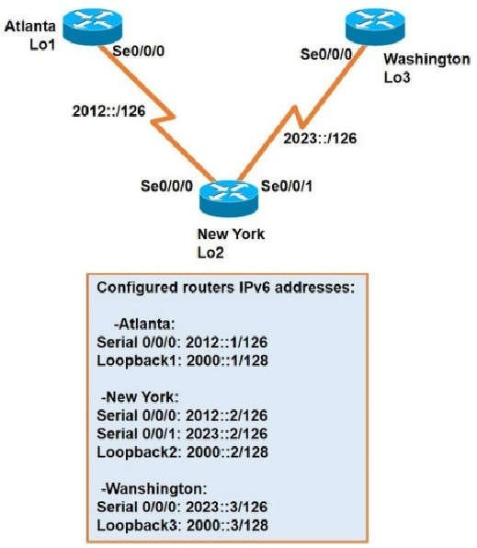

Which two tasks must be performed so that the Serial0/0/0 interfaces on the Atlanta and Washington routers can reach one another? (Choose two.)

1. Configure the ipv6 route 2012::/126 2023::1 command on the Washington router.
2. Configure the ipv6 route 2023::/126 2012::1 command on the Atlanta router.
3. Configure the Ipv6 route 2012::/126 s0/0/0 command on the Atlanta router.
4. Configure the ipv6 route 2023::/126 2012::2 command on the Atlanta router.
5. Configure the ipv6 route 2012::/126 2023::2 command on the Washington router.

## Correct Answer: DE Section: 3. IP Connectivity Explanation

Which result occurs when PortFast is enabled on an interface that is connected to another switch?

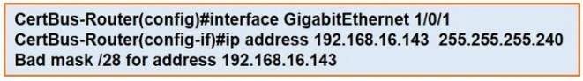

1. Spanning tree may fail to detect a switching loop in the network that causes broadcaststorms.
2. VTP is allowed to propagate VLAN configuration information from switch to switch automatically.
3. Root port choice and spanning tree recalculation are accelerated when a switch link goes down.
4. After spanning tree converges PortFast shuts down any port that receives BPDUS.

## Correct Answer: A

**Section: 2. Network Access Explanation**

**Explanation/Reference:**

Enabling the PortFast feature causes a switch or a trunk port to enter the STP forwarding-state immediately or upon a linkup event, thus bypassing the listening and learning states.

Note: To enable portfast on a trunk port you need the trunk keyword "spanning-tree portfast trunk"

## QUESTION 72

Refer to exhibit. Which statement explains the configuration error message that is received?

1. It is a broadcast IP address.
2. The router does not support/28 mask.
3. It belongs to a private IP address range.
4. It is a network IP address.

## Correct Answer: A

**Section: 1. Network Fundamentals Explanation**

**Explanation/Reference:**

**QUESTION 73**

When a floating static route is configured, which action ensures that the backup route is used when the primary route fails?

1. The floating static route must have a higher administrative distance than the primary route so it is used as a backup.
2. The administrative distance must be higher on the primary route so that the backup route becomes secondary
3. The floating static route must have a lower administrative distance than the primary route so it is used as a backup.
4. The default-information originate command must be configured for the route to be installed into the routing table.

## Correct Answer: A Section:



**QUESTION 74**

What makes Cisco DNA Center different from traditional network management applications and their management of networks?

1. It only supports auto-discovery of network elements in a greenfield deployment.
2. It modular design allows someone to implement different versions to meet the specific needs of an organization.
3. It abstracts policy from the actual device configuration.
4. It does not support high availability of management functions when operating in clustermode.

## Correct Answer: C

**Section: 6. Automation and Programmability Explanation**

**Explanation/Reference:**

**QUESTION 75**

Which network allows devices to communicate without the need to access the Internet?

A. 172.9.0.0/16

B. 172.28.0.0/16

C. 192.0.0.0/8

D. 209.165.201.0/24

## Correct Answer: B

**Section: 1. Network Fundamentals Explanation**

**Explanation/Reference:**

This question asks about the private ranges of IPv4 addresses. The private ranges of each class of IPv4 are listed below:

Class A private IP address ranges from 10.0.0.0 to 10.255.255.255 Class B private IP address ranges from

172.16.0.0 to 172.31.255.255 Class C private IP address ranges from 192.168.0.0 to 192.168.255.255 Only the network 172.28.0.0/16 belongs to the private IP address (of class B).

## QUESTION 76

Refer to the exhibit. What does router R1 use as its OSPF router-ID?

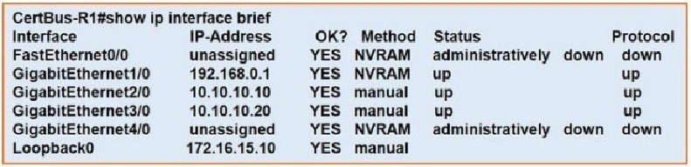

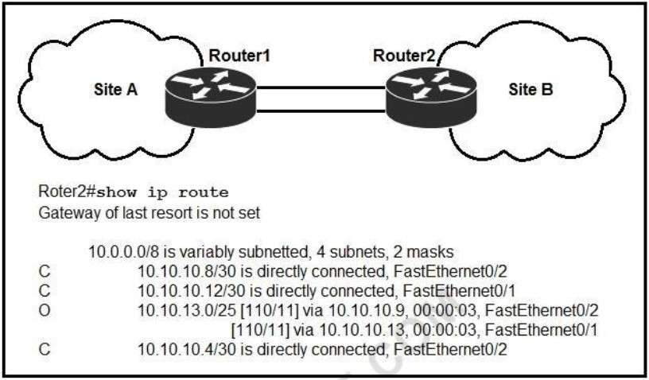

## Correct Answer: C Section: 3. IP Connectivity Explanation

**Explanation/Reference:**

OSPF uses the following criteria to select the router ID:

1. Manual configuration of the router ID (via the "router-id x.x.x.x" command under OSPF router configuration mode).
2. Highest IP address on a loopback interface.
3. Highest IP address on a non-loopback and active (no shutdown) interface

## QUESTION 77

Refer to the exhibit. If OSPF is running on this network, how does Router 2 handle traffic from Site B to 10.10.13.128/25 at Site A?

1. It sends packets out of interface Fa0/2 only.
2. It sends packets out of interface Fa0/1 only.
3. It cannot send packets to 10.10.13.128/25.
4. It load-balances traffic out of Fa0/1 and Fa0/2.

## Correct Answer: C Section: 3. IP Connectivity Explanation

When a site-to-site VPN is used, which protocol is responsible for the transport of user data?

1. IKEv2
2. IKEv1
3. IPsec
4. MD5

## Correct Answer: C

**Section: 5. Security Fundamentals Explanation**

**Explanation/Reference:**

A site-to-site VPN allows offices in multiple fixed locations to establish secure connections with each other over a public network such as the Internet. A site-to-site VPN means that two sites create a VPN tunnel by encrypting and sending data between two devices. One set of rules for creating a siteto-site VPN is defined by IPsec.

## QUESTION 79

Refer to the exhibit. An extended ACL has been configured and applied to router R2 The configuration farted to work as intended.

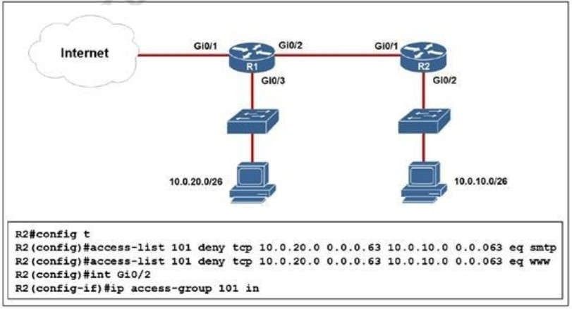

Refer to the exhibit. An extended ACL has been configured and applied to router R2 The configuration started to work as intended.Which two changes stop outbound traffic on TCP ports 25 and 80 to 10.0.20.0/26 from the 10.0.10.0/26 subnet while still allowing all other traffic? (Choose two)

1. Add a “permit ip any any” statement to the begining of ACL 101 for allowed traffic.
2. Add a “permit ip any any” statement at the end of ACL 101 for allowed traffic.

## Correct Answer: BC

**Section: 5. Security Fundamentals Explanation**

**Explanation/Reference:**

**QUESTION 80**

Which mode must be used to configure EtherChannel between two switches without using a negotiation protocol?

1. on
2. auto
3. active
4. desirable

## Correct Answer: A

**Section: 2. Network Access Explanation**

**Explanation/Reference:**

The Static Persistence (or “on” mode) bundles the links unconditionally and no negotiation protocol is used. In this mode, neither PAgP nor LACP packets are sent or received.

## QUESTION 81

A router running EIGRP has learned the same route from two different paths. Which parameter does the router use to select the best path?

1. cost
2. adminstrative distance
3. metric
4. as-path

## Correct Answer: C Section: 3. IP Connectivity Explanation

**Explanation/Reference:**

If a router learns two different paths for the same network from the same routing protocol, it has to decide which route is better and will be placed in the routing table. Metric is the measure used to decide which route is better (lower number is better). Each routing protocol uses its own metric.

For example, RIP uses hop counts as a metric, while OSPF uses cost. Click hereClick here

## QUESTION 82

R1 has learned route 192.168.12.0/24 via IS-IS. OSPF, RIP. and Internal EIGRP Under normal operating conditions, which routing protocol is installed in the routing table?

1. IS-IS
2. RIP
3. Internal EIGRP
4. OSPF

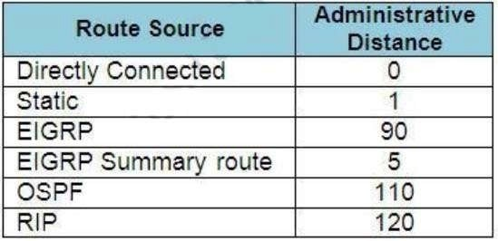

## Explanation/Reference:

With the same route (prefix), the router will choose the routing protocol with lowest Administrative Distance (AD) to install into the routing table. The AD of Internal EIGRP (90) is lowest so it would be chosen. The table below lists the ADs of popular routing protocols.

Note: The AD of IS-IS is 115. The "EIGRP" in the table above is "Internal EIGRP". The AD of "External EIGRP" is 170. An EIGRP external route is a route that was redistributed into EIGRP.

## QUESTION 83

Which MAC address is recognized as a VRRP virtual address?

A. 0000.5E00.010a

B. 0005.3711.0975

C. 0000.0C07.AC99

D. 0007.C070/AB01

## Correct Answer: A Section:

**3. IP Connectivity Explanation**

**Explanation/Reference:**

With VRRP, the virtual router's MAC address is 0000.5E00.01xx , in which xx is the VRRP group.

## QUESTION 84

Which statement correctly compares traditional networks and controller-based networks?

1. Only traditional networks offer a centralized control plane.
2. Only traditional networks natively support centralized management.
3. Traditional and controller-based networks abstract policies from device configurations.
4. Only controller-based networks decouple the control plane and the data plane.

## Correct Answer: D

**Section: 6. Automation and Programmability Explanation**

**Explanation/Reference:**

networking devices into one device, called SDN controller -> Answer D is correct.

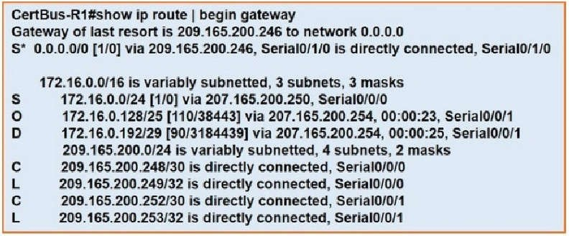

## QUESTION 85

If a notice-level messaging is sent to a syslog server, which event has occurred?

1. A network device has restarted.
2. An ARP inspection has failed.
3. A routing instance has flapped.
4. A debug operation is running.

## Correct Answer: C Section: 4. IP Services Explanation

**Explanation/Reference:**

Usually no action is required when a route flaps so it generates the notification syslog level message (level 5).

## QUESTION 86

Refer to the exhibit. With which metric was the route to host 172.16.0.202 learned?

A. 0

B. 110

C. 38443

D. 3184439

## Correct Answer: C Section: 3. IP Connectivity Explanation

**Explanation/Reference:**

Both the line "O 172.16.0.128/25" and "S 172.16.0.0/24" cover the host 172.16.0.202 but with the "longest (prefix) match" rule the router will choose the first route.

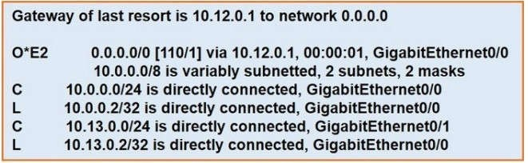

1. It ignores the new static route until the existing OSPF default route is removed.
2. It immediately replaces the existing OSPF route in the routing table with the newly configured static route.
3. It starts load-balancing traffic between the two default routes.
4. It starts sending traffic without a specific matching entryin the routing table to GigabitEthernet0/1.

## Correct Answer: A Section:

**3. IP Connectivity Explanation**

**Explanation/Reference:**

Our new static default route has the Administrative Distance (AD) of 120, which is bigger than the AD of OSPF External route (O*E2) so it will not be pushed into the routing table until the current OSPF External route is removed.

For your information, if you don't type the AD of 120 (using the command "ip route 0.0.0.0 0.0.0.0 10.13.0.1") then the new static default route would replace the OSPF default route as the default AD of static route is 1. You will see such line in the routing table:

S* 0.0.0.0/0 [1/0] via 10.13.0.1

## QUESTION 88

Refer to the Exhibit. After the switch configuration the ping test fails between PC A and PC B Based on the output for switch 1.

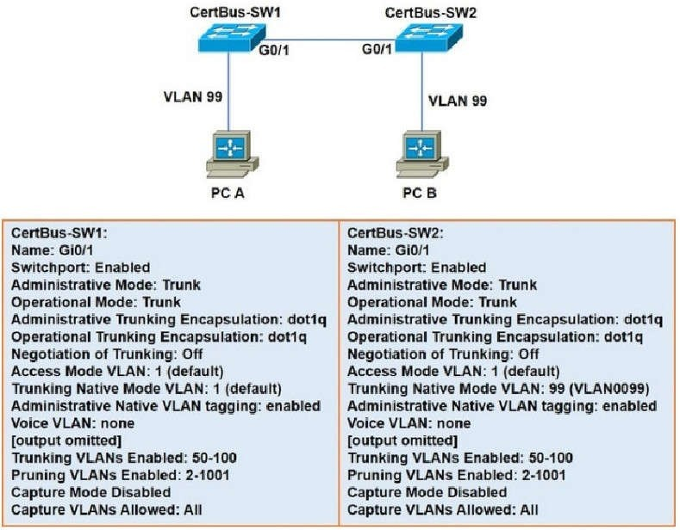

Which error must be corrected?

1. There is a native VLAN mismatch.
2. Access mode is configured on the switch ports.
3. The PCs are in the incorrect VLAN.
4. All VLANs are not enabled on the trunk.

## Correct Answer: A

**Section: 2. Network Access Explanation**

**Explanation/Reference:**

From the output we see the native VLAN of Switch1 on Gi0/1 interface is VLAN 1 while that of Switch2 is VLAN 99 so there would be a native VLAN mismatch.

1. RC4
2. AES
3. TKIP

## Correct Answer: C

**Section: 5. Security Fundamentals Explanation**

**Explanation/Reference:**

Many routers provide WPA2-PSK (TKIP), WPA2-PSK (AES), and WPA2-PSK (TKIP/AES) as options.

TKIP is actually an older encryption protocol introduced with WPA to replace the very-insecure WEP encryption at the time. TKIP is actually quite similar to WEP encryption. TKIP is no longer considered secure, and is now deprecated. In other words, you shouldn't be using it.

AES is a more secure encryption protocol introduced with WPA2 and it is currently the strongest encryption type for WPA2-PSK/

## QUESTION 90

Which statement about Link Aggregation when implemented on a Cisco Wireless LAN Controller is true?

1. To pass client traffic two or more ports must be configured.
2. The EtherChannel must be configured in “modeactive”.
3. When enabled, the WLC bandwidth drops to 500 Mbps.
4. One functional physical port is needed to pass client traffic.

## Correct Answer: D

**Section: 2. Network Access Explanation**

**Explanation/Reference:**

Link aggregation (LAG) is a partial implementation of the 802.3ad port aggregation standard. It bundles all of the controller's distribution system ports into a single 802.3ad port channel.

Restriction for Link aggregation:

* LAG requires the EtherChannel to be configured for `mode on' on both the controller and the Catalyst switch -

> Answer B is not correct.

* If the recommended load-balancing method cannot be configured on the Catalyst switch, then configure the LAG connection as a single member link or disable LAG on the controller -> Answer A is not correct while answer D is correct.

Reference: Click here

## QUESTION 91

When configuring a WLAN with WPA2 PSK in the Cisco Wireless LAN Controller GUI, which two formats are available to select? (Choose two)

1. ASCII
2. base64
3. binary
4. decimal
5. hexadecimal

## Correct Answer: AE

**Section: 5. Security Fundamentals**

Reference: ht[tps://w](http://www.cisco.com/c/en/us/td/docs/wireless/controller/7-4/configuration/guides/consolidated/)ww[.cisco.com/c/en/us/td/](http://www.cisco.com/c/en/us/td/docs/wireless/controller/7-4/configuration/guides/consolidated/)do[cs/wireless/controller/7-4/configuration/guides/consolidated/](http://www.cisco.com/c/en/us/td/docs/wireless/controller/7-4/configuration/guides/consolidated/) b_cg74_CONSOLIDATED/b_cg74_CONSOLIDATED_chapter_01010001.html

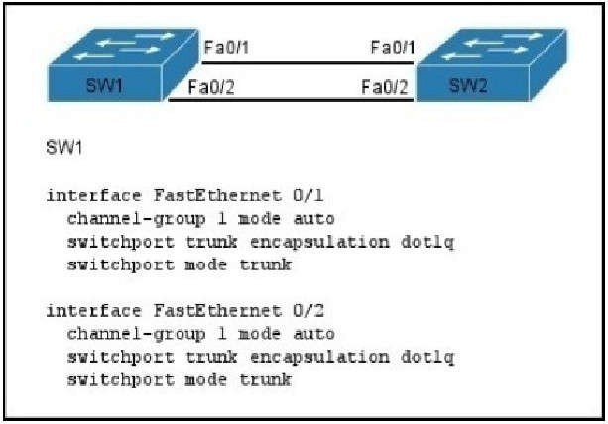

## QUESTION 92

Which API is used in controller-based architectures to interact with edge devices?

1. overlay
2. northbound
3. underlay
4. southbound

## Correct Answer: D

**Section: 6. Automation and Programmability Explanation**

**Explanation/Reference:**

**QUESTION 93**

Refer to the exhibit. A network administrator is configuring an EtherChannel between SW1 and SW2. The SW1 configuration is shown.

What is the correct configuration for SW2?

1. interface FastEthernet 0/1

switchport trunk encapsulation dot1q switchport mode trunk

1. interface FastEthernet 0/1 channel-group 2 mode auto

switchport trunk encapsulation dot1q switchport mode trunk

interface FastEthernet 0/2 channel-group 2 mode auto

switchport trunk encapsulation dot1q switchport mode trunk

1. interface FastEthernet 0/1 channel-group 1 mode desirable

switchport trunk encapsulation dot1q switchport mode trunk

interface FastEthernet 0/2 channel-group 1 mode desirable

switchport trunk encapsulation dot1q switchport mode trunk

1. interface FastEthernet 0/1 channel-group 1 mode passive switchport trunk encapsulation dot1q switchport mode trunk interface FastEthernet 0/2 channel-group 1 mode passive

switchport trunk encapsulation dot1q switchport mode trunk

## Correct Answer: C Section: Not categorized Explanation

**Explanation/Reference:**

If the etherchannel was configured with mode “auto”, it was using PagP, so, we need to configure the other switch with “desirable” mode.

PagP modes: auto | Desirable LACP modes: active | pasive

## QUESTION 94

Refer to the exhibit. A frame on VLAN 1 on switch S1 is sent to switch S2 where the frame is received on VLAN 2.

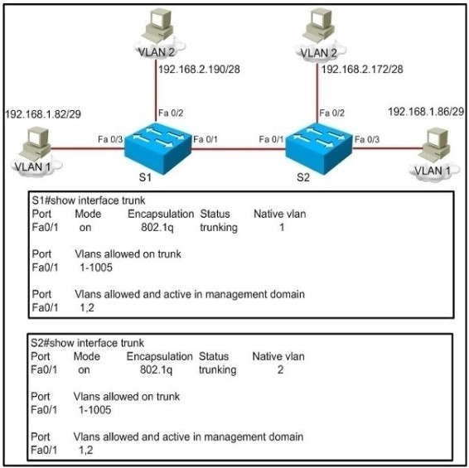

What causes this behavior?

1. trunk mode mismatches
2. allowing only VLAN 2 on the destination
3. native VLAN mismatches
4. VLANs that do not correspond to a unique IP subnet

## Correct Answer: C Section: Not categorized Explanation

**Explanation/Reference:**

Untagged frames are encapsulated with the native VLAN. In this case, the native VLANs are different so although S1 will tag it as VLAN 1 it will be received by S2.

1. It supports up to 2 instances of OSPFv3 over a common link.
2. It routes over links rather than over networks.

## Correct Answer: BD Section: Not categorized Explanation

**Explanation/Reference:**

**QUESTION 96**

Which option is a valid IPv6 address?

A. 2001:0000:130F::099a::12a

B. 2002:7654:A1AD:61:81AF:CCC1

C. FEC0:ABCD:WXYZ:0067::2A4

D. 2004:1:25A4:886F::1

## Correct Answer: D Section: Not categorized Explanation

**Explanation/Reference:**

An IPv6 address is represented as eight groups of four hexadecimal digits, each group representing 16 bits (two octets). The groups are separated by colons (:). An example of an IPv6 address is 2001:0db8:85a3:0000:0000:8a2e:0370:7334.

The leading 0’s in a group can be collapsed using ::, but this can only be done once in an IP address.

## QUESTION 97

Which three are characteristics of an IPv6 anycast address? (Choose three.)

1. one-to-many communication model
2. one-to-nearest communication model
3. any-to-many communication model
4. a unique IPv6 address for each device in the group
5. the same address for multiple devices in thegroup
6. delivery of packets to the group interface that is closest to the sendingdevice

## Correct Answer: BEF Section: Not categorized Explanation

**Explanation/Reference:**

A new address type made specifically for IPv6 is called the Anycast Address. These IPv6 addresses are global addresses, these addresses can be assigned to more than one interface unlike an IPv6 unicast address.

Anycast is designed to send a packet to the nearest interface that is a part of that anycast group. The sender creates a packet and forwards the packet to the anycast address as the destination address which goes to the nearest router. The nearest router or interface is found by using the metric of a routing protocol currently running on the network. However in a LAN setting the nearest interface is found depending on the order the neighbors were learned. The anycast packet in a LAN setting forwards the packet to the neighbor it learned about first.

## QUESTION 98

Which two statements describe characteristics of IPv6 unicast addressing? (Choose two.)

1. Link-local addresses start with FE00:/12.
2. Link-local addresses start with FF00::/10.
3. There is only one loopback address and it is ::1.
4. If a global address is assigned to an interface, then that is the only allowable address for the interface.

## Correct Answer: AD Section: Not categorized Explanation

**Explanation/Reference:**

Below is the list of common kinds of IPv6 addresses:

Loopback address ::1

Link-local address FE80::/10 Site-local address FEC0::/10 Global address 2000::/3 Multicast address FF00::/8

## QUESTION 99

What is the alternative notation for the IPv6 address B514:82C3:0000:0000:0029:EC7A:0000:EC72?

A. B514 : 82C3 : 0029 : EC7A : EC72

B. B514 : 82C3 :: 0029 : EC7A : EC72

C. B514 : 82C3 : 0029 :: EC7A : 0000 : EC72

D. B514 : 82C3 :: 0029 : EC7A : 0 : EC72

## Correct Answer: D Section: Not categorized Explanation

**Explanation/Reference:**

There are two ways that an IPv6 address can be additionally compressed: compressing leading zeros and substituting a group of consecutive zeros with a single double colon(::). Both of these can be used in any number of combinations to notate the same address. It is important to note that the double colon (::) can only be used once within a single IPv6 address notation. So, the extra 0’s can only be compressed once.

## QUESTION 100

Which IPv6 address is valid?

A. 2001:0db8:0000:130F:0000:0000:08GC:140B

B. 2001:0db8:0:130H::87C:140B

C. 2031::130F::9C0:876A:130B

D. 2031:0:130F::9C0:876A:130B

## Correct Answer: D Section: Not categorized Explanation

**Explanation/Reference:**

An IPv6 address is represented as eight groups of four hexadecimal digits, each group representing 16 bits (two octets). The groups are separated by colons (:). An example of an IPv6 address is



1. anycast
2. broadcast
3. multicast
4. podcast
5. allcast

## Correct Answer: AC Section: Not categorized Explanation

**Explanation/Reference:**

IPv6 addresses are classified by the primary addressing and routing methodologies common in networking: unicast addressing, anycast addressing, and multicast addressing. A unicast address identifies a single network interface. The Internet Protocol delivers packets sent to a unicast address to that specific interface. An anycast address is assigned to a group of interfaces, usually belonging to different nodes. A packet sent to an anycast address is delivered to just one of the member interfaces, typically the nearest host, according to the routing protocol’s definition of distance. Anycast addresses cannot be identified easily, they have the same format as unicast addresses, and differ only by their presence in the network at multiple points. Almost any unicast address can be employed as an anycast address.

A multicast address is also used by multiple hosts, which acquire the multicast address destination by participating in the multicast distribution protocol among the network routers. A packet that is sent to a multicast address is delivered to all interfaces that have joined the corresponding multicast group.

## QUESTION 102

Which command enables IPv6 forwarding on a Cisco router?

1. ipv6 local
2. ipv6 host
3. ipv6 unicast-routing
4. ipv6 neighbor

## Correct Answer: C Section: Not categorized Explanation

**Explanation/Reference:**

To enable IPv6 routing on the Cisco router use the following command: ipv6 unicast-routing If this command is not recognized, your version of IOS does not support IPv6.

## QUESTION 103

Which IPv6 address is the equivalent of the IPv4 interface loopback address 127.0.0.1?

A. : :1

B. ::

C. 2000::/3

D. 0::/10

## Correct Answer: A

**Section: Not categorized**



**QUESTION 104**

In which two formats can the IPv6 address fd15:0db8:0000:0000:0700:0003:400F:572B be written? (Choose two.)

A. fd15:0db8:0000:0000:700:3:400F:527B

B. fd15::db8::700:3:400F:527B

C. fd15:db8:0::700:3:4F:527B

D. fd15:0db8::7:3:4F:527B

E. fd15:db8::700:3:400F:572B

## Correct Answer: AE Section: Not categorized Explanation

**Explanation/Reference:**

**QUESTION 105**

Refer to the exhibit. The MAC address table is shown in its entirety. The Ethernet frame that is shown arrives at the switch.

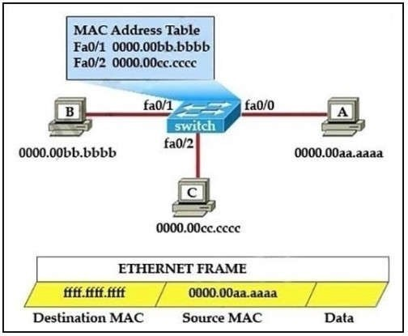

What two operations will the switch perform when it receives this frame? (Choose two.)

1. The switch will not forward a frame with this destination MAC address.
2. The frame will be forwarded out of all the ports on the switch.

## Correct Answer: DE Section: Not categorized Explanation

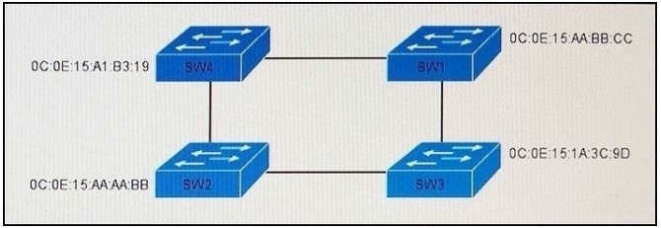

**Explanation/Reference:**

**QUESTION 106**

Refer to the exhibit. Which switch in this configuration becomes the root bridge?

1. SW1
2. SW2
3. SW3
4. SW4

## Correct Answer: C Section: Not categorized Explanation

**Explanation/Reference:**

**QUESTION 107**

Refer to the exhibit. Which two statements are true about the loopback address that is configured on RouterB? (Choose two.)

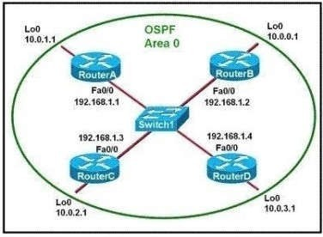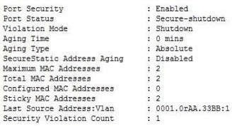

1. It ensures that data will be forwarded by RouterB.
2. It provides stability for the OSPF process on RouterB.
3. It specifies that the router ID for RouterB should be 10.0.0.1.
4. It decreases the metric for routes that are advertised from RouterB.
5. It indicates that RouterB should be elected the DR for the LAN.

## Correct Answer: BC Section: Not categorized Explanation

**Explanation/Reference:**

A loopback interface never comes down even if the link is broken so it provides stability for the OSPF process (for example we use that loopback interface as the router-id) – The router-ID is chosen in the order below:

+ The highest IP address assigned to a loopback (logical) interface. + If a loopback interface is not defined, the highest IP address of all active router’s physical interfaces will be chosen.

-> The loopback interface will be chosen as the router ID of RouterB ?

## QUESTION 108

Refer to the exhibit. Which two statements about the interface that generated the output are true? (Choose two.)

E. An SNMP trap is generated when the maximum number of secure MAC addresses is reached on the interface.

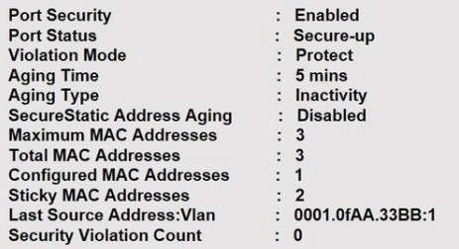

## Correct Answer: CD Section: Not categorized Explanation

**Explanation/Reference:**

**QUESTION 109**

Refer to the exhibit. Which two statements about the interface that generated the output are true? (Choose two.)

1. learned MAC addresses are deleted after five minutes of inactivity
2. the interface is error-diabled if packets arrive from a new unknown source address
3. it has dynamically learned two secure MAC addresses
4. it has dynamically learned three secure MAC addresses
5. the security violation counter increments if packets arrive from a new unknown source address

## Correct Answer: AC Section: Not categorized Explanation

**Explanation/Reference:**

**QUESTION 110**

Refer to the exhibit. Which two events occur on the interface, if packets from an unknown Source address arrive after the interface learns the maximum number of secure MAC address? (Choose two.)

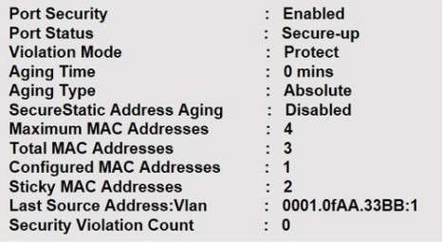

1. The security violation counter dose not increment
2. The port LED turns off
3. The interface is error-disabled
4. A syslog message is generated
5. The interface drops traffic from unknown MAC address

## Correct Answer: AE Section: Not categorized Explanation

**Explanation/Reference:**

**QUESTION 111**

Refer to the exhibit. Which two statements about the network environment of router R1 must be true? (Choose two.)

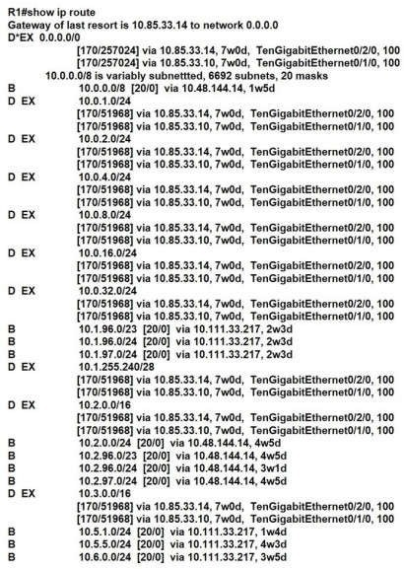

1. there are 20 different network masks within the 10.0.0.0/8 network
2. A static default route to 10.85.33.14 was defined
3. Ten routes are equally load-balanced between Te0/1/0.100 and Te0/2/0.100
4. The 10.0.0.0/8 network was learned via external EIGRP
5. The EIGRP administrative distance was manually changed from 90 to 170

## Correct Answer: AC Section: Not categorized Explanation

**Explanation/Reference:**

**QUESTION 112**

Refer to the exhibit. Which statement about the interface that generated the output is true?

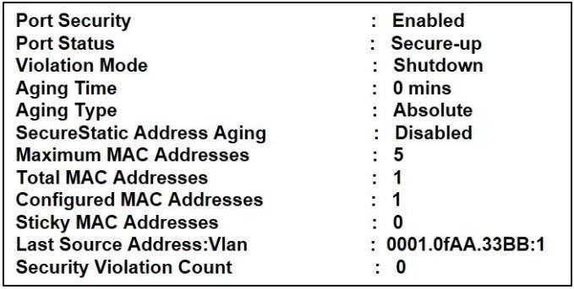

1. Five secure MAC addresses are dynamically learned on the interface.
2. A syslog message is generated when a violation occurs.
3. One secure MAC address is manually configured on the interface.
4. One secure MAC address is dynamically configured on the interface.

## Correct Answer: C Section: Not categorized Explanation

**Explanation/Reference:**

**QUESTION 113**

Refer to the exhibit. When PC 1 sends a packet to PC2,the packet has. Which source and destination IP address when it arrives at interface Gi0/0 on router R2?

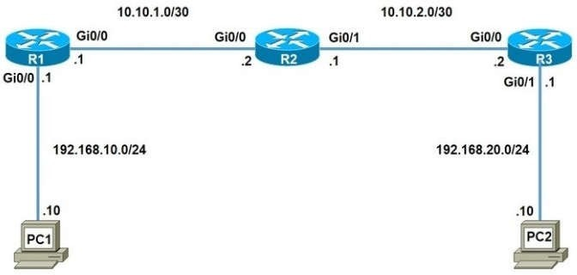

A. source 192.168.10.10 and destination 10.10.2.2

B. source 192.168.20.10 and destination 192.168.20.1

C. source 192.168.10.10 and destination 192.168.20.10

D. source 10.10.1.1 and destination 10.10.2.2

## Correct Answer: C Section: Not categorized Explanation

**Explanation/Reference:**

The source and destination IP addresses of the packets are unchanged on all the way. Only source and destination MAC addresses are changed.

## QUESTION 114

Refer to the exhibit Users in your office are complaining that they cannot connect to the severs at a remote site. When troubleshooting, you find that you can successfully reach the severs from router R2. What is the most likely reason that the other users are experiencing connection failure?

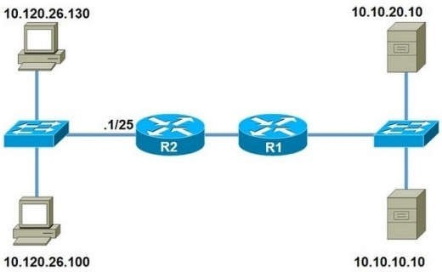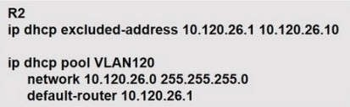

1. interface ports are shut down on the remote servers
2. The DHCP address pool has been exhausted
3. The ip helper-address command is missing on the R2 interface that connects to the switch
4. VLSM is misconfigured between the router interface and the DHCP pool.

## Correct Answer: D Section: Not categorized Explanation

**Explanation/Reference:**

**QUESTION 115**

After you deploy a new WLAN controller on your network, which two additional tasks should you consider? (Choose two)

1. deploy load balancers
2. configure additional vlans
3. configure multiple VRRP groups
4. deploy POE switches
5. configure additional security policies

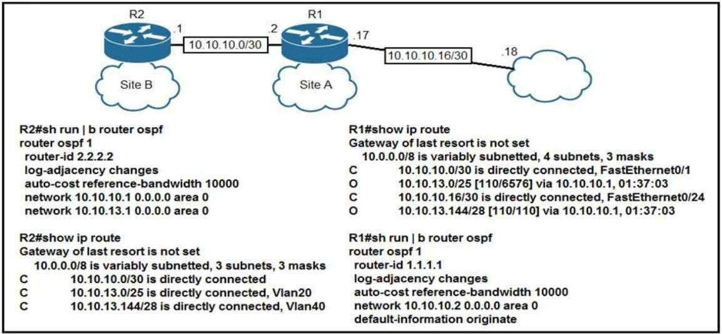

## Explanation/Reference:

**QUESTION 116**

Refer to the exhibit. The default-information originate command is configured under the R1 OSPF configuration. After testing, workstations on VLAN 20 at Site B cannot reach a DNS server on the Internet. Which action corrects the configuration issue?

1. Add the default-information originate command on R2.
2. Add the always keyword to the default-information originate command on R1.
3. Configure the ip route 0.0.0.0 0.0.0.0 10.10.10.18 command on R1.
4. Configure the ip route 0.0.0.0 0.0.0.0 10.10.10.2 command on R2.

## Correct Answer: C Section: Not categorized Explanation

**Explanation/Reference:**

**QUESTION 117**

Which of the following is the JSON encoding of a dictionary or hash?

1. {“key”:”value”}
2. [“key”,”value”]
3. {“key”,”value”}
4. (“key”:”value”)



## QUESTION 118

Which option best describes an API?

1. A contract that describes how various components communicate and exchange data with eachother.
2. an architectural style (versus a protocol) for designing applications
3. a stateless client-server model
4. request a certain type of data by specifying the URL path that models thedata

## Correct Answer: A Section: Not categorized Explanation

**Explanation/Reference:**

**QUESTION 119**

Which command verifies whether any IPv6 ACLs are configured on a router?

1. show ipv6 interface
2. show access-list
3. show ipv6 access-list
4. show ipv6 route

## Correct Answer: C Section: Not categorized Explanation

**Explanation/Reference:**

**QUESTION 120**

Which command can you enter to allow Telnet to be supported in addition to SSH?

1. transport input telnet ssh
2. transport input telnet
3. no transport input telnet
4. privilege level 15

## Correct Answer: A Section: Not categorized Explanation

**Explanation/Reference:**

**QUESTION 121**

AAA stands for authentication, authorization, and accounting

## Explanation Explanation/Reference:

**QUESTION 122**

What will happen if you configure the logging trap debug command on a router?

1. It causes the router to send messages with lower severity levels to the syslog server.
2. It causes the router to send all messages with the severity levels Warning, Error, Critical, and Emergency to the syslog server.
3. It causes the router to send all messages to the syslog server
4. It causes the router to stop sending all messages to the syslog server.

## Correct Answer: C Section: Not categorized Explanation

**Explanation/Reference:**

**QUESTION 123**

Which Cisco IOS command will indicate that interface GigabitEthernet 0/0 is configured via DHCP?

1. show ip interface GigabitEthernet 0/0 dhcp
2. show interface GigabitEthernet 0/0
3. show ip interface dhcp
4. show ip interface GigabitEthernet 0/0
5. show ip interface GigabitEthernet 0/0 brief

## Correct Answer: D Section: Not categorized Explanation

**Explanation/Reference:**

**QUESTION 124**

Which statement about the nature of NAT overload is true?

1. applies a one-to-many relationship to internal IP addresses
2. applies a one-to-one relationship to internal IP addresses
3. applies a many-to-many relationship to internal IP addresses
4. can be configured only on Gigabit interface

## Correct Answer: A Section: Not categorized Explanation

**Explanation/Reference:**

1. ipv6 route ::/0 interface next-hop5
2. ipv6 route default interface next-hop
3. ipv6 route 0.0.0.0/0 interface next-hop
4. ip route 0.0.0.0/0 interface next-hop

## Correct Answer: A Section: Not categorized Explanation

**Explanation/Reference:**

**QUESTION 126**

Which statement about static and dynamic routes is true?

1. Dynamic routes are manually configured by a network administrator, while static routes are automatically learned and adjusted by a routing protocol.
2. Static routes are manually configured by a network administrator, while dynamic routes are automatically learned and adjusted by a routing protocol.
3. Static routes tell the router how to forward packets to networks that are not directly connected, while dynamic routes tell the router how to forward packets to networks that are directly connected.
4. Dynamic routes tell the router how to forward packets to networks that are not directly connected, while static routes tell the router how to forward packets to networks that are directly connected.

## Correct Answer: B Section: Not categorized Explanation

**Explanation/Reference:**

**QUESTION 127**

What is the purpose of the show ip ospf interface command?

1. displaying OSPF-related interface information
2. displaying general information about OSPF routing processes
3. displaying OSPF neighbor information on a per-interface basis
4. displaying OSPF neighbor information on a per-interface-type basis

## Correct Answer: A Section: Not categorized Explanation

**Explanation/Reference:**

**QUESTION 128**

How can the Cisco Discovery Protocol be used?

1. to allow a switch to discover the devices that are connected to its ports
2. to determine the hardware platform of the device
3. to determine the IP addresses of connected Cisco devices

## Section: Not categorized Explanation

**Explanation/Reference:**

**QUESTION 129**

How does STP prevent forwarding loops at OSI Layer 2?

1. TTL
2. MAC address forwarding
3. Collision avoidance
4. Port blocking

## Correct Answer: D Section: Not categorized Explanation

**Explanation/Reference:**

**QUESTION 130**

Which two statements about EtherChannel technology are true? (Choose two.)

1. EtherChannel provides increased bandwidth by bundling existing FastEthernet or Gigabit Ethernet interfaces into a single EtherChannel.
2. STP does not block EtherChannel links.
3. You can configure multiple EtherChannel links between two switches, using up to a limit of sixteen physical ports.
4. EtherChannel does not allow load sharing of traffic among the physical links within the EtherChannel.
5. EtherChannel allows redundancy in case one or more links in the EtherChannelfail.

## Correct Answer: AE Section: Not categorized Explanation

**Explanation/Reference:**

**QUESTION 131**

Which three statements about MAC addresses are correct? (Choose three.)

1. To communicate with other devices on a network, a network device must have a unique MACaddress.
2. The MAC address is also referred to as the IP address.
3. The MAC address of a device must be configured in the Cisco IOS CLI by a user with administrative privileges.
4. A MAC address contains two main components, the first of which identifies the manufacturer of the hardware and the second of which uniquely identifies the hardware.
5. An example of a MAC address is 0A:26:38: D6:65:90.
6. A MAC address contains two main components, the first of which identifies the network on which the host



## Explanation/Reference:

**QUESTION 132**

Which three statements about network characteristics are true? (Choose three.)

1. Speed is a measure of the data rate in bits per second of a given link in the network.
2. Scalability indicates how many nodes are currently on thenetwork.
3. The logical topology is the arrangement of cables, network devices, and end systems.
4. Availability is a measure of the probability that the network will be available for use when it is required.
5. Reliability indicates the dependability of the components that make up thenetwork.

## Correct Answer: ADE Section: Not categorized Explanation

**Explanation/Reference:**

**QUESTION 133**

Which two statements about the purpose of the OSI model are accurate? (Choose two.)

1. Defines the network functions that occur at each layer
2. Facilitates an understanding of how information travels throughout a network
3. Changes in one layer do not impact other layer
4. Ensures reliable data delivery through its layered approach

## Correct Answer: AB Section: Not categorized Explanation

**Explanation/Reference:**

**QUESTION 134**

You have two paths for the 10.10.10.0 network – one that has a feasible distance of 3072 and the other of 6144. What do you need to do to load balance your EIGRP routes?

1. Change the maximum paths to 2
2. Change the configuration so they both have the same feasible distance
3. Change the variance for the path that has a feasible distance of 3072 to 2
4. Change the IP addresses so both paths have the same source IP address

## Correct Answer: BC Section: (none) Explanation

**Explanation/Reference:**

1. EIGRP
2. OSPF
3. BGP
4. RIP

## Correct Answer: BE Section: (none) Explanation

**Explanation/Reference:**

**QUESTION 136**

Refer to the exhibit. If R1 receives a packet destined to 172.16.1.1, to which IP address does it send the packet?

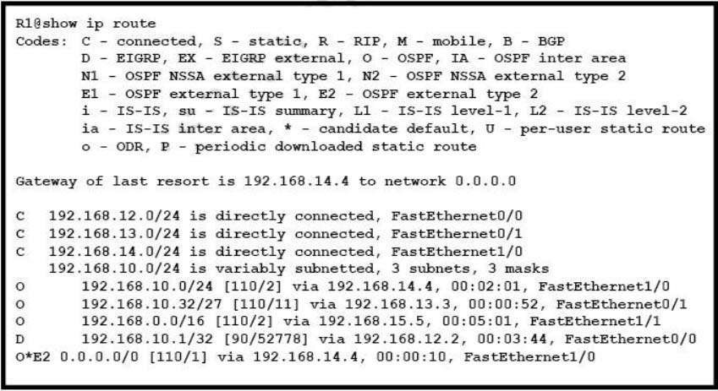

A. 192.168.14.4

B. 192.168.12.2

C. 192.168.13.3

D. 192.168.15.5

## Correct Answer: A Section: (none) Explanation

**Explanation/Reference:**

1. 0
2. 1

C. 1005

D. 1006

E. 4096

## Correct Answer: BC Section: (none) Explanation

**Explanation/Reference:**

VLAN 1 is a system default VLAN, you can use this VLAN but you cannot delete it. By default VLAN 1 is use for every port on the switch.

Standard VLAN range from 1002-1005 it’s Cisco default for FDDI and Token Ring. You cannot delete VLANs 1002-1005. mostly we don’t use VLAN in this range.

## QUESTION 138

Refer to the exhibit. If RTR01 is configured as shown, which three addresses will be received by other routers that are running EIGRP on the network? (Choose three)

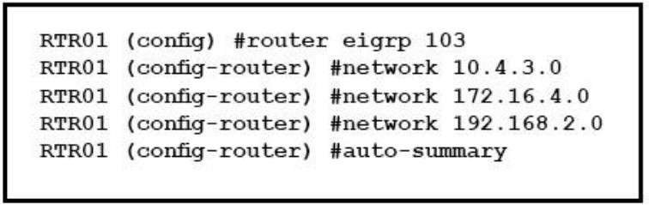

A. 192.168.2.0

B. 10.4.3.0

C. 10.0.0.0

D. 172.16.0.0

E. 172.16.4.0

F. 192.168.0.0

## Correct Answer: ACD Section: (none) Explanation

**Explanation/Reference:**

**QUESTION 139**

Which two options are the best reasons to use an IPV4 private IP space?(choose two)

A. to enable intra-enterprise communication

E. to manage routing overhead

## Correct Answer: AD Section: (none) Explanation

**Explanation/Reference:**

**QUESTION 140**

Which technique can you use to route IPv6 traffic over an IPv4 infrastructure?

1. NAT
2. 6to4 tunneling
3. L2TPv3
4. dual-stack

## Correct Answer: B Section: (none) Explanation

**Explanation/Reference:**

**QUESTION 141**

Which three describe the reasons large OSPF networks use a hierarchical design? (Choose Three)

1. to speed up convergence
2. to reduce routing overhead
3. to lower costs by replacing routers with distribution layer switches.
4. to decrease latency by increasing bandwidth.
5. to confine network instability to single areas of the network.
6. to reduce the complexity of router configuration.

## Correct Answer: ABE Section: (none) Explanation

**Explanation/Reference:**

**QUESTION 142**

Which statements describe the routing protocol OSPF? (Choose three.)

1. It supports VLSM.
2. It is used to route between autonomous systems.
3. It confines network instability to one area of the network.
4. It increases routing overhead on the network.
5. It allows extensive control of routing updates.
6. It is simpler to configure than RIP v2.

## Explanation/Reference:

The OSPF protocol is based on link-state technology, which is a departure from the Bellman-Ford vector based algorithms used in traditional Internet routing protocols such as RIP. OSPF has introduced new concepts such as authentication of routing updates, Variable Length Subnet Masks (VLSM), route summarization, and so forth. OSPF uses flooding to exchange link-state updates between routers. Any change in routing information is flooded to all routers in the network. Areas are introduced to put a boundary on the explosion of link-state updates. Flooding and calculation of the Dijkstra algorithm on a router is limited to changes within an area.

## QUESTION 143

Which command should you enter to view the error log in an EIGRP for IPv6 environment?

1. show ipv6 eigrp neighbors
2. show ipv6 eigrp topology
3. show ipv6 eigrp traffic
4. show ipv6 eigrp events

## Correct Answer: D Section: (none) Explanation

**Explanation/Reference:**

**QUESTION 144**

Which component of an Ethernet frame is used to notify a host that traffic is coming?

1. start of frame delimiter
2. Type field
3. preamble
4. Data field

## Correct Answer: C Section: (none) Explanation

**Explanation/Reference:**

**QUESTION 145**

Which command must you enter to guarantee that an HSRP router with higher priority becomes the HSRP primary router after it is reloaded?

1. standby 10 preempt
2. standby 10 version 1
3. standby 10 priority 150
4. standby 10 version 2

## Correct Answer: A Section: (none) Explanation

**Explanation/Reference:**

The “preempt” command enables the HSRP router with the highest priority to immediately become the active router.

## QUESTION 146

Which configuration command can u apply to a HSRP router so that its local interface becomes active if all other routers in the group fail?

1. no additional config is required
2. standby 1 track ethernet
3. standby 1 preempt
4. standby 1 priority 250

## Correct Answer: A Section: (none) Explanation

**Explanation/Reference:**

Simply because that will be the default behavior routers would follow in the event all other routers in the HSRP group fail, then it would not keep attributes such as priority or preemption.

What preemption does in summary is to make sure that the configured Priority on all routers within the same HSRP group is always respected. That is, if R1 is configured on the HSRP group with a priority of 150 but he stands as active since all other routers currently subscribed to that group have a priority 150, then will router will preempt the current active router and will take over hence becoming the new active router.

With preemption disabled, the new router does not preempt the current active router, unless routers in the group have to renegotiate their roles based on each router's priority at the time of negotiation.

## QUESTION 147

You are configuring your edge routers interface with a public IP address for Internet connectivity.

The router needs to obtain the IP address from the service provider dynamically. Which command is needed on interface FastEthernet 0/0 to accomplish this?

1. ip default-gateway
2. ip route
3. ip default-network
4. ip address dhcp
5. ip address dynamic

## Correct Answer: D Section: (none) Explanation

**Explanation/Reference:**

**QUESTION 148**

Which type does a port become when it receives the best BPDU on a bridge?

1. The designated port
2. The backup port
3. The alternate port
4. The root port

## Correct Answer: D Section: (none) Explanation

**Explanation/Reference:**

**QUESTION 149**

Which two command sequences must you configure on a switch to establish a Layer 3 EtherChannel with an open-standard protocol? (Choose two.)

1. interface GigabitEthernet0/0/1 channel-group 10 mode on
2. interface GigabitEthernet0/0/1 channel-group 10 mode active
3. interface GigabitEthernet0/0/1 channel-group 10 mode auto
4. interface port-channel 10 switchport

switchport mode trunk

1. interface port-channel 10 no switchport

ip address 172.16.0.1.255.255.255.0

## Correct Answer: BE Section: (none) Explanation

**Explanation/Reference:**

**QUESTION 150**

Which statement about VLAN configuration is true?

1. The switch must be in VTP server or transparent mode before you can configure a VLAN
2. The switch must be in config-vlan mode before you configure an extended VLAN
3. Dynamic inter-VLAN routing is supported on VLAN2 through VLAN 4064
4. A switch in VTP transparent mode save the VLAN databases to the running configurationonly

## Correct Answer: A Section: (none) Explanation

**Explanation/Reference:**

**QUESTION 151**

Refer to the exhibit. After you apply the given configuration to arouter, the DHCP clients behind the device connot communicate with hosts outside of their subnet. Which action is most likely to correct the problem?

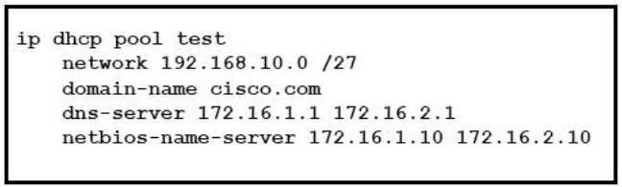

1. Activate the dhcp pool
2. Correct the subnet mask
3. configure the default gateway

## Correct Answer: D Section: (none) Explanation

**Explanation/Reference:**

**QUESTION 152**

Refer to the exhibit. How will the router handle a packet destined for 192.0.2.156?

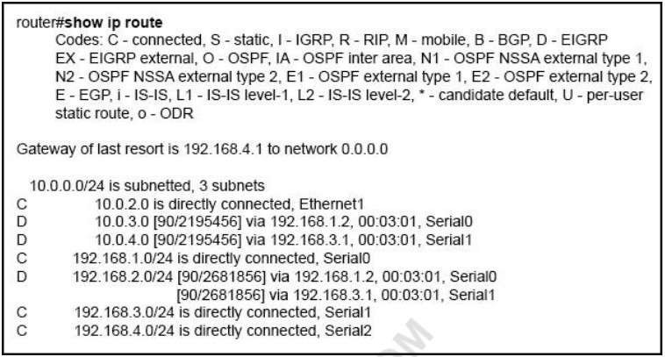

1. The router will forward the packet via either Serial0 or Serial1.
2. The router will return the packet to itssource.
3. The router will forward the packet via Serial2.
4. The router will drop the packet.

## Correct Answer: C Section: (none) Explanation

**Explanation/Reference:**

**QUESTION 153**

Which unified access point mode continues to serve wireless clients after losing connectivity to the Cisco Wireless LAN Controller?

1. mesh

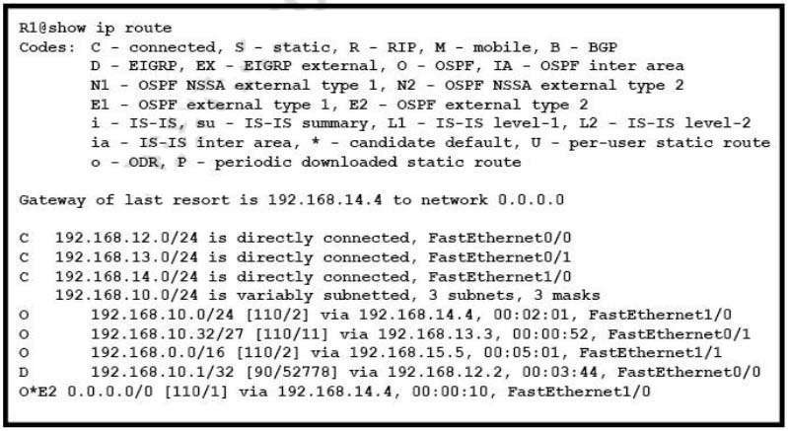

1. flexconnect
2. local

## Correct Answer: C Section: (none) Explanation

**Explanation/Reference:**

In previous releases, whenever a FlexConnect access point disassociates from a controller, it moves to the standalone mode. The clients that are centrally switched are disassociated.

However, the FlexConnect access point continues to serve locally switched clients. When the FlexConnect access point rejoins the controller (or a standby controller), all clients are disconnected and are authenticated again. This functionality has been enhanced and the connection between the clients and the FlexConnect access points are maintained intact and the clients experience seamless connectivity. When both the access point and the controller have the same configuration, the connection between the clients and APs is maintained.

Reference: [https://w](http://www.cisco.com/c/en/us/td/docs/wireless/controller/7-4/configuration/guides/consolidated/)ww[.cisco.com/c/en/us/td/](http://www.cisco.com/c/en/us/td/docs/wireless/controller/7-4/configuration/guides/consolidated/)docs[/wireless/controller/7-4/configuration/guides/consolidated/](http://www.cisco.com/c/en/us/td/docs/wireless/controller/7-4/configuration/guides/consolidated/) b_cg74_CONSOLIDATED/b_cg74_CONSOLIDATED_chapter_010001101.html

## QUESTION 154

Refer to exhibit. What Administrative distance has route to 192.168.10.1 ?

1. 1
2. 90



## Explanation/Reference:

**QUESTION 155**

Refer to the exhibit. Which command would you use to configure a static route on Router1 to network 192.168.202.0/24 with a nondefault administrative distance?

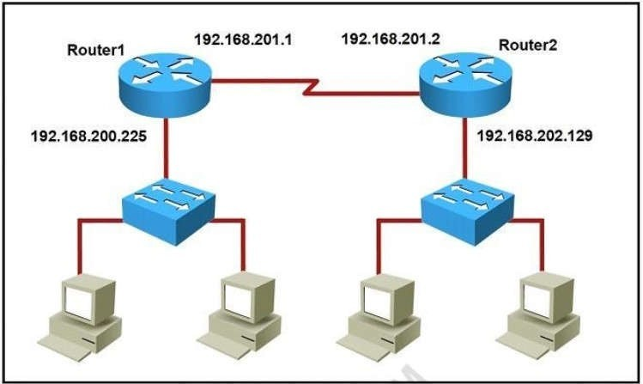

A. router1(config)#ip route 192.168.202.0 255.255.255.0 192.168.201.2 1

B. router1(config)#ip route 192.168.202.0 255.255.255.0 192.168.201.2 5

C. router1(config)#ip route 1 192.168.201.1 255.255.255.0 192.168.201.2

D. router1(config)#ip route 5 192.168.202.0 255.255.255.0 192.168.201.2

## Correct Answer: B Section: (none) Explanation

**Explanation/Reference:**

The default AD of static route is 1 so we need to configure another number for the static route.

## QUESTION 156

Which feature or protocol is required for an IP SLA to measure UDP jitter?

1. LLDP
2. EEM

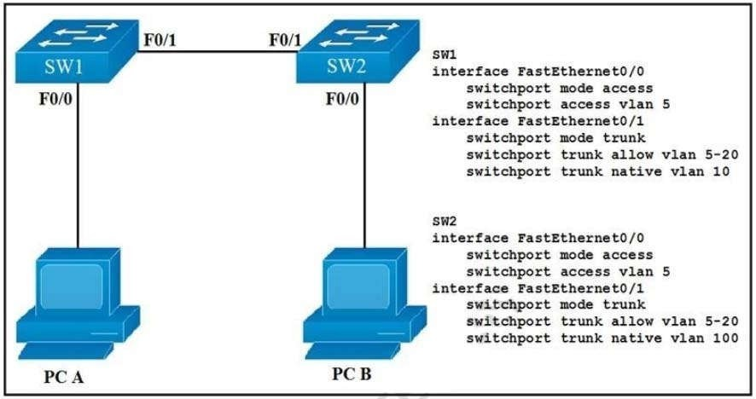

## Explanation/Reference:

**QUESTION 157**

Which effete does the aaa new-model configuration command have?

1. It enables AAA services on the device
2. It configures the device to connect to a RADIUS server for AAA
3. It associates a RADIUS server to an group.
4. It configures a local user on the device.

## Correct Answer: A Section: (none) Explanation

**Explanation/Reference:**

**QUESTION 158**

Refer to the exhibit. How will switch SW2 handle traffic from VLAN 10 on SW1?

1. It sends the traffic to VLAN 10.
2. It sends the traffic to VLAN 100.
3. It drops the traffic.
4. It sends the traffic to VLAN 1.

## Explanation/Reference:

Since SW-1 is configured native VLAN is VLAN10, so traffic coming out of VLAN-10 is untagged, & goes directly to SW-2 Native VLAN: VLAN100, due to VLAN mismatch.

## QUESTION 159

Which two commands can you use to configure an actively negotiate EtherChannel? (Choose two)

1. channel-group 10 mode on
2. channel-group 10 mode auto
3. channel-group 10 mode passive
4. channel-group 10 mode desirable
5. channel-group 10 mode active

## Correct Answer: DE Section: (none) Explanation

**Explanation/Reference:**

**QUESTION 160**

What is the binary pattern of unique ipv6 unique local address?

A. 00000000

B. 11111100

C. 11111111

D. 11111101

## Correct Answer: B Section: (none) Explanation

**Explanation/Reference:**

A IPv6 Unique Local Address is an IPv6 address in the block FC00::/7, which means that IPv6 Unique Local addresses begin with 7 bits with exact binary pattern as 1111 110 -> Answer B is correct.

Note: IPv6 Unique Local Address is the approximate IPv6 counterpart of the IPv4 private address. It is not routable on the global Internet.

## QUESTION 161

Which two statements about exterior routing protocols are true? (Choose two.)

1. They determine the optimal within an autonomous system.
2. They determine the optimal path between autonomous systems.
3. BGP is the current standard exterior routing protocol.
4. Most modern networking supports both EGP and BGP for external routing.
5. Most modern network routers support both EGP and EIGRP for external routing.

## Correct Answer: BC Section: (none) Explanation

**Explanation/Reference:**



A. 00:00:0c:07:ac:01

B. ff:ff:ff:ff:ff:ff

C. 43:2e:08:00:00:0c

D. 00:00:0c:43:2e:08

E. 00:00:0c:ff:ff:ff

## Correct Answer: B Section: (none) Explanation

**Explanation/Reference:**

**QUESTION 163**

You have configured a router with an OSPF router ID, but its IP address still reflects the physical interface. Which action can you take to correct the problem in the least disruptive way?

1. Reload the OSPF process.
2. Specify a loopback address
3. Reboot the router.
4. Save the router configuration

## Correct Answer: A Section: (none) Explanation

**Explanation/Reference:**

Once an OSPF Router ID selection is done, it remains there even if you remove it or configure another OSPF Router ID. So the least disruptive way is to correct it using the command "clear ip ospf process".

## QUESTION 164

Which two statements about VTP are true? (Choose two.)

1. All switches must be configured with the same VTP domain name
2. All switches must be configured to perform trunk negotiation.
3. All switches must be configured with a unique VTP domain name
4. The VTP server must have the highest revision number in the domain
5. All switches must use the same VTP version.

## Correct Answer: AE Section: (none) Explanation

**Explanation/Reference:** ht[tps://w](http://www.cisco.com/c/en/us/td/docs/switches/lan/catalyst3750/software/release/12-2_25_sea/configuration/)ww[.cisco.com/c/en/us/td/](http://www.cisco.com/c/en/us/td/docs/switches/lan/catalyst3750/software/release/12-2_25_sea/configuration/)do[cs/switches/lan/catalyst3750/software/release/12-2_25_sea/configuration/](http://www.cisco.com/c/en/us/td/docs/switches/lan/catalyst3750/software/release/12-2_25_sea/configuration/) guide/3750scg/swvtp.pdf

## QUESTION 165

Which two pieces of information about a Cisco device can Cisco Discovery Protocol communicate? (Choose two.)

A. the native VLAN

1. the spanning-tree priority



1. the spanning tree protocol

## Correct Answer: AC Section: (none) Explanation

**Explanation/Reference:**

**QUESTION 166**

Refer to the exhibit. On R1 which routing protocol is in use on the route to 192.168.10.1?

1. RIP
2. OSPF
3. IGRP
4. EIGRP

## Correct Answer: D Section: (none) Explanation

**Explanation/Reference:**

**QUESTION 167**

Refer to the exhibit. Which VLAN ID is associated with the default VLAN in the given environment?

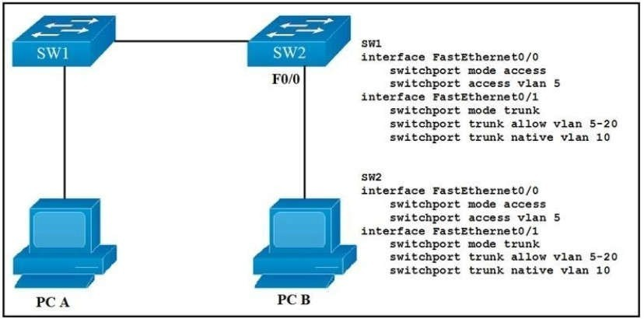

1. VLAN 1
2. VLAN 5
3. VLAN 10
4. VLAN 20

## Correct Answer: A Section: (none) Explanation

**Explanation/Reference:**

**QUESTION 168**

Which two circumstances can prevent two routers from establishing an OSPF neighbor adjacency? (Choose two.)

1. mismatched autonomous system numbers
2. an ACL blocking traffic from multicast address 224.0.0.10
3. mismatched process IDs
4. mismatched hello timers and dead timers
5. use of the same router ID on both devices

## Correct Answer: DE Section: (none) Explanation

**Explanation/Reference:**

1. The two devices must reside in different autonomous systems

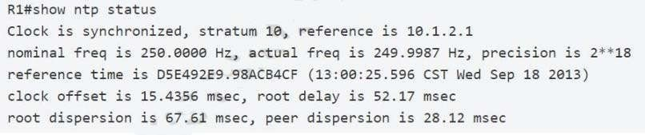

1. Neighbors must be specifically declared in the configuration of each device
2. They can be created dynamically after the network statement is configured.
3. The two devices must reside in the same autonomous system
4. The two devices must have matching timer settings

## Correct Answer: AB Section: (none) Explanation

**Explanation/Reference:**

**QUESTION 170**

Which two pieces of information can you determine from the output of the show ntp status command? (Choose two)

1. whether the NTP peer is statically configured
2. the IP address of the peer to which the clock is synchronized
3. the configured NTP servers
4. whether the clock is synchronized
5. the NTP version number of the peer

## Correct Answer: BD Section: (none) Explanation

**Explanation/Reference:**

Below is the output of the "show ntp status" command. From this output we learn that R1 has a stratum of 10 and it is getting clock from 10.1.2.1.

## QUESTION 171

Which keyword in a NAT configuration enables the use of one outside IP address for multiple inside hosts?

1. source
2. static
3. pool
4. overload

## Correct Answer: D Section: (none) Explanation

Translation). This is also a kind of dynamic NAT that maps multiple private IP addresses to a single public IP address (many-to-one) by using different ports. Static NAT and Dynamic NAT both require a one-to-one mapping from the inside local to the inside global address. By using PAT, you can have thousands of users connect to the Internet using only one real global IP address. PAT is the technology that helps us not run out of public IP address on the Internet.

This is the most popular type of NAT.

An example of using "overload" keyword is shown below:

R1(config)# ip nat inside source list 1 interface ethernet1 overload

## QUESTION 172

Which two pieces of information can you learn by viewing the routing table? (Choose two)

1. whether an ACL was applied inbound or outbound to an interface
2. the EIGRP or BGP autonomous system
3. whether the administrative distance was manually or dynamically configured
4. Which neighbor adjacencies are established
5. the length of time that a route has been known

## Correct Answer: CE Section: (none) Explanation

**Explanation/Reference:**

**QUESTION 173**

Which NAT term is defined as a group of addresses available for NAT use?

1. NAT pool
2. dynamic NAT
3. static NAT
4. one-way NAT

## Correct Answer: A Section: (none) Explanation

**Explanation/Reference:**

**QUESTION 174**

Which command is used to enable LLDP globally on a Cisco IOS ISR?

1. lldp run
2. lldp enable
3. lldp transmit
4. cdp run
5. cdp enable

## Correct Answer: A Section: (none) Explanation

have to use this command under global configuration mode:

Sw(config)# lldp run

## QUESTION 175

Refer to the exhibit. After you apply the give configurations to R1 and R2 you notice that OSPFv3 fails to start. Which reason for the problem is most likely true ?

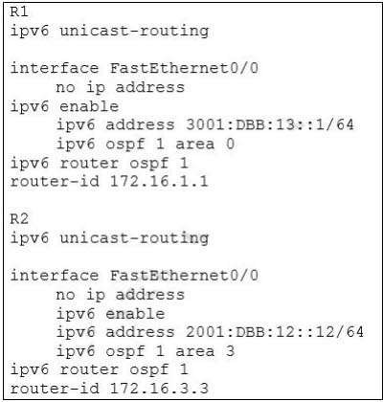

1. The area numbers on R1 and R2 are mismatched
2. The IPv6 network addresses on R1 and R2 are mismatched
3. The autonomous system numbers on R1 and R2 are mismatched
4. The router ids on R1 and R2 are mismatched

## Correct Answer: A Section: (none) Explanation

**Explanation/Reference:**

**QUESTION 176**

Which command should you enter to configure a device as an NTP sever?

1. ntp sever
2. ntp peer
3. ntp authenticate

## Explanation

**Explanation/Reference:**

To configure a Cisco device as an Authoritative NTP Server, use the ntp master [stratum] command. To configure a Cisco device as a NTP client, use the command ntp server <IP address>. For example:

Router(config)#ntp server 192.168.1.1. This command will instruct the router to query 192.168.1.1 for the time.

## QUESTION 177

Which feature or protocol determines whether the QOS on the network is sufficient to support IP services?

1. LLDP
2. CDP
3. IP SLA
4. EEM

## Correct Answer: C Section: (none) Explanation

**Explanation/Reference:**

IP SLA allows an IT professional to collect information about network performance in real time. Therefore it helps determine whether the QoS on the network is sufficient for IP services or not.

Cisco IOS Embedded Event Manager (EEM) is a powerful and flexible subsystem that provides realtime network event detection and onboard automation. It gives you the ability to adapt the behavior of your network devices to align with your business needs.

## QUESTION 178

Refer to the exhibit. Which feature is enabled by this configuration?



1. static NAT translation
2. a DHCP pool
3. a dynamic NAT address pool
4. PAT

## Correct Answer: C Section: (none) Explanation

**Explanation/Reference:**

**QUESTION 179**

In a CDP environment, what happens when the CDP interface on an adjacent device is configured without an IP address?

1. CDP becomes inoperable on that neighbor
2. CDP uses the IP address of another interface for that neighbor
3. CDP operates normally,but it cannot provide IP address information for that neighbor

## Explanation

**Explanation/Reference:**

Although CDP is a Layer 2 protocol but we can check the neighbor IP address with the "show cdp neighbor detail" command. If the neighbor does not has an IP address then CDP still operates without any problem. But the IP address of that neighbor is not provided.

## QUESTION 180

Which two statements about NTP operations are true? (Choose two.)

1. NTP uses UDP over IP.
2. Cisco routers can act as both NTP authoritative servers and NTP clients.
3. Cisco routers can act only as NTP servers.
4. Cisco routers can act only as NTP clients.
5. NTP uses TCP over IP.

## Correct Answer: AB Section: (none) Explanation

**Explanation/Reference:**

**QUESTION 181**

Which command should you enter to configure an LLDP delay time of 5 seconds?

1. lldp timer 5000
2. lldp holdtime 5
3. lldp reinit 5000
4. lldp reinit 5

## Correct Answer: D Section: (none) Explanation

**Explanation/Reference:**

+ lldp holdtime seconds: Specify the amount of time a receiving device should hold the information from your device before discarding it

+ lldp reinit delay: Specify the delay time in seconds for LLDP to initialize on an interface

+ lldp timer rate: Set the sending frequency of LLDP updates in seconds Reference: Click here

## QUESTION 182

Which value is used to determine the active router in an HSRP default configuration?

1. Router loopback address
2. Router IP address
3. Router priority
4. Router tracking number

active. Furthermore, if there are more than two routers in the group, the second highest IP address determines the standby router and the other router/routers are in the listen state.

## QUESTION 183

Which statement about Cisco Discovery Protocol is true?

1. It is a Cisco-proprietary protocol.
2. It runs on the network layer.
3. It can discover information from routers, firewalls, and switches.
4. It runs on the physical layer and the data link layer.

## Correct Answer: A Section: (none) Explanation

**Explanation/Reference:**

**QUESTION 184**

Which value can you modify to configure a specific interface as the preferred forwarding interface?

1. The interface number
2. The port priority
3. The VLAN priority
4. The hello time

## Correct Answer: B Section: (none) Explanation

**Explanation/Reference:**

**QUESTION 185**

When configuring an EtherChannel bundle, which mode enables LACP only if a LACP device is detected?

1. Passive
2. Desirable
3. On
4. Auto
5. Active

## Correct Answer: A Section: (none) Explanation

**Explanation/Reference:**

The LACP is Link Aggregation Control Protocol. LACP is an open protocol, published under the 802.3ad. The modes of LACP are active, passive or on. The side configured as "pasive" will waiting the other side that should an Active for the Etherchannel to be established.

SwitchFormula1(config-if-range)# channel-group 13 mode ? active Enable LACP unconditionally

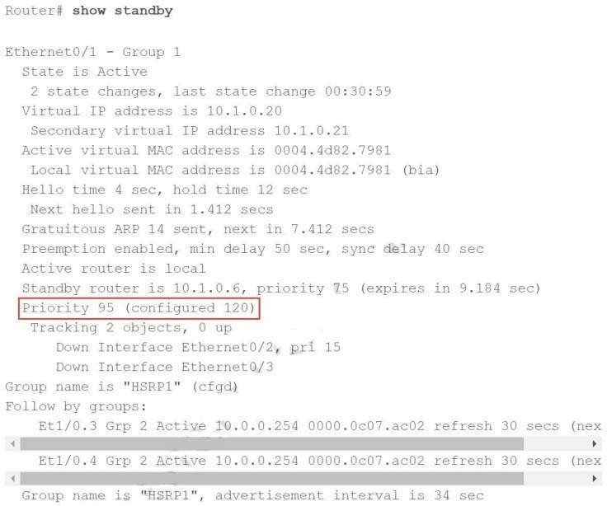

auto Enable PAgP only if a PAgP device is detected desirable Enable PAgP unconditionally

on Enable Etherchannel only

passive Enable LACP only if a LACP device is detected

## QUESTION 186

Which command should you enter to verify the priority of a router in an HSRP group?

1. show hsrp
2. show sessions
3. show interfaces
4. show standby

## Correct Answer: D Section: (none) Explanation

**Explanation/Reference:**

The following is sample output from the show standby command:



## QUESTION 187

Refer to the exhibit. Which Command do you enter so that R1 advertises the loopback0 interface to the BGP Peers?

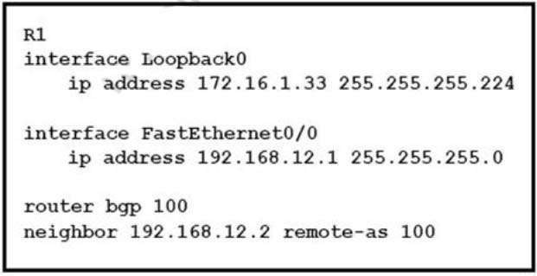

A. Network 172.16.1.32 mask 255.255.255.224

B. Network 172.16.1.0 0.0.0.255

C. Network 172.16.1.32 255.255.255.224

D. Network 172.16.1.33 mask 255.255.255.224

E. Network 172.16.1.32 mask 0.0.0.31

F. Network 172.16.1.32 0.0.0.31

## Correct Answer: A Section: (none) Explanation

**Explanation/Reference:**

**QUESTION 188**

For what two purposes does the Ethernet protocol use physical addresses?

1. to uniquely identify devices at Layer 2
2. to allow communication with devices on a different network
3. to differentiate a Layer 2 frame from a Layer 3 packet
4. to establish a priority system to determine which device gets to transmit first
5. to allow communication between different devices on the same network
6. to allow detection of a remote device when its physical address is unknown

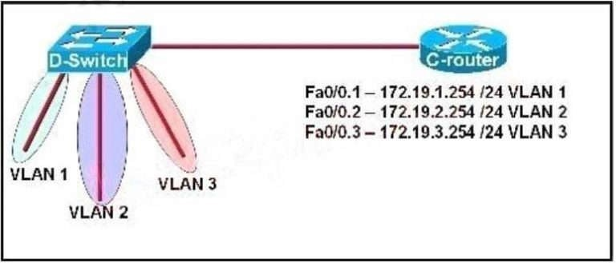

## QUESTION 189

Which command is used to display the collection of OSPF link states?

1. show ip ospf link-state
2. show ip ospf lsa database
3. show ip ospf neighbors
4. show ip ospf database

## Correct Answer: D Section: (none) Explanation

**Explanation/Reference:**

The “show ip ospf database” command displays the link states. Here is an example: Here is the lsa database on R2.

R2#show ip ospf database

OSPF Router with ID (2.2.2.2) (Process ID 1) Router Link States (Area 0)

Link ID ADV Router Age Seq# Checksum Link count2.2.2.2 2.2.2.2 793 0x80000003 0x004F85 210.4.4.4 10.4.4.4 776 0x80000004 0x005643 1111.111.111.111 111.111.111.111 755 0x80000005 0x0059CA

2133.133.133.133 133.133.133.133 775 0x80000005 0x00B5B1 2 Net Link States (Area 0) Link ID ADV Router

Age Seq# Checksum10.1.1.1 111.111.111.111 794 0x80000001 0x001E8B10.2.2.3 133.133.133.133 812

0x80000001 0x004BA910.4.4.1 111.111.111.111 755 0x80000001 0x007F1610.4.4.3 133.133.133.133 775

0x80000001 0x00C31F

## QUESTION 190

Refer to the exhibit. C-router is to be used as a “router-on-a-stick” to route between the VLANs. All the interfaces have been properly configured and IP routing is operational. The hosts in the VLANs have been configured with the appropriate default gateway. What is true about this configuration?

A. These commands need to be added to the configuration: C-router(config)# router eigrp 123

C-router(config)# router rip

C-router(config-router)# network 172.19.0.0

D. No further routing configuration is required.

## Correct Answer: D Section: (none) Explanation

**Explanation/Reference:**

Since all the same router (C-router) is the default gateway for all three VLANs, all traffic destined to a different VLAN will be sent to the C-router. The C-router will have knowledge of all three networks since they will appear as directly connected in the routing table. Since the C-router already knows how to get to all three networks, no routing protocols need to be configured.

## QUESTION 191

A user configured OSPF in a single area between two routers A serial interface connecting R1 and R2 is running encapsulation PPP. By default which OSPF network type is seen on this interface when the user types show ip ospf interface on R1 or R2?

1. port-to-multipoint
2. broadcast
3. point-to-point
4. non-broadcast

## Correct Answer: C Section: (none) Explanation

**Explanation/Reference:**

The default OSPF network type for HDLC and PPP on Serial link is point-to-point (while the default OSPF network type for Ethernet link is Broadcast).

## QUESTION 192

Refer to the exhibit. Which address and mask combination represents a summary of the routes learned by EIGRP?

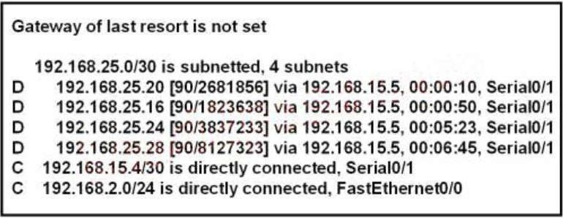

C. 192.168.25.16255.255.255.240

D. 192.168.25.16255.255.255.252

E. 192.168.25.28 255.255.255.240

F. 192.168.25.28 255.255.255.252

## Correct Answer: C Section: (none) Explanation

**Explanation/Reference:**

The binary version of 20 is 10100. The binary version of 16 is 10000. The binary version of 24 is 11000. The binary version of 28 is11100.

The subnet mask is /28. The mask is 255.255.255.240. Note:

From the output above, EIGRP learned 4 routes and we need to find out the summary of them:

+ 192.168.25.16

+ 192.168.25.20

+ 192.168.25.24

+ 192.168.25.28

-> The increment should bE. 28 ?16 = 12 but 12 is not an exponentiation of 2 so we must choose 16 (24).

Therefore the subnet mask is /28 (=1111 1111.1111 1111.1111 1111.11110000) = 255.255.255.240

So the best answer should be 192.168.25.16 255.255.255.240

## QUESTION 193

Refer to the exhibit. A network associate has configured OSPF with the command: City(config-router)# network 192.168.12.64 0.0.0.63 area 0.

After completing the configuration, the associate discovers that not all the interfaces are participating in OSPF. Which three of the interfaces shown in the exhibit will participate in OSPF according to this configuration statement? (Choose three.)

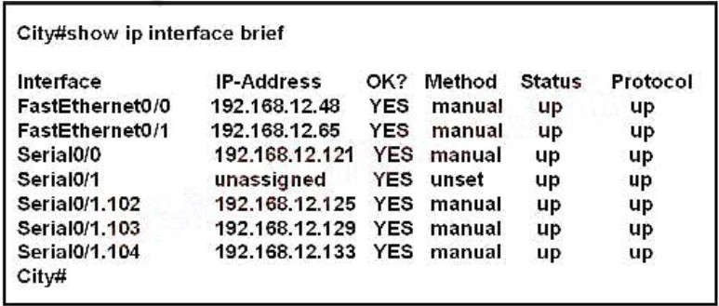

1. FastEthernet0 /0
2. FastEthernet0 /1

F. Serial0/1.104

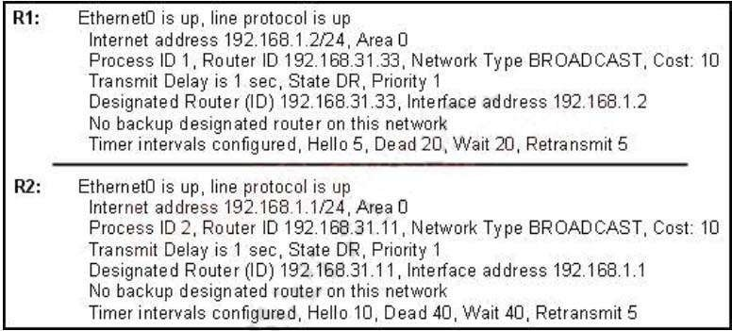

## Correct Answer: BCD Section: (none) Explanation

**Explanation/Reference:**

The “network 192.168.12.64 0.0.0.63 equals to network 192.168.12.64/26. This network has:

+ Increment: 64 (/26= 1111 1111.1111 1111.1111 1111.1100 0000) + Network address:

192.168.12.64

+ Broadcast address: 192.168.12.127

Therefore all interface in the range of this network will join OSPF.

## QUESTION 194

A network administrator is troubleshooting the OSPF configuration of routers R1 and R2. The routers cannot establish an adjacency relationship on their common Ethernet link. The graphic shows the output of the show ip ospf interface e0 command for routers R1 and R2. Based on the information in the graphic, what is the cause of this problem?

1. The OSPF area is not configured properly.
2. The OSPF area is not configured properly.
3. The cost on R1 should be set higher.
4. The hello and dead timers are not configured properly.
5. A backup designated router needs to be added to the network.
6. The OSPF process ID numbers must match.

## Correct Answer: D Section: (none) Explanation

**Explanation/Reference:**

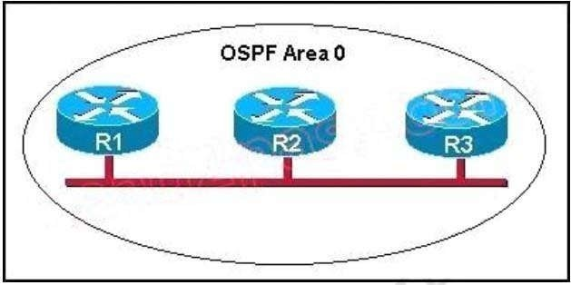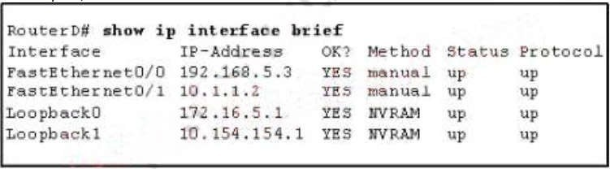

1. All of the routers need to be configured for backbone Area 1.
2. R1 and R2 are the DR and BDR, so OSPF will not establish neighbor adjacencywith R3.
3. A static route has been configured from R1 to R3 and prevents the neighbor adjacency from being established.
4. The hello and dead interval timers are not set to the same values on R1 and R3.
5. EIGRP is also configured on these routers with a lower administrative distance.
6. R1 and R3 are configured in different areas.

## Correct Answer: DF Section: (none) Explanation

**Explanation/Reference:**

This question is to examine the conditions for OSPF to create neighborhood. So as to make the two routers become neighbors, each router must be matched with the following items:

1. The area ID and its types;
2. Hello and failure time interval timer;
3. OSPF Password (Optional);

## QUESTION 196

Refer to the exhibit. Given the output for this command, if the router ID has not been manually set, what router ID will OSPF use for this router?

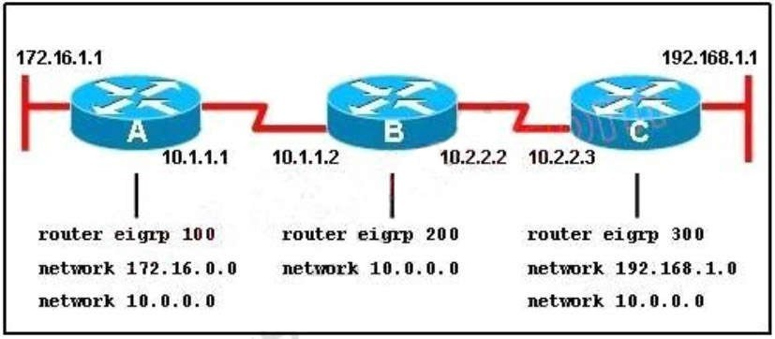

A. 10.1.1.2

B. 10.154.154.1

C. 172.16.5.1

D. 192.168.5.3

## Correct Answer: C Section: (none) Explanation

**Explanation/Reference:**

The highest IP address of all loopback interfaces will be chosen -> Loopback 0 will be chosen as the router ID.

## QUESTION 197

Refer to the exhibit. When running EIGRP, what is required for RouterA to exchange routing updates with RouterC?

1. AS numbers must be changed to match on all the routers
2. Loopback interfaces must be configured so a DR is elected
3. The no auto-summary command is needed on Router A and Router C
4. Router B needs to have two network statements, one for each connected network

## Correct Answer: A Section: (none) Explanation

**Explanation/Reference:**

This question is to examine the understanding of the interaction between EIGRP routers. The following information must be matched so as to create neighborhood. EIGRP routers to establish, must match the following information:

1. AS Number;
2. K value.

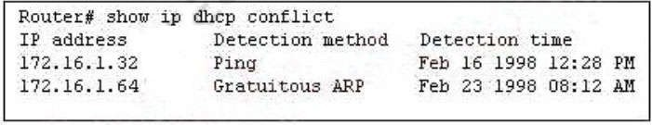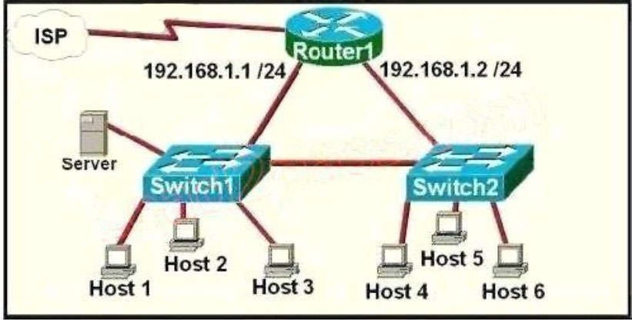

1. The address is removed from the pool until the conflict is resolved.
2. The address remains in the pool until the conflict is resolved.
3. Only the IP detected by Gratuitous ARP is removed from the pool.
4. Only the IP detected by Ping is removed from the pool.
5. The IP will be shown, even after the conflict is resolved.

## Correct Answer: A Section: (none) Explanation

**Explanation/Reference:**

An address conflict occurs when two hosts use the same IP address. During address assignment, DHCP checks for conflicts using ping and gratuitous ARP. If a conflict is detected, the address is removed from the pool. The address will not be assigned until the administrator resolves the conflict.

## QUESTION 199

Refer to the exhibit. A network technician is asked to design a small network with redundancy. The exhibit represents this design, with all hosts configured in the same VLAN. What conclusions can be made about this design?

1. The connection between switches should be a trunk.
2. The router interfaces must be encapsulated with the 802.1Q protocol.

## Correct Answer: C Section: (none) Explanation

**Explanation/Reference:**

Each interface on a router must be in a different network. If two interfaces are in the same network, the router will not accept it and show error when the administrator assigns it.

## QUESTION 200

What benefit does controller-based networking provide versus traditional networking?

1. moves from a two-tier to a three-tier network architecture to provide maximum redundancy
2. provides an added layer of security to protect from DDoS attacks
3. allows configuration and monitoring of the network from one centralized point
4. combines control and data plane functionality on a single device to minimize latency

## Correct Answer: C Section: (none) Explanation

**Explanation/Reference:**

**QUESTION 201**

A network engineer must create a diagram of a multivendor network. Which command must be configured on the Cisco devices so that the topology of the network can be mapped?

1. Device(Config)#lldp run
2. Device(Config)#cdp run
3. Device(Config-if)#cdp enable
4. Device(Config)#flow-sampler-map topology

## Correct Answer: A Section: (none) Explanation

**Explanation/Reference:**

**QUESTION 202**

What are two descriptions of three-tier network topologies? (Choose two)

1. The core and distribution layers perform the same functions
2. The access layer manages routing between devices in different domains
3. The network core is designed to maintain continuous connectivity when devices fail.
4. The core layer maintains wired connections for each host
5. The distribution layer runs Layer 2 and Layer 3 technologies

## Explanation/Reference:

**QUESTION 203**

What is the expected outcome when an EUI-64 address is generated?

1. The seventh bit of the original MAC address of the interface is inverted
2. The interface ID is configured as a random 64-bit value
3. The characters FE80 are inserted at the beginning of the MAC address of the interface
4. The MAC address of the interface is used as the interface ID without modification

## Correct Answer: A Section: (none) Explanation

**Explanation/Reference:**

**QUESTION 204**

Which function docs an SNMP agent perform?

1. it sends information about MIB variables in response to requests from the NMS
2. it coordinates user authentication between a network device and a TACACS+ or RADIUSserver
3. it requests information from remote network nodes about catastrophic system events.
4. it manages routing between Layer 3 devices in a network

## Correct Answer: A Section: (none) Explanation

**Explanation/Reference:**

**QUESTION 205**

R1 has learned route 10.10.10.0/24 via numerous routing protocols. Which route is installed?

1. route with the lowest cost
2. route with the next hop that has the highest IP
3. route with the shortest prefix length
4. route with the lowest administrative distance

## Correct Answer: D Section: (none) Explanation

**Explanation/Reference:**

**QUESTION 206**

What is a characteristic of spine-and-leaf architecture?

## Correct Answer: A Section: (none) Explanation

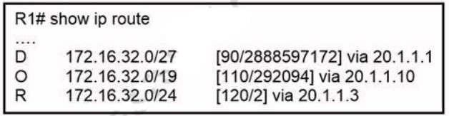

**Explanation/Reference:**

**QUESTION 207**

Which action must be taken to assign a global unicast IPv6 address on an interface that is derived from the MAC address of that interface?

1. configure a stateful DHCPv6 server on the network
2. enable SLAAC on aninterface
3. disable the EUI-64 bit process
4. explicitly assign a link-local address

## Correct Answer: B Section: (none) Explanation

**Explanation/Reference:**

**QUESTION 208**

Refer to the exhibit. Router R1 is running three different routing protocols. Which route characteristic is used by the router to forward the packet that it receives for destination IP 172.16.32.1?

1. longest prefix
2. metric
3. cost
4. administrative distance

## Correct Answer: A Section: (none) Explanation

**Explanation/Reference:**

**QUESTION 209**

Router R1 must send all traffic without a matching routing-table entry to 192.168.1.1. Which configuration accomplishes this task?

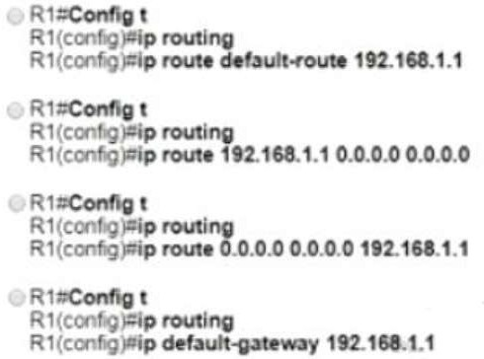

1. Option A
2. Option B
3. Option C
4. Option D

## Correct Answer: C Section: (none) Explanation

**Explanation/Reference:**

**QUESTION 210**

Which WPA3 enhancement protects against hackers viewing traffic on the Wi-Fi network?

1. TKiP encryption
2. AES encryption
3. scrambled encryption key
4. SAE encryption

## Correct Answer: D Section: (none) Explanation

**Explanation/Reference:**

**QUESTION 211**

Refer to the exhibit. An engineer is bringing up a new circuit to the MPLS provider on the Gi0/1 interface of Router1 The new circuit uses eBGP and teams the route to VLAN25 from the BGP path What s the expected behavior for the traffic flow for route 10.10.13.0/25?

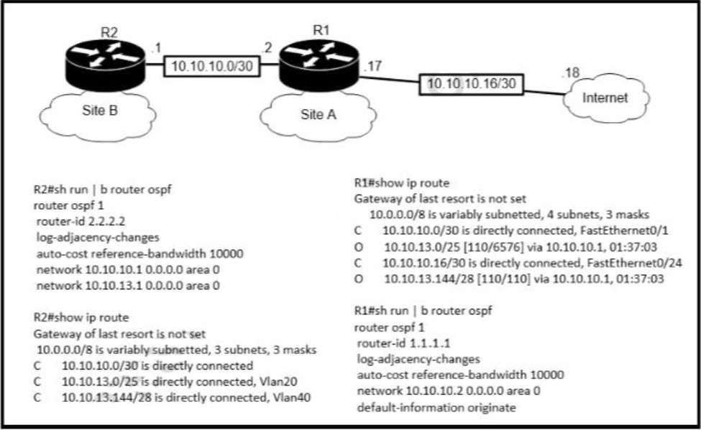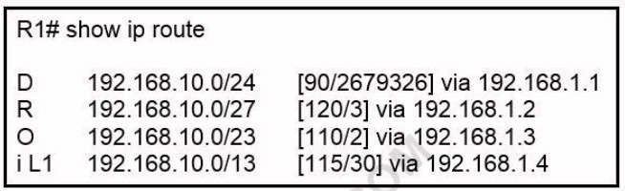

1. Traffic to 10.10.13.0.25 is load balanced out of multiple interfaces
2. Route 10.10.13.0/25 is updated in the routing table as being learned from interface Gi0/1.
3. Traffic to 10.10.13.0/25 is asymmeteical
4. Route 10.10.13.0/25 learned via the GiO/0 interface remains in the routing table

## Correct Answer: B Section: (none) Explanation

**Explanation/Reference:**

**QUESTION 212**

Refer to the exhibit. How does router R1 handle traffic to 192.168.10.16?

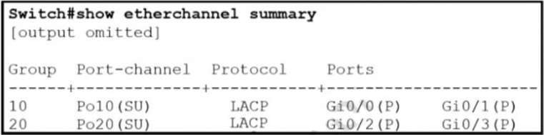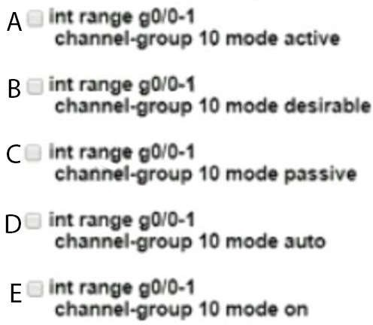

1. It selects the IS-IS route because it has the shortest prefix inclusive of the destination address.
2. It selects the EIGRP route because it has the lowest administrative distance.
3. It selects the OSPF route because it has the lowest cost.
4. It selects the RIP route because it has the longest prefix inclusive of the destinationaddress.

## Correct Answer: D Section: (none) Explanation

**Explanation/Reference:**

**QUESTION 213**

Refer to the exhibit.

Which two commands were used to create port channel 10? (Choose two )

1. Option A
2. Option B
3. Option C
4. Option D
5. Option E

## Correct Answer: AC Section: (none) Explanation

**Explanation/Reference:**

**QUESTION 214**

What is a difference between RADIUS and TACACS+?

1. RADIUS is most appropriate for dial authentication, but TACACS+ can be used for multiple types of authentication
2. TACACS+ encrypts only password information and RADIUS encrypts the entire payload
3. TACACS+ separates authentication and authorization, and RADIUS merges them
4. RADIUS logs all commands that are entered by the administrator, but TACACS+ logs only start, stop, and interim commands

## Correct Answer: C Section: (none) Explanation

**Explanation/Reference:**

**QUESTION 215**

Refer to the exhibit. How does the router manage traffic to 192.168.12.16?

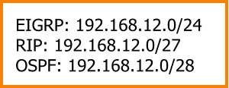

1. It selects the RIP route because it has the longest prefix inclusive of the destinationaddress.
2. It chooses the OSPF route because it has the longest prefix inclusive of the destinationaddress.
3. It load-balances traffic between all three routes
4. It chooses the EIGRP route because it has the lowest administrative distance

## Correct Answer: A Section: (none) Explanation

**Explanation/Reference:**

1. It supports numerous extensibility options including cross-domain adapters and third-party SDKs.
2. It supports high availability for management functions when operating in cluster mode.
3. It enables easy autodiscovery of network elements m a brownfield deployment.
4. It is designed primarily to provide network assurance.

## Correct Answer: A Section: (none) Explanation

**Explanation/Reference:**

**QUESTION 217**

While examining excessive traffic on the network, it is noted that all incoming packets on an interface appear to be allowed even though an IPv4 ACL is applied to the interface. Which two misconfigurations cause this behavior? (Choose two)

1. The packets fail to match any permit statement
2. A matching permit statement is too high in the access test
3. A matching permit statement is too broadly defined
4. The ACL is empty
5. A matching deny statement is too high in the access list

## Correct Answer: BC Section: (none) Explanation

**Explanation/Reference:**

**QUESTION 218**

How do traditional campus device management and Cisco DNA Center device management differ in regards to deployment?

1. Cisco DNA Center device management can deploy a network more quickly than traditional campus device management
2. Traditional campus device management allows a network to scale more quickly than with Cisco DNA Center device management
3. Cisco DNA Center device management can be implemented at a lower cost than most traditional campus device management options
4. Traditional campus device management schemes can typically deploy patches and updates more quickly than Cisco DNA Center device management

## Correct Answer: A Section: (none) Explanation

**Explanation/Reference:**

**QUESTION 219**

How do AAA operations compare regarding user identification, user services and access control?

1. Accounting tracks user services, and authentication provides access control
2. Authorization identifies users and authentication provides access control

## Correct Answer: B Section: (none) Explanation

**Explanation/Reference:**

**QUESTION 220**

What is a difference between local AP mode and FiexConnet AP mode?

1. Local AP mode creates two CAPWAP tunnels per AP to the WLC
2. FiexConnect AP mode fails to function if me AP loses connectivity with the WLC
3. FlexConnect AP mode bridges the traffic from the AP to the WLC when local switching isconfigured
4. Local AP mode causes the AP to behave as if it were an autonomous AP

## Correct Answer: A Section: (none) Explanation

**Explanation/Reference:**

**QUESTION 221**

Which function does the range of private IPv4 addresses perform?

1. allows multiple companies to each use the same addresses without conflicts
2. provides a direct connection for hosts from outside of the enterprise network
3. ensures that NAT is not required to reach the internet with private range addressing
4. enables secure communications to the internet for all external hosts

## Correct Answer: A Section: (none) Explanation

**Explanation/Reference:**

**QUESTION 222**

What event has occurred if a router sends a notice level message to a syslog server?

1. A TCP connection has been torn down
2. An ICMP connection has been built
3. An interface line has changed status
4. A certificate has expired

## Correct Answer: C Section: (none) Explanation

**Explanation/Reference:**

**QUESTION 223**

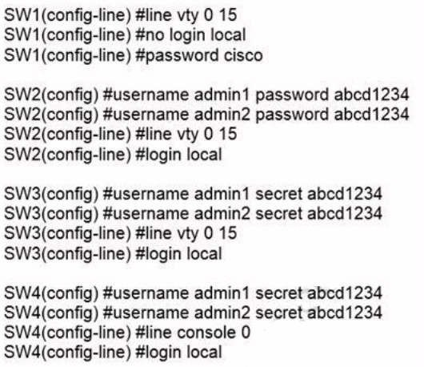Refer to the exhibit. An administrator configures four switches for local authentication using passwords that are stored in a cryptographic hash. The four switches must also support SSH access for administrators to manage the network infrastructure. Which switch is configured correctly to meet these requirements?

1. SW1
2. SW2
3. SW3
4. SW4

## Correct Answer: C Section: (none) Explanation

**Explanation/Reference:**

**QUESTION 224**

What are two fundamentals of virtualization? (choose two)

1. The environment must be configured with one hypervisor that serves solely as a network manager to monitor SNMP traffic
2. It allows logical network devices to move traffic between virtual machines and the rest of the physical network
3. It allows multiple operating systems and applications to run independently on one physical server.
4. It allows a physical router to directly connect NICs from each virtual machine into thenetwork
5. It requires that some servers, virtual machines and network gear reside on the Internet

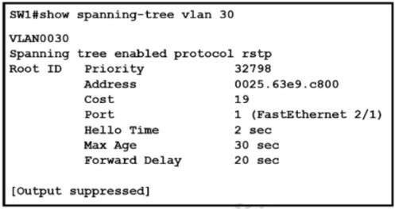

## Correct Answer: BC Section: (none) Explanation

**Explanation/Reference:**

**QUESTION 225**

Refer to the exhibit. What two conclusions should be made about this configuration? (Choose two)

1. The designated port is FastEthernet 2/1
2. This is a root bridge
3. The spanning-tree mode is Rapid PVST+
4. The spanning-tree mode is PVST+
5. The root port is FastEthernet 2/1

## Correct Answer: CE Section: (none) Explanation

**Explanation/Reference:**

**QUESTION 226**

Refer to the exhibit. A router reserved these five routes from different routing information sources. Which two routes does the router install in its routing table? (Choose two)

A. RIP route 10.0.0.0/30

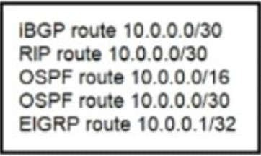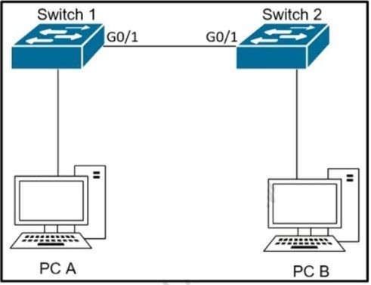

1. iBGP route 10.0.0.0/30
2. OSPF route 10.0.0.0/30
3. EIGRP route 10.0.0.1/32
4. OSPF route 10.0.0.0/16

## Correct Answer: CD Section: (none) Explanation

**Explanation/Reference:**

**QUESTION 227**

Refer to the exhibit. The network administrator wants VLAN 67 traffic to be untagged between Switch 1 and Switch 2 while all other VLANs are to remain tagged. Which command accomplishes this task?

1. switchport access vlan 67
2. switchport trunk allowed vlan 67
3. switchport private-vlan association host 67
4. switchport trunk native vlan 67

## Correct Answer: D Section: (none) Explanation

**Explanation/Reference:**

**QUESTION 228**

What are two differences between optical-fiber cabling and copper cabling? (Choose two)

1. Light is transmitted through the core of the fiber
2. A BNC connector is used for fiber connections
3. The glass core component is encased in a cladding
4. Fiber connects to physical interfaces using Rj-45 connections
5. The data can pass through the cladding

## Correct Answer: AC Section: (none) Explanation

**Explanation/Reference:**

**QUESTION 229**

Which two minimum parameters must be configured on an active interface to enable OSPFv2 to operate? (Choose two)

1. OSPF area
2. OSPF MD5 authentication key
3. iPv6 address
4. OSPf process ID
5. OSPf stub flag

## Correct Answer: AD Section: (none) Explanation

**Explanation/Reference:**

**QUESTION 230**

Refer to the exhibit. Refer to the exhibit. After the configuration is applied, the two routers fail to establish an OSPF neighbor relationship. what is the reason for the problem?

1. The OSPF router IDs are mismatched.

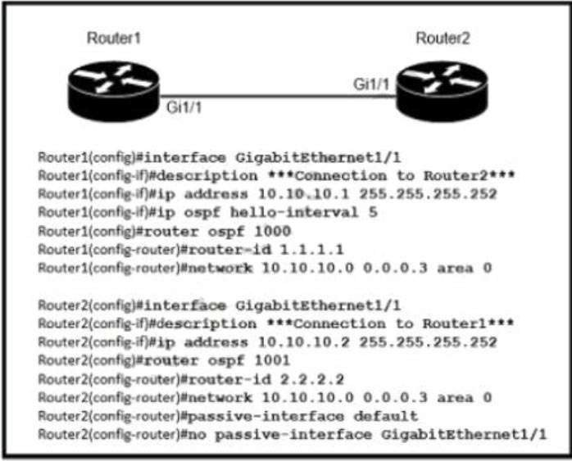

1. Router2 is using the default hellotimer.
2. The network statement on Router1 is misconfigured.
3. The OSPF process IDs are mismatched.

## Correct Answer: B Section: (none) Explanation

**Explanation/Reference:**

**QUESTION 231**

How do TCP and UDP differ in the way they provide reliability for delivery of packets?

1. TCP is a connectionless protocol that does not provide reliable delivery of data, UDP is a connection- oriented protocol that uses sequencing to provide reliable delivery.
2. TCP does not guarantee delivery or error checking to ensure that there is no corruption of data UDP provides message acknowledgement and retransmits data if lost.
3. TCP provides flow control to avoid overwhelming a receiver by sending too many packets at once, UDP sends packets to the receiver in a continuous stream without checking for sequencing
4. TCP uses windowing to deliver packets reliably; UDP provides reliable message transfer between hosts by establishing a three-way handshake

## Correct Answer: C Section: (none) Explanation

**Explanation/Reference:**

**QUESTION 232**

A packet is destined for 10.10.1.22. Which static route does the router choose to forward the packet?

A. ip route 10.10.1.0 255.255.255.240 10.10.255.1

B. ip route 10.10.1.16 255.255.255.25210.10.255.1

C. ip route 10.10.1.20 255.255.255.252 10.10.255.1

D. ip route 10.10.1.20 255.255.255.254 10.10.255.1

## Correct Answer: C Section: (none) Explanation

**Explanation/Reference:**

**QUESTION 233**

Refer to the exhibit. Router R1 Fa0/0 cannot ping router R3 Fa0/1. Which action must be taken in router R1 to help resolve the configuration issue?

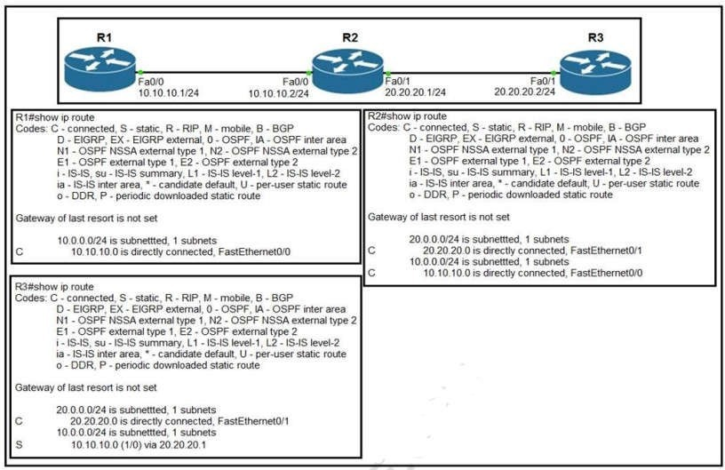

1. set the default network as 20.20.20.0/24
2. set the default gateway as 20.20.20.2
3. configure a static route with Fa0/1 as the egress interface to reach the 20.20.20.0/24 network
4. configure a static route with 10.10.10.2 as the next hop to reach the 20.20.20.0/24 network

## Correct Answer: D Section: (none) Explanation

**Explanation/Reference:**

**QUESTION 234**

Refer to the exhibit. Refer to the exhibit. An engineer must add a subnet for a new office that will add 20 users to the network. Which IPv4 network and subnet mask combination does the engineer assign to minimize wasting addresses?

A. 10.10.225.48 255.255.255.240

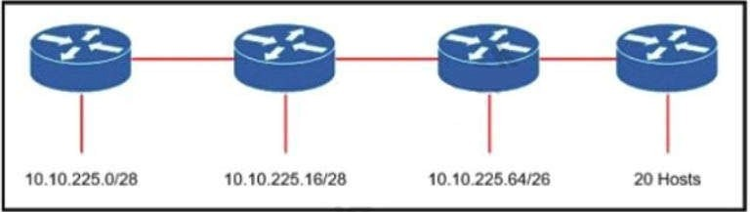

B. 10.10.225.32 255.255.255.240

C. 10.10.225.48 255.255.255.224

D. 10.10.225.32 255.255.255.224

## Correct Answer: D Section: (none) Explanation

**Explanation/Reference:**

**QUESTION 235**

A corporate office uses four floors in a building

* Floor 1 has 24 users
* Floor 2 has 29 users
* Floor 3 has 28 users
* Floor 4 has 22 users

Which subnet summarizes and gives the most efficient distribution of IP addresses for the router configuration?

A. 192.168.0.0/26 as summary and 192.168.0.0/29 for each floor

B. 192.168.0.0.24 as summary and 192.168.0.0/28 for each floor

C. 192.168.0.0/23 as summary and 192.168.0.0/25 for each floor

D. 192.168.0.0/25 as summary and 192.168.0.0/27 for each floor

## Correct Answer: D Section: (none) Explanation

**Explanation/Reference:**

**QUESTION 236**

By default, how Does EIGRP determine the metric of a route for the routing table?

1. it uses the bandwidth and delay values of the path to calculate the route metric
2. it uses a default metric of 10 for all routes that are learned by therouter
3. it uses a reference Bandwidth and the actual bandwidth of the connected link to calculate the route metric
4. it counts the number of hops between the receiving and destination routers and uses that value as the metric

## Correct Answer: A Section: (none) Explanation

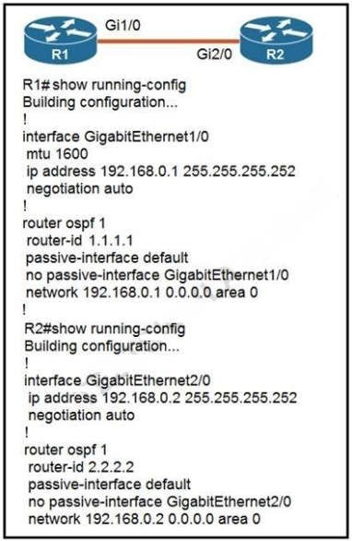

**Explanation/Reference:**

**QUESTION 237**

Refer to the exhibit. Which configuration issue is preventing the OSPF neighbor relationship from being established between the two routers?

1. R2 is using the passive-interface default command
2. R1 has an incorrect network command for interface Gi1/0
3. R2 should have its network command in area 1
4. R1 interface Gi1/0 has a larger MTU size

## Correct Answer: D Section: (none) Explanation

**Explanation/Reference:**

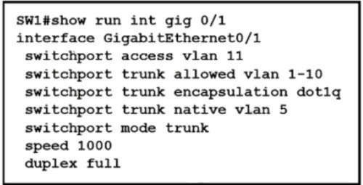

**QUESTION 238**

What are two roles of the Dynamic Host Configuration Protocol (DHCP)? (Choose two)

1. The DHCP server offers the ability to exclude specific IP addresses from a pool of IPaddresses
2. The DHCP client can request up to four DNS server addresses
3. The DHCP server assigns IP addresses without requiring the client to renewthem
4. The DHCP server leases client IP addresses dynamically.
5. The DHCP client maintains a pool of IP addresses it can assign.

## Correct Answer: AD Section: (none) Explanation

**Explanation/Reference:**

**QUESTION 239**

How does CAPWAP communicate between an access point in local mode and a WLC?

1. The access point must directly connect to the WLC using a copper cable
2. The access point must not be connected to the wired network, as it would create aloop
3. The access point must be connected to the same switch as the WLC
4. The access point has the ability to link to any switch in the network, assuming connectivity to the WLC

## Correct Answer: D Section: (none) Explanation

**Explanation/Reference:**

**QUESTION 240**

Refer to the exhibit. Which action is expected from SW1 when the untagged frame is received on the GigabitEthernet0/1 interface?

1. The frame is processed in VLAN 5.
2. The frame is processed in VLAN 11
3. The frame is processed in VLAN 1
4. The frame is dropped

## Correct Answer: A Section: (none) Explanation

**Explanation/Reference:**

**QUESTION 241**

What are two reasons for an engineer to configure a floating state route? (Choose two)

1. to automatically route traffic on a secondary path when the primary path goes down
2. to route traffic differently based on the source IP of the packet
3. to enable fallback static routing when the dynamic routing protocol fails
4. to support load balancing via static routing
5. to control the return path of traffic that is sent from the router

## Correct Answer: AC Section: (none) Explanation

**Explanation/Reference:**

**QUESTION 242**

Refer to the exhibit. Which route type is configured to reach the internet?

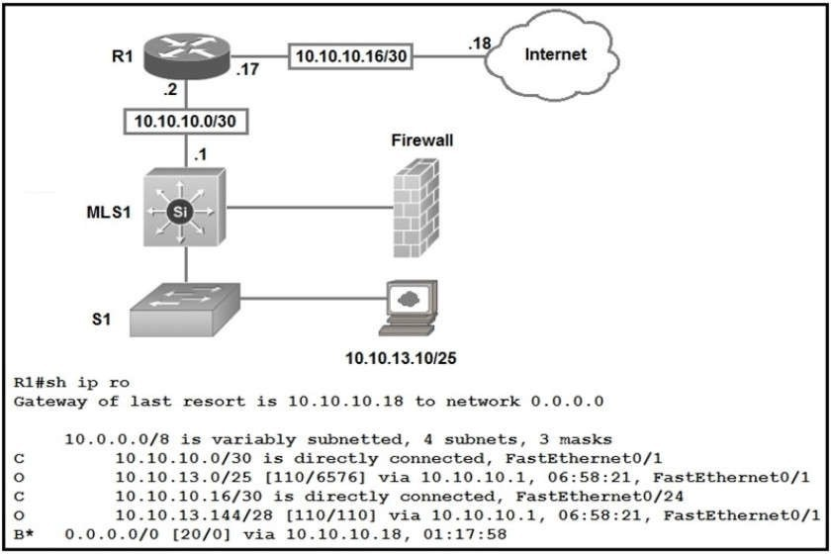

1. floating static route
2. host route
3. default route
4. network route

## Correct Answer: C Section: (none) Explanation

**Explanation/Reference:**

**QUESTION 243**

How does Cisco DNA Center gather data from the network?

1. Network devices use different services like SNMP, syslog, and streaming telemetry to send data to the controller
2. Devices establish an iPsec tunnel to exchange data with the controller
3. Devices use the call-home protocol to periodically send data to thecontroller.
4. The Cisco CU Analyzer tool gathers data from each licensed network device and streams it to thecontroller.

## Correct Answer: A



**Explanation/Reference:**

**QUESTION 244**

What is the difference regarding reliability and communication type between TCP and UDP?

1. TCP is reliable and is a connection-oriented protocol; UDP is not reliable and is a connectionless protocol
2. TCP is not reliable and is a connection-oriented protocol; UDP is reliable and is a connectionless protocol
3. TCP is not reliable and is a connectionless protocol; UDP is reliable and is a connection-oriented protocol
4. TCP is reliable and is a connectionless protocol; UDP is not reliable and is a connection-oriented protocol

## Correct Answer: A Section: (none) Explanation

**Explanation/Reference:**

**QUESTION 245**

Several new coverage cells are required to improve the Wi-Fi network of an organization. Which two standard designs are recommended? (Choose two.)

1. 5GHz provides increased network capacity with up to 23 nonoverlapping channels.
2. 5GHz channel selection requires an autonomous access point.
3. Cells that overlap one another are configured to use nonoverlapping channels.
4. Adjacent cells with overlapping channels use a repeater access point.
5. For maximum throughput, the WLC is configured to dynamically set adjacent access points to the channel.

## Correct Answer: CE Section: (none) Explanation

**Explanation/Reference:**

**QUESTION 246**

The service password-encryption command is entered on a router. What is the effect of this configuration?

1. restricts unauthorized users from viewing clear-text passwords in the running configuration
2. prevents network administrators from configuring clear-text passwords
3. protects the VLAN database from unauthorized PC connections on the switch
4. encrypts the password exchange when a VPN tunnel is established

## Correct Answer: A Section: (none) Explanation

**Explanation/Reference:**

**QUESTION 247**

Which type of ipv6 address is publicly routable in the same way as ipv4 public addresses?

1. unique local
2. link-local
3. global unicast

## Correct Answer: D Section: (none) Explanation

**Explanation/Reference:**

**QUESTION 248**

Which two statements are true about the command ip route 172.16.3.0 255.255.255.0 192.168.2.4? (Choose two.)

1. It establishes a static route to the 172.16.3.0 network.
2. It establishes a static route to the 192.168.2.0 network.
3. It configures the router to send anytraffic for an unknown destination to the 172.16.3.0 network.
4. It configures the router to send any traffic for an unknown destination out the interface with the address 192.168.2.4.
5. It uses the default administrative distance.
6. It is a route that would be used last if other routes to the same destination exist.

## Correct Answer: AE Section: (none) Explanation

**Explanation/Reference:**

**QUESTION 249**

Which three statements are typical characteristics of VLAN arrangements? (Choose three.)

1. A new switch has no VLANs configured.
2. Connectivity between VLANs requires a Layer 3 device.
3. VLANs typically decrease the number of collision domains.
4. Each VLAN uses a separate address space.
5. A switch maintains a separate bridging table for each VLAN.
6. VLANs cannot span multiple switches.

## Correct Answer: BDE Section: (none) Explanation

**Explanation/Reference:**

**QUESTION 250**

Refer to the exhibit. To which device does Router1 send packets that are destined to host 10.10.13.165?

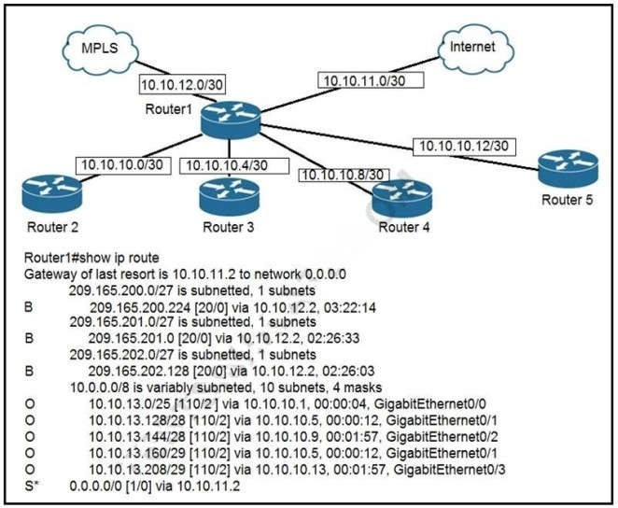

1. Router2
2. Router3
3. Router4
4. Router5

## Correct Answer: B Section: (none) Explanation

**Explanation/Reference:**

**QUESTION 251**

Refer to the exhibit. Which two commands were used to create port channel 10? (Choose two.)

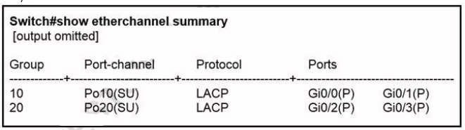

1. int range g0/0-1

channel-group 10 mode active

1. int range g0/0-1

channel-group 10 mode desirable

1. int range g0/0-1

channel-group 10 mode passive

1. int range g0/0-1

channel-group 10 mode auto

1. int range g0/0-1

channel-group 10 mode on

## Correct Answer: AC Section: (none) Explanation

**Explanation/Reference:**

**QUESTION 252**

What are two requirements for an HSRP group? (Choose two.)

1. exactly one active router
2. one or more standby routers
3. one or more backup virtual routers
4. exactly one standby active router
5. exactly one backup virtual router

## Correct Answer: AB Section: (none) Explanation

**Explanation/Reference:**

A: exactly one active router: Only one Active Router per HSRP group will be elected based on highest priority. In case of equal priority, Highest IP address will be elected as Active Router.

B: one or more standby routers : There can be one or more Standby Routers. C, D And E are incorrect: Wrong terminology.

## QUESTION 253

1. Frames are sent to every port on the switch in the same VLAN except from the originatingport.
2. Frames are sent to every port on the switch in the same VLAN.

## Correct Answer: C Section: (none) Explanation

**Explanation/Reference:**

**QUESTION 254**

If all OSPF routers in a single area are configured with the same priority value, what value does a router use for the OSPF router ID in the absence of a loopback interface?

1. the IP address of the first Fast Ethernet interface
2. the IP address of the console management interface
3. the highest IP address among its active interfaces
4. the lowest IP address among its active interfaces
5. the priority value until a loopback interface is configured

## Correct Answer: C Section: (none) Explanation

**Explanation/Reference:**

**QUESTION 255**

Which IPv6 address block forwards packets to a multicast address rather than a unicast address?

A. 2000::/3

B. FC00::/7

C. FE80::/10

D. FF00::/12

## Correct Answer: D Section: (none) Explanation

**Explanation/Reference:**

**QUESTION 256**

The OSPF Hello protocol performs which of the following tasks? (Choose two.)

1. It negotiates correctness parameters between neighboring interfaces.
2. It broadcasts hello packets throughout the internetwork to discover all routers that are running OSP
3. It provides dynamic neighbor discovery.
4. It detects unreachable neighbors in 90 second intervals.
5. It uses timers to elect the router with the fastest links as the designated router.

## Explanation/Reference:

**QUESTION 257**

What are two benefits of using VTP in a switching environment? (Choose two.)

1. It allows switches to read frame tags.
2. It allows ports to be assigned to VLANs automatically.
3. It maintains VLAN consistency across a switched network.
4. It allows frames from multiple VLANs to use a single interface.
5. It allows VLAN information to be automatically propagated throughout the switchingenvironment.

## Correct Answer: CE Section: (none) Explanation

**Explanation/Reference:**

**QUESTION 258**

Which purpose does a northbound API serve in a controller-based networking architecture?

1. communicates between the controller and the physical network hardware
2. reports device errors to a controller
3. generates statistics for network hardware and traffic
4. facilitates communication between the controller and the applications

## Correct Answer: D Section: (none) Explanation

**Explanation/Reference:**

**QUESTION 259**

The OSPF Hello protocol performs which of the following tasks? (Choose two.)

1. It provides dynamic neighbor discovery.
2. It detects unreachable neighbors in 90 second intervals.
3. It maintains neighbor relationships.
4. It negotiates correctness parameters between neighboring interfaces.
5. It uses timers to elect the router with the fastest links as the designated router.
6. It broadcasts hello packets throughout the internetwork to discover all routers that are running OSPF.

## Correct Answer: AC Section: (none) Explanation

**Explanation/Reference:**

**QUESTION 260**

What are two reasons a network administrator would use CDP? (Choose two.)

1. to verify the type of cable interconnecting two devices

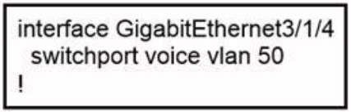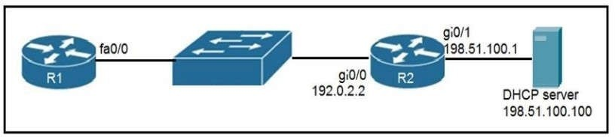

1. to determine the status of network services on a remote device
2. to obtain VLAN information from directly connected switches
3. to verify Layer 2 connectivity between two devices when Layer 3 fails
4. to obtain the IP address of a connected device in order to telnet to the device
5. to determine the status of the routing protocols between directly connected routers

## Correct Answer: DE Section: (none) Explanation

**Explanation/Reference:**

**QUESTION 261**

Refer to the exhibit. An administrator is tasked with configuring a voice VLAN. What is the expected outcome when a Cisco phone is connected to the GigabitEthernet 3/1/4 port on a switch?

1. The phone and a workstation that is connected to the phone do not have VLAN connectivity.
2. The phone sends and receives data in VLAN 50, but a workstation connected to the phone sends and receives data in VLAN 1.
3. The phone sends and receives data in VLAN 50, but a workstation connected to the phone has no VLAN connected.
4. The phone and a workstation that is connected to the phone send and receive data in VLAN 50.

## Correct Answer: B Section: (none) Explanation

**Explanation/Reference:**

**QUESTION 262**

Refer to the exhibit. An engineer deploys a topology in which R1 obtains its IP configuration from DHCP. If the switch and DHCP server configurations are complete and correct. Which two sets of commands must be configured on R1 and R2 to complete the task? (Choose two)

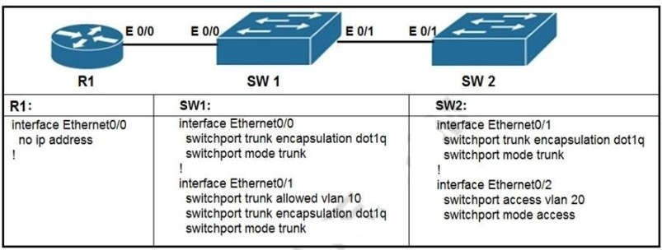

1. R1(config)# interface fa0/0

R1(config-if)# ip helper-address 198.51.100.100

1. R2(config)# interface gi0/0

R2(config-if)# ip helper-address 198.51.100.100

1. R1(config)# interface fa0/0 R1(config-if)# ip address dhcp R1(config-if)# no shutdown
2. R2(config)# interface gi0/0 R2(config-if)# ip address dhcp
3. R1(config)# interface fa0/0

R1(config-if)# ip helper-address 192.0.2.2

## Correct Answer: BC Section: (none) Explanation

**Explanation/Reference:**

**QUESTION 263**

Refer to the exhibit. What commands are needed to add a subinterface to Ethernet0/0 on R1 to allow for VLAN 20, with IP address 10.20.20.1/24?

1. R1(config)#interface ethernet0/0 R1(config)#encapsulation dot1q 20 R1(config)#ip address 10.20.20.1 255.255.255.0
2. R1(config)#interface ethernet0/0.20 R1(config)#encapsulation dot1q 20 R1(config)#ip address 10.20.20.1 255.255.255.0
3. R1(config)#interface ethernet0/0.20 R1(config)#ip address 10.20.20.1 255.255.255.0
4. R1(config)#interface ethernet0/0

R1(config)#ip address 10.20.20.1 255.255.255.0

## Correct Answer: B

**Explanation/Reference:**

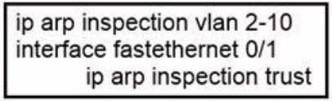

**QUESTION 264**

On a corporate network, hosts on the same VLAN can communicate with each other, but they are unable to communicate with hosts on different VLANs. What is needed to allow communication between the VLANs?

1. a router with subinterfaces configured on the physical interface that is connected to theswitch
2. a router with an IP address on the physical interface connected to the switch
3. a switch with an access link that is configured between the switches
4. a switch with a trunk link that is configured between the switches

## Correct Answer: A Section: (none) Explanation

**Explanation/Reference:**

Different VLANs can’t communicate with each other , they can communicate with the help of Layer3 router. Hence , it is needed to connect a router to a switch , then make the sub-interface on the router to connect to the switch, establishing Trunking links to achieve communications of devices which belong to different VLANs.

## QUESTION 265

Which command can you enter to determine the addresses that have been assigned on a DHCP Server?

1. Show ip DHCP database.
2. Show ip DHCP pool.
3. Show ip DHCP binding.
4. Show ip DHCP server statistic.

## Correct Answer: C Section: (none) Explanation

**Explanation/Reference:**

**QUESTION 266**

Refer to the exhibit. If the network environment is operating normally, which type of device must be connected to interface FastEthernet 0/1?

1. DHCP client
2. access point
3. router
4. PC

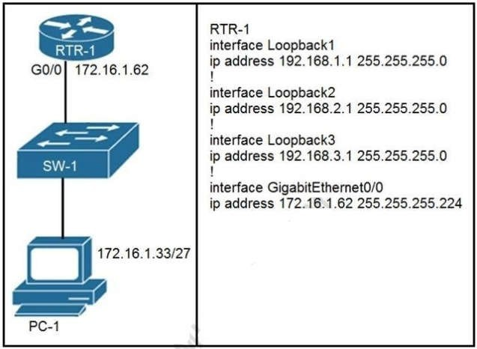

## Explanation/Reference:

**QUESTION 267**

Refer to the exhibit. What configuration on RTR-1 denies SSH access from PC-1 to any RTR-1 interface and allows all other traffic?

1. access-list 100 deny top host 172.16.1.33 any eq 22 access-list 100 permit ip any any

interface GigabitEthernet0/0 ip access-group 100 in

1. access-list 100 deny top host 172.16.1.33 any eq 22 access-list 100 permit ip any any

line vty 0 15

access-class 100 in

1. access-list 100 deny top host 172.16.1.33 any eq 23 access-list 100 permit ip any any

interface Gigabit Ethernet0/0 ip access-group 100 in

1. access-list 100 deny top host 172.16.1.33 any eq 23 access-list 100 permit ip any any

access-class 100 in

## Correct Answer: B Section: (none) Explanation

**Explanation/Reference:**

**QUESTION 268**

Which function dose the range of private IPv4 addresses perform?

1. allow multiple companies to each use the same address without conflicts
2. provides a direct connection for hosts from outside of the enterprise network
3. ensues that NAT is not required to reach the internet with private range addressing
4. enable secure communications to the internet for all external hosts

## Correct Answer: A Section: (none) Explanation

**Explanation/Reference:**

**QUESTION 269**

Which type of API would be used to allow authorized salespeople of an organization access to internal sales data from their mobile devices?

1. partner
2. open
3. public
4. private

## Correct Answer: D Section: (none) Explanation

**Explanation/Reference:**

**QUESTION 270**

What is a characteristic of the REST API?

1. evolved into what became SOAP
2. used for exchanging XML structured information over HTTP or SMTP
3. considered slow, complex, and rigid
4. most widely used API for web services

## Correct Answer: D Section: (none) Explanation

**Explanation/Reference:**

What is the name of the layer in the Cisco borderless switched network design that is considered to be the backbone used for high-speed connectivity and fault isolation?

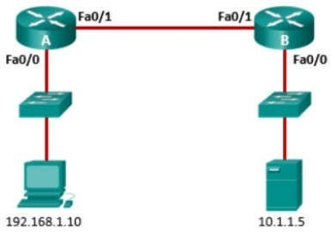

1. data link
2. access
3. core
4. network
5. network access

## Correct Answer: C Section: (none) Explanation

**Explanation/Reference:**

**QUESTION 272**

Refer to the exhibit. An administrator configures the following ACL in order to prevent devices on the 192.168.1.0 subnet from accessing the server at 10.1.1.5:

*access-list 100 deny ip 192.168.1.0 0.0.0.255 host 10.1.1.5 access-list 100 permit ip any any*

Where should the administrator place this ACL for the most efficient use of network resources?

1. inbound on router A Fa0/0
2. outbound on router B Fa0/0
3. outbound on router A Fa0/1
4. inbound on router B Fa0/1

## Correct Answer: A Section: (none) Explanation

**Explanation/Reference:**

1. electing the designated router
2. establishing neighbor adjacencies
3. injecting the default route
4. exchanging link-state advertisements

## Correct Answer: B Section: (none) Explanation

**Explanation/Reference:**

**QUESTION 274**

Refer to the exhibit. Router R1 is configured with static NAT. Addressing on the router and the web server are correctly configured, but there is no connectivity between the web server and users on the Internet. What is a possible reason for this lack of connectivity?

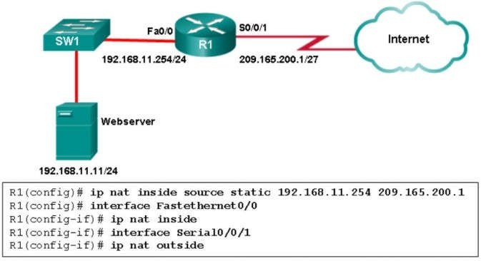

1. The router NAT configuration has an incorrect inside local address.
2. The inside global address is incorrect.
3. The NAT configuration on interface S0/0/1 is incorrect.
4. Interface Fa0/0 should be configured with the command ip nat outside

## Correct Answer: A Section: (none) Explanation

**Explanation/Reference:**

1. Cisco ACI

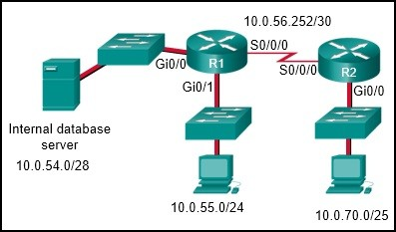

1. cloud services
2. APIC-EM
3. data center

## Correct Answer: B Section: (none) Explanation

**Explanation/Reference:**

**QUESTION 276**

A company needs to interconnect several branch offices across a metropolitan area. The network engineer is seeking a solution that provides high-speed converged traffic, including voice, video, and data on the same network infrastructure. The company also wants easy integration to their existing LAN infrastructure in their office locations. Which technology should be recommended?

1. VSAT
2. ISDN
3. Frame Relay
4. Ethernet WAN

## Correct Answer: D Section: (none) Explanation

**Explanation/Reference:**

Ethernet WAN uses many Ethernet standards and it connects easily to existing Ethernet LANs. It provides a switched, high-bandwidth Layer 2 network capable of managing data, voice, and video all on the same infrastructure. ISDN, while capable of supporting both voice and data, does not provide high bandwidth. VSAT uses satellite connectivity to establish a private WAN connection but with relatively low bandwidth. Use of VSAT, ISDN, and Frame Relay require specific network devices for the WAN connection and data conversion between LAN and WAN.

## QUESTION 277

Refer to the exhibit. Which two configurations would be used to create and apply a standard access list on R1, so that only the 10.0.70.0/25 network devices are allowed to access the internal database server? (Choose two.)

1. R1(config)# interface GigabitEthernet0/0 R1(config-if)# ip access-group 5 out
2. R1(config)# access-list 5 permit 10.0.54.0 0.0.1.255
3. R1(config)# interface Serial0/0/0 R1(config-if)# ip access-group 5 in
4. R1(config)# access-list 5 permit 10.0.70.0 0.0.0.127
5. R1(config)# access-list 5 permit any

## Correct Answer: AD Section: (none) Explanation

Which type of VPN uses a hub-and-spoke configuration to establish a full mesh topology?

1. GRE over IPsec
2. dynamic multipoint VPN
3. MPLS VPN
4. IPsec virtual tunnel interface

## Correct Answer: B Section: (none) Explanation

**Explanation/Reference:**

**QUESTION 279**

What are two purposes of launching a reconnaissance attack on a network? (Choose two.)

1. to prevent other users from accessing the system
2. to escalate access privileges
3. to gather information about the network and devices
4. to scan for accessibility
5. to retrieve and modify data

## Correct Answer: CD Section: (none) Explanation

**Explanation/Reference:**

Gathering information about a network and scanning for access is a reconnaissance attack. Preventing other users from accessing a system is a denial of service attack. Attempting to retrieve and modify data, and attempting to escalate access privileges are types of access attacks.

## QUESTION 280

Refer to the exhibit. If the switch reboots and all routers have to re-establish OSPF adjacencies, which routers will become the new DR and BDR?

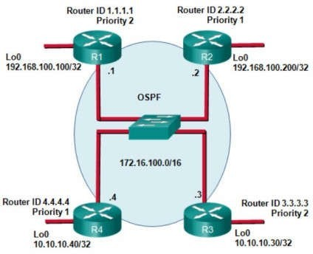

1. Router R3 will become the DR and router R1 will become the BDR.
2. Router R4 will become the DR and router R3 will become the BDR.
3. Router R1 will become the DR and router R2 will become the BDR.
4. Router R3 will become the DR and router R2 will become the BDR.

## Correct Answer: A Section: (none) Explanation

**Explanation/Reference:**

OSPF elections of a DR are based on the following in order of precedence:

highest pritority from 1 -255 (0 = never a DR) highest router ID

highest IP address of a loopback or active interface in the absence of a manually configured router ID. Loopback IP addresses take higher precedence than other interfaces.

In this case routers R1 and R3 have the highest router priority. Between the two, R3 has the higher router ID. Therefore, R3 will become the DR and R1 will become the BDR.

## QUESTION 281

The SW1 interface g0/1 is in the down/down state. Which two configurations are valid reasons for the interface conditions?(choose two)

1. There is a duplex mismatch
2. There is a speed mismatch
3. There is a protocol mismatch
4. The interface is shut down
5. The interface is error-disabled

## Explanation/Reference:

**QUESTION 282**

In which two ways does a password manager reduce the chance of a hacker stealing a users password? (Choose two.)

1. It automatically provides a second authentication factor that is unknown to the originaluser.
2. It uses an internal firewall to protect the password repository from unauthorized access.
3. It protects against keystroke logging on a compromised device or web site.
4. It stores the password repository on the local workstation with built-in antivirus and anti-malware functionality
5. It encourages users to create stronger passwords.

## Correct Answer: CE Section: (none) Explanation

**Explanation/Reference:**

**QUESTION 283**

What is the primary purpose of a First Hop Redundancy Protocol?

1. It allows directly connected neighbors to share configuration information.
2. It allows a router to use bridge priorities to create multiple loop-free paths to a singledestination.
3. It reduces routing failures by allowing Layer 3 load balancing between OSPF neighbors that have the same link metric.
4. It reduces routing failures by allowing more than one router to represent itself, as the default gateway of a network.

## Correct Answer: D Section: (none) Explanation

**Explanation/Reference:**

**QUESTION 284**

Refer to the exhibit. Which path is used by the router for internet traffic?

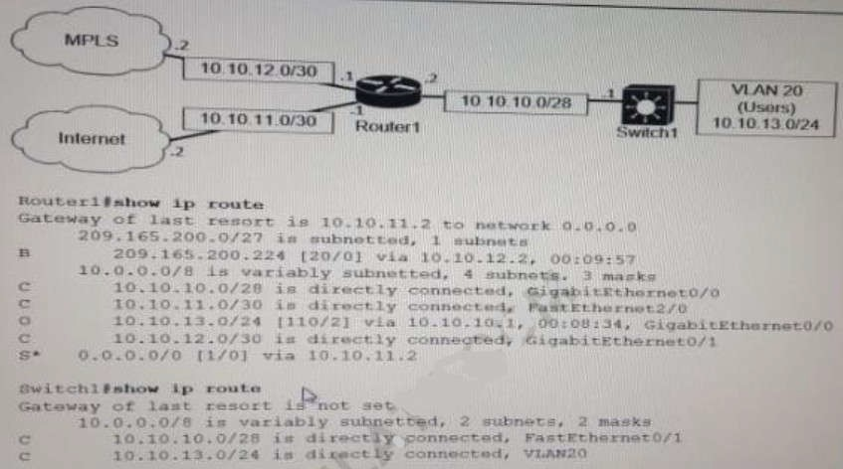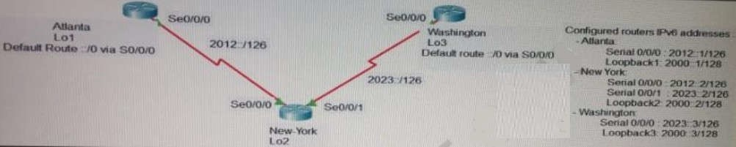

A. 209.165.200.0/27

B. 10.10.10.0/28

C. 0.0.0.0/0

D. 10.10.13.0/24

## Correct Answer: C Section: (none) Explanation

**Explanation/Reference:**

**QUESTION 285**

Refer to Exhibit. The loopback1 interface of the Atlanta router must reach the loopback3 interface of the Washington router. Which two static host routes must be configured on the NEW York router? (Choose two)

D. ipv6 route 2000::1/128 2012::2

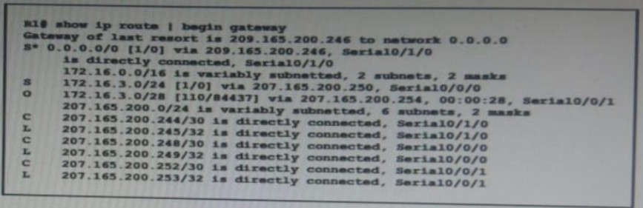

E. ipv6 route 2000::1/128 s0/0/1

## Correct Answer: AB Section: (none) Explanation

**Explanation/Reference:**

**QUESTION 286**

Refer to the exhibit. A packet is being sent across router R1 to host 172.16.3.14. To which destination does the router send the packet?

A. 207 165 200 246 via Serial0/1/0

B. 207.165.200.254 via Serial0/0/0

C. 207.165 200.254 viaSerial0/0/1

D. 207.165.200.250 viaSerial0/0/0

## Correct Answer: C Section: (none) Explanation

**Explanation/Reference:**

**QUESTION 287**

Which goal is achieved by the implementation of private IPv4 addressing on a network?

1. allows servers and workstations to communicate across public network boundaries
2. provides a reduction in size of the forwarding table on network routers
3. allows communication across the Internet to other private networks
4. provides an added level of protection against Internet exposure

## Correct Answer: D Section: (none) Explanation

**Explanation/Reference: QUESTION 288**

Refer to the exhibit. A network administrator assumes a task to complete the connectivity between PC A and the File Server Switch A and Switch B have been partially configured with VLANs 10, 11, 12, and 13 What is the next step in the configuration?

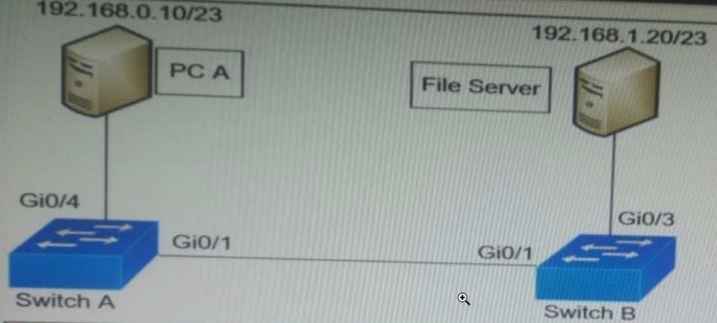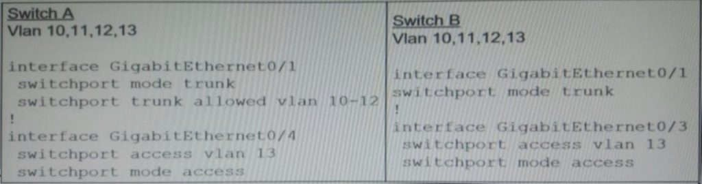

1. Add PDA to VLAN 10 and the File Server to VLAN 11 for VLAN segmentation
2. Add VLAN 13 to the trunk links on Switch A and Switch B for VLAN propagation
3. Add a router on a stick between Switch A and Switch B allowing for Inter VLAN routing
4. Add PC A to the same subnet as the File Server allowing for intra-VLAN communication

## Correct Answer: B Section: (none) Explanation

**Explanation/Reference:**

**QUESTION 289**

When a WPA2-PSK WLAN is configured in the Wireless LAN Controller, what is the minimum number of characters that is required in ASCII formar?

1. 6
2. 8
3. 12
4. 18

## Correct Answer: B Section: (none) Explanation

**Explanation/Reference:**

**QUESTION 290**

Refer to the exhibit Which outcome is expected when PC_A sends data to PC_B?

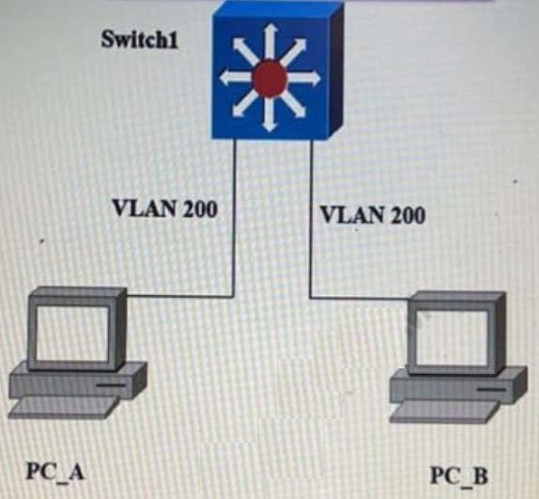

1. The switch rewrites the source and destination MAC addresses with its own
2. The source and destination MAC addresses remain the same
3. The source MAC address is changed
4. The destination MAC address is replaced with ffff.ffff.ffff

## Correct Answer: B Section: (none) Explanation

**Explanation/Reference:**

**QUESTION 291**

An engineer needs to configure LLDP to send the port description time length value (TLV). What command sequence must be implemented?

1. switch#lldp port-description
2. switch(config)#lldp port-description
3. switch(config-line)#lldp port-description
4. switch(config-if)#lldp port-description

## Correct Answer: B

**Section: (none) Explanation**

**Explanation/Reference:**

**QUESTION 292**

Refer to the exhibit. Which switch becomes the root bridge?

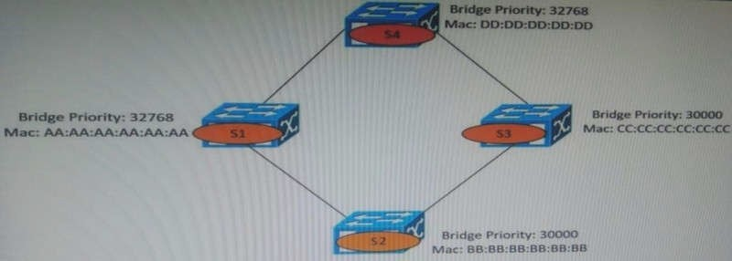

1. S1
2. S2
3. S3

## Correct Answer: B Section: (none) Explanation

**Explanation/Reference:**

**QUESTION 293**

Refer to the exhibit. What is the next hop address for traffic that is destined to host 10.0.1.5?

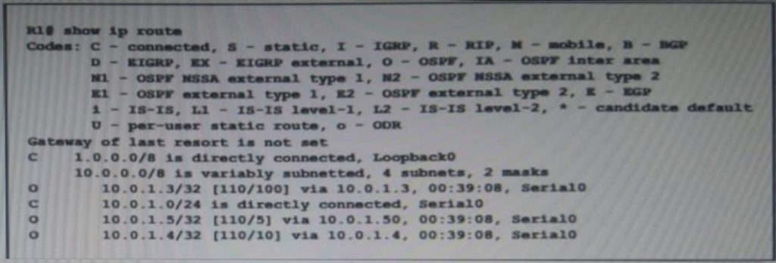

A. Loopback 0

B. 10.0.1.4

C. 10.0.1.50

D. 10.0.1.3

## Correct Answer: C Section: (none) Explanation

**Explanation/Reference:**

**QUESTION 294**

When the active router in an HSRP group fails, what router assumes the role and forwards packets?

1. forwarding
2. backup
3. standby
4. listening

## Correct Answer: C Section: (none) Explanation

**Explanation/Reference:**

**QUESTION 295**

An organization secures its network with multi-factor authentication using an authenticator app on employee smartphones. How is the applic secured in the case of a user’s smartphone being lost or stolen?

1. The application requires the user to enter a PIN before it provides the second factor
2. The application challenges a user by requiring an administrator password to reactivate when the smartphone is rebooted
3. The application requires an aadministrator password to reactivate after a configured interval
4. The application verifies that the user is in a specific location before it provides the second factor

## Correct Answer: A Section: (none) Explanation

**Explanation/Reference:**

**QUESTION 296**

Refer to the exhibit. What action establishes the OSPF neighbor relationship without forming an adjacency?

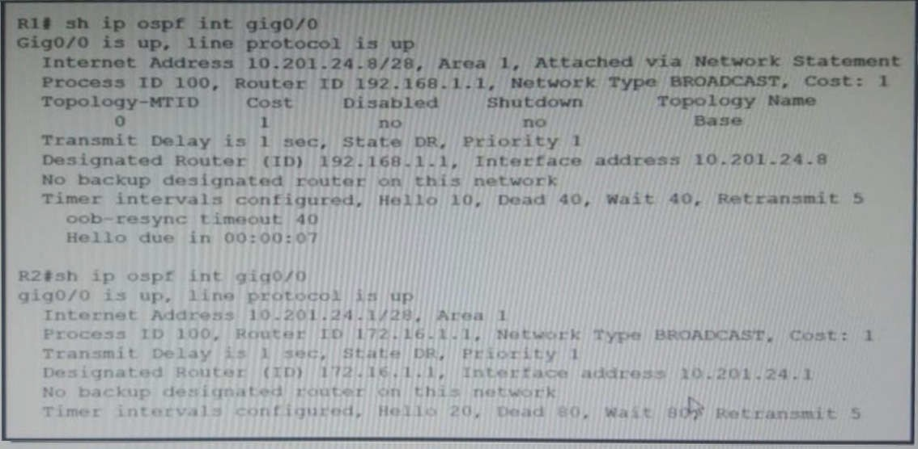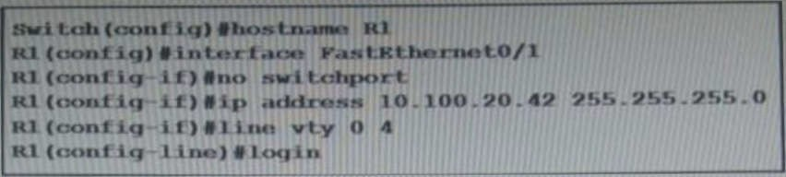

1. modify priority
2. modify process ID
3. modify hello interval
4. modity network type

## Correct Answer: C Section: (none) Explanation

**Explanation/Reference:**

**QUESTION 297**

Refer to the exhibit. An engineer booted a new switch and applied this configuration via the console port. Which additional configuration must be applied to allow administrators to authenticate directly to enable privilege mode via Telnet using a local username and password?

A. R1(config)#username admin R1(config-if)#line vty 0 4

R1(config-line)#password p@ss1234

R1(config-line)#password p@ss1234 R1(config-line)#transport input telnet

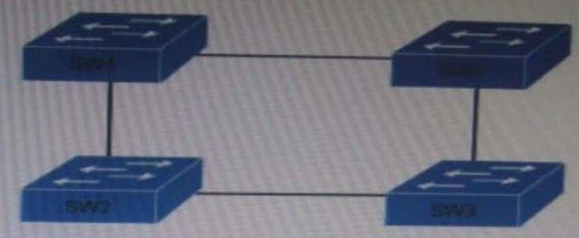

1. R1(config)#username admin secret p@ss1234 R1(config-if)#line vty 0 4

R1(config-line)#login local R1(config)#enable secret p@ss1234

1. R1(config)#username admin privilege 15 secretp@ss1234 R1(config-if)#line vty 0 4

R1(config-line)#login local

## Correct Answer: D Section: (none) Explanation

**Explanation/Reference:**

**QUESTION 298**

Refer to the exhibit. Which switch in this configuration will be elected as the root bridge?

SW1: 0C:E0:38:00:36:75 SW2: 0C:0E:15:22:05:97 SW3: 0C:0E:15:1A:3C:9D SW4: 0C:E0:18:A1:B3:19

1. SW1
2. SW2
3. SW3
4. SW4

## Correct Answer: C Section: (none) Explanation

**Explanation/Reference:**

192.168.3.1, 192.168.3.2, 192.168.3.3 . Which configuration should be used? A.

enable

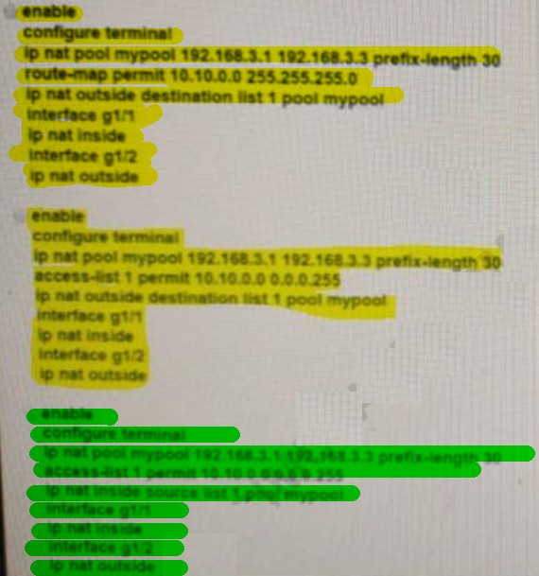configure terminal

ip nat pool mypool 192.168.3.1 192.168.3.3 prefix-length 30

route-map permit 10.10.0.0 255.255.255.0 ip nat outside destination list 1 pool mypool interface g1/1

ip nat inside interface g1/2 ip nat outside

B.

enable

configure terminal

ip nat pool mypool 192.168.3.1 192.168.3.3 prefix-length 30

access-list 1 permit 10.10.0.0 0.0.0.255

ip nat outside destination list 1 pool mypool interface g1/1

ip nat inside interface g1/2 ip nat outside

C.

enable

configure terminal

ip nat pool mypool 192.168.3.1 192.168.3.3 prefix-length 30

access-list 1 permit 10.10.0 0.0 0.255 ip nat inside source list 1 pool mypool interface g1/1

ip nat inside interface g1/2

ip nat outside</span>

1. Option A
2. Option B
3. Option C

## Correct Answer: C Section: (none) Explanation

**Explanation/Reference:**

**QUESTION 300**

An office has 8 floors with approximately 30-40 users per floor What command must be configured on the router Switched Virtual Interface to use address space efficiently?

A. ip address 192.168.0.0 255.255.0.0

B. ip address 192.168.0.0 255.255.254.0

C. ip address 192.168.0.0255.255.255.128

D. ip address 192.168.0.0255.255.255.224

## Explanation/Reference:

**QUESTION 301**

Which device performs stateful inspection of traffic?

1. firewall
2. switch
3. access point
4. wireless controller

## Correct Answer: A Section: (none) Explanation

**Explanation/Reference:**

**QUESTION 302**

What criteria is used first during the root port selection process?

1. local port ID
2. lowest path cost to the root bridge
3. lowest neighbor’s bridge ID
4. lowest neighbor’s port ID

## Correct Answer: B Section: (none) Explanation

**Explanation/Reference:**

**QUESTION 303**

Router R2 is configured with multiple routes to reach network 10 1.1.0/24 from router R1. What protocol is chosen by router R2 to reach the destination network 10.1.1.0/24?

1. eBGP
2. static
3. OSPF
4. EIGRP

## Correct Answer: B Section: (none) Explanation

**Explanation/Reference:**

**QUESTION 304**

A network administrator enabled port security on a switch interface connected to a printer. What is the next configuration action in order to allow the port to learn the MAC address of the printer and insert it into the table

1. implement static MAC addressing.
2. enable sticky MAC addressing
3. implement auto MAC address learning

## Correct Answer: C Section: (none) Explanation

**Explanation/Reference:**

**QUESTION 305**

Which configuration ensures that the switch is always the root for VLAN 750?

1. Switch(config)#spanning-tree vlan 750 priority 38003685
2. Switch(config)#spanning-tree vlan 750 root primary
3. Switch(config)#spanning-tree vlan 750 priority 614440
4. Switch(config)#spanning-tree vlan 750 priority 0

## Correct Answer: D Section: (none) Explanation

**Explanation/Reference:**

**QUESTION 306**

An engineer must configure an OSPF neighbor relationship between router R1 and R3 The authentication configuration has been configured and the connecting interfaces are in the same 192.168 1.0/30 sublet. What are the next two steps to complete the configuration? (Choose two.)

1. configure the hello and dead timers to match on both sides
2. configure the same process ID for the router OSPF process
3. configure the same router ID on both routing processes
4. configure the interfaces as OSPF active on both sides.
5. configure both interfaces with the same area ID

## Correct Answer: AE Section: (none) Explanation

**Explanation/Reference:**

**QUESTION 307**

What protocol allows an engineer to back up 20 network router configurations globally while using the copy function?

1. SMTP
2. SNMP
3. TCP
4. FTP

## Explanation Explanation/Reference:

**QUESTION 308**

Which state does the switch port move to when PortFast is enabled?

1. learning
2. forwarding
3. blocking
4. listening

## Correct Answer: B Section: (none) Explanation

**Explanation/Reference:**

**QUESTION 309**

What are two roles of Domain Name Services (DNS)? (Choose Two)

1. builds a flat structure of DNS names for more efficient IP operations
2. encrypts network Traffic as it travels across a WAN by default
3. improves security by protecting IP addresses under Fully Qualified Domain Names (FQDNs)
4. enables applications to identify resources by name instead of IP address
5. allows a single host name to be shared across more than one IP address

## Correct Answer: DE Section: (none) Explanation

**Explanation/Reference:**

**QUESTION 310**

How do TCP and UDP differ in the way they guarantee packet delivery?

1. TCP uses checksum, acknowledgement, and retransmissions, and UDP uses checksums only.
2. TCP uses retransmissions, acknowledgement and parity checks and UDP uses cyclic redundancy checks only.
3. TCP uses checksum, parity checks, and retransmissions, and UDP uses acknowledgements only.
4. TCP uses two-dimensional parity checks, checksums, and cyclic redundancy checks and UDP uses retransmissions only.

## Correct Answer: A Section: (none) Explanation

**Explanation/Reference:**



1. collision
2. CRC
3. runt
4. late collision

## Correct Answer: D Section: (none) Explanation

**Explanation/Reference:**

**QUESTION 312**

Which technology is used to improve web traffic performance by proxy caching?

1. WSA
2. Firepower
3. ASA
4. FireSIGHT

## Correct Answer: A Section: (none) Explanation

**Explanation/Reference:**

**QUESTION 313**

Using direct sequence spread spectrum, which three 2.4-GHz channels are used to limit collisions?

A. 1,6.11

B. 1,5,10

C. 1,2,3

D. 5,6,7

## Correct Answer: A Section: (none) Explanation

**Explanation/Reference:**

**QUESTION 314**

Which type of attack can be mitigated by dynamic ARP inspection?

1. worm
2. malware
3. DDoS
4. man-in-the-middle

## Explanation/Reference:

**QUESTION 315**

What are two benefits of controller-based networking compared to traditional networking?

1. Controller-based increases network bandwidth usage, while traditional lightens the load on the network.
2. Controller-based inflates software costs, while traditional decreases individual licensing costs
3. Controller-based reduces network configuration complexity, while traditional increases the potential for errors
4. Controller-based provides centralization of key IT functions. While traditional requires distributes management function
5. Controller-based allows for fewer network failure, while traditional increases failure rates.

## Correct Answer: CD Section: (none) Explanation

**Explanation/Reference:**

**QUESTION 316**

What software defined architecture plane assists network devices with making packet-forwarding decisions by providing Layer 2 reachability and Layer 3 routing information?

1. data plane
2. control plane
3. policy plane
4. management plane

## Correct Answer: B Section: (none) Explanation

**Explanation/Reference:**

**QUESTION 317**

Which WAN access technology is preferred for a small office / home office architecture?

1. broadband cable access
2. frame-relay packet switching
3. dedicated point-to-point leased line
4. Integrated Services Digital Network switching.

## Correct Answer: A Section: (none) Explanation

**Explanation/Reference:**

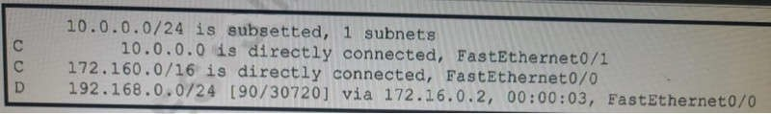

1. internal BGP route
2. /24 route of a locally configured IP
3. statically assigned route
4. route learned through EIGRP

## Correct Answer: D Section: (none) Explanation

**Explanation/Reference:**

**QUESTION 319**

Which two WAN architecture options help a business scalability and reliability for the network? (Choose two)

1. asychronous routing
2. single-homed branches
3. dual-homed branches
4. static routing
5. dynamic routing

## Correct Answer: AC Section: (none) Explanation

**Explanation/Reference:**

**QUESTION 320**

A wireless administrator has configured a WLAN; however, the clients need access to a less congested 5-GHz network for their voice quality. What action must be taken to meet the requirement?

1. enable AAA override
2. enable RX-SOP
3. enable DTIM
4. enable Band Select

## Correct Answer: D Section: (none) Explanation

**Explanation/Reference:**

1. ISATAP
2. GRE over iPsec
3. iPsec over ISATAP
4. GRE

## Correct Answer: B Section: (none) Explanation

**Explanation/Reference:**

An engineer must establish a trunk link between two switches. The neighboring switch is set to trunk or desirable mode. What action should be taken?

1. configure switchport nonegotiate
2. configure switchport mode dynamic desirable
3. configure switchport mode dynamic auto
4. configure switchport trunk dynamic desirable Correct Answer: C

**QUESTION323**

Which type of information resides on a DHCP server?

1. a list of the available IP addresses in a pool
2. a list of public IP addresses and their corresponding names
3. usernames and passwords for the end users in a domain
4. a list of statically assigned MAC addresses Correct Answer: A

**QUESTION 324**

What is a function of Wireless LAN Controller?

1. register with a single access point that controls traffic between wired and wireless endpoints.
2. use SSIDs to distinguish between wireless clients.
3. send LWAPP packets to access points.
4. monitor activity on wireless and wired LANs Correct Answer: C

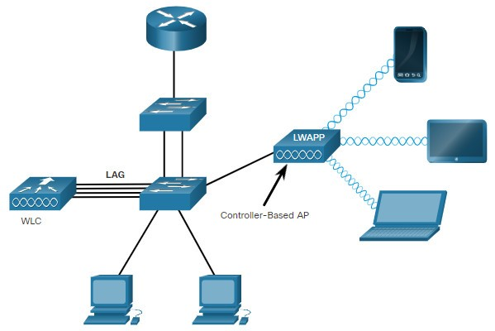Explanation/Reference: Lightweight APs (LAPs) is devices require no initial configuration. LAPs use the Lightweight Access Point Protocol (LWAPP) to communicate with a WLAN controller (WLC), as shown in the below figure. Controller-based APs are useful in situations where many APs are required in the network. As more APs are added, each AP is automatically configured and managed by the WLC.

What role does a hypervisor provide for each virtual machine in server virtualization?

1. infrastructure-as-a-service.
2. Software-as-a-service
3. control and distribution of physical resources
4. services as a hardware controller.

**Correct Answer: C**

Explanation/Reference: The hypervisor creates and manages virtual machines on a host computer and allocates physical system resources to them.

QUESTION 326

Which technology must be implemented to configure network device monitoring with the highest security?

1. syslog
2. NetFlow
3. IP SLA
4. SNMPv3 Correct Answer: B **QUESTION327**

# What is the function of a server?

1. It transmits packets between hosts in the same broadcast domain.
2. It provides shared applications to end users.
3. It routes traffic between Layer 3 devices.
4. It Creates security zones between trusted and untrusted networks Correct Answer: B

QUESTION328

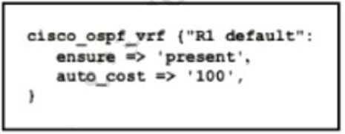Refer to the exhibit. Which type of configuration is represented in the output?

1. Ansible
2. JSON
3. Chef
4. Puppet Answer: D

QUESTION329

A port security violation has occurred on a switch port due to the maximum MAC address count being exceeded Which command must be configured to increment the

security-violation count and forward an SNMP trap?

1. switchport port-security violation access
2. switchport port-security violation protect
3. switchport port-security violation restrict
4. switchport port-security violation shutdown Answer: C

Explanation/Reference: [Click here](https://www.cisco.com/c/en/us/td/docs/switches/lan/catalyst4500/12-2/25ew/configuration/guide/conf/port_sec.html)

QUESTION330

Which spanning-tree enhancement avoids the learning and listening states and immediately places ports in the forwarding state?

1. BPDUfilter
2. PortFast
3. Backbonefast
4. BPDUguard Answer: B

Explanation/Reference: PortFast

Spanning Tree Portfast causes layer 2 switch interfaces to enter forwarding state immediately,

bypassing the listening and learning states. It should be used on ports connected directly to end hosts

like servers or workstations. Note: If portfast isn’t enabled, DHCP timeouts can occur while STP

converges, causing more problems. Reference: [Click here](https://itexamanswers.net/ccnp-switch-spanning-tree-stp.html)

QUESTION331

What are two functions of a Layer 2 switch? (Choose two)

1. acts as a central point for association and authentication servers
2. selects the best route between networks on a WAN
3. moves packets within a VLAN
4. moves packets between different VLANs
5. makes forwarding decisions based on the MAC address of a packet Answer: A, E

QUESTION332

A manager asks a network engineer to advise which cloud service models are used so employees do not have to waste their time installing, managing, and updating software which is only used occasionally Which cloud service model does the engineer recommend?

1. infrastructure-as-a-service
2. platform-as-a-service
3. business process as service to support different types of service
4. software-as-a-service Answer: D

Q333

Which two functions are performed by the core layer in a three-tier architecture? (Choose two)

1. Provide uninterrupted forwarding service.
2. Police traffic that is sent to the edge of the network.
3. Provide direct connectivity for end user devices.
4. Ensure timely data transfer between layers.
5. Inspect packets for malicious activity. Answer: A,E

Q334

When using Rapid PVST+, which command guarantees the switch is always the root bridge for VLAN 200?

1. spanning -tree vlan 200 priority 614440
2. spanning -tree vlan 200 priority 0
3. spanning -tree vlan 200 priority 38572422
4. spanning -tree vlan 200 root primary Answer: B

Q335

What are two functions of a server on a network? (Choose two)

1. achieves redundancy by exclusively using virtual server clustering
2. runs applications that send and retrieve data for workstations that make requests
3. handles requests from multiple workstations at the same time
4. runs the same operating system in order to communicate with other servers
5. housed solely in a data center that is dedicated to a single client Answer: B,C

Q336

What is the primary function of a Layer 3 device?

1. to analyze traffic and drop unauthorized traffic from the Internet
2. to transmit wireless traffic between hosts
3. to pass traffic between different networks
4. forward traffic within the same broadcast domain Answer: C

Q337

Refer to the exhibit. After the election process what is the root bridge in the HQ LAN?

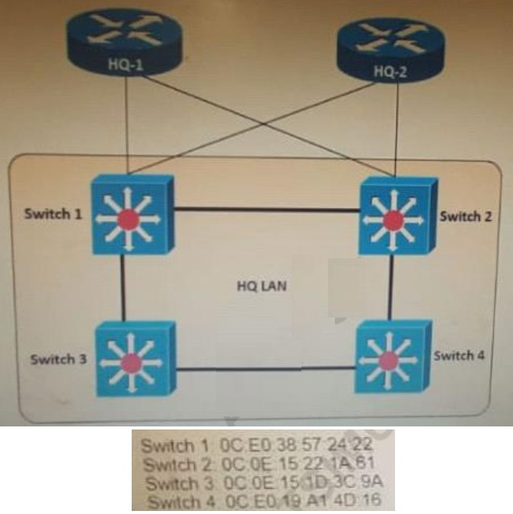

1. Switch 1
2. Switch 2
3. Switch 3
4. Switch 4 Answer: C

Explanation: The root bridge is determined by the lowest bridge ID, which consists of the priority value and the MAC address. Because the priority values of all of the switches are not avalable, the MAC address is used to determine the root bridge. Because S3 has the lowest MAC address, S3 becomes the root bridge.

Q338

An engineer requires a scratch interface to actively attempt to establish a trunk link with a neighbor switch. What command must be configured?

1. switchport mode trunk
2. switchport mode dynamic desirable
3. switchport mode dynamic auto
4. switchport nonegotiate Answer: B

Q339

What is a function of TFTP in network operations?

1. transfers a backup configuration file from a server to a switch using a username and password
2. transfers files between file systems on a router
3. transfers a configuration files from a server to a router on a congested link
4. transfers IOS images from a server to a router for firmware upgrades Answer: D

Q340

What are two recommendations for protecting network ports from being exploited when located in an office space outside of an IT closet? (Choose two)

1. configure static ARP entries
2. enable the PortFast feature on ports
3. implement port-based authentication
4. configure ports to a fixed speed
5. shut down unused ports Answer: C,E

Q341

What is a recommended approach to avoid co-channel congestion while installing access points that use the 2.4 GHz frequency?

1. different nonoverlapping channels
2. different overlapping channels
3. one overlapping channel
4. one nonoverlapping channel Answer: A

Q342

Refer to the exhibit. An engineer configured the New York router with state routes that point to the Atlanta and Washington sites. When command must be configured on the Atlanta and Washington routers so that both sites are able to reach the loopback2 interface on the New York router?

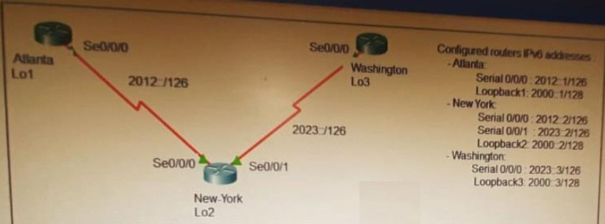

1. ipv6 route ::/0 Serial 0/0/1
2. ipv6 route 0/0 Serial 0/0/0
3. ipv6 route ::/0 Serial 0/0/0

D. ip route 0.0.0.0.0.0.0.0 Serial 0/0/0

E. ipv6 route ::/0 2000::2 Answer: C

Q343

What is a function of a remote access VPN?

1. used cryptographic tunneling to protect the privacy of data for multiple users simultaneously
2. used exclusively when a user is connected to a company’s internal network
3. establishes a secure tunnel between two branch sites
4. allows the users to access company internal network resources through a secure tunnel Answer: D

Q344

Which CRUD operation modifies an existing table or view?

1. read
2. create
3. replace
4. update Answer: D Q345

What is a DHCP client?

1. a workstation that requests a domain name associated with its IP address
2. a host that is configured to request an IP address automatically
3. a server that dynamically assigns IP addresses to hosts.
4. a router that statically assigns IP addresses to hosts. Answer: B

Q346

What is the same for both copper and fiber interfaces when using SFP modules?

1. They support an inline optical attenuator to enhance signal strength
2. They provide minimal interruption to services by being hot-swappable
3. They offer reliable bandwidth up to 100 Mbps in half duplex mode
4. They accommodate single-mode and multi-mode in a single module Answer: B

Q347

When using Rapid PVST+, which command guarantees the switch is always the root bridge for VLAN 200?

1. spanning -tree vlan 200 priority 614440
2. spanning -tree vlan 200 priority 38572422
3. spanning -tree vlan 200 priority 0
4. spanning -tree vlan 200 root primary Answer: C

Q348An engineer must configure Interswitch VLAN communication between a Cisco switch and a third-party switch. Which action should be taken?

1. configure IEEE 802.1p
2. configure IEEE 802.1q
3. configure ISL
4. configure DSCP Answer: B

Q349

Which protocol prompts the Wireless LAN Controller to generate its own local web administration SSL certificate for GUI access?

1. HTTPS
2. RADIUS
3. TACACS+
4. HTTP Answer: A Q350

In software defined architectures, which plane is distributed and responsible for traffic forwarding?

1. management plane
2. control plane
3. policy plane
4. data plane Answer: D Q351

Which function is performed by the collapsed core layer in a two-tier architecture?

* + A. enforcing routing policies
  + B. marking interesting traffic for data polices
  + C. attaching users to the edge of the network
  + D. applying security policies Answer: A

Q352

Where does the configuration reside when a helper address Is configured to support DHCP?

1. on the router closest to the server
2. on the router closest to the client
3. on every router along the path
4. on the switch trunk interface Answer: B

Q353

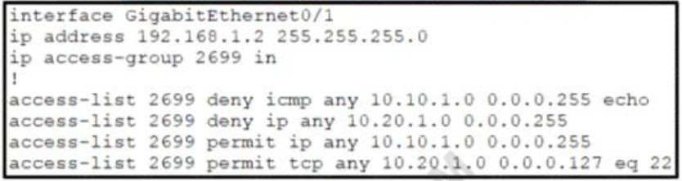Refer to the exhibit. A network administrator must permit SSH access to remotely manage routers in a network. The operations team resides on the 10.20.1.0/25 network. Which command will accomplish this task?

A. access-list 2699 permit udp 10.20.1.0 0.0.0.255

1. no access-list 2699 deny tcp any 10.20.1.0 0.0.0.127 eq 22
2. access-list 2699 permit tcp any 10.20.1.0 0.0.0.255 eq 22
3. no access-list 2699 deny ip any 10.20.1.0 0.0.0.255 Answer: D

Explanation: Already a statement is there in last to allow SSH Traffic for network 10.20.1.0 0.0.0.127, but

Second statement says deny ip any 10.20.1.0 0.0.0.255, so how it will work once it is denied. So the

right answer is remove the — no access-list 2699 deny ip any 10.20.1.0 0.0.0.255. Q354

What is the purpose of traffic shaping?

1. to mitigate delays over slow links
2. to provide fair queuing for buffered flows
3. to limit the bandwidth that a flow can use to
4. be a marking mechanism that identifies different flows Answer: B

Explanation: Traffic shaping retains excess packets in a queue and then schedules the excess for later transmission over increments of time.

Q355

Which configuration management mechanism uses TCP port 22 by default when communicating with managed nodes?

1. Ansible
2. Python
3. Puppet
4. Chef Answer: A Q356

Refer to the exhibit. If OSPF Is running on this network, how does Router2 handle traffic from Site B to 10.10.13.128/25 at Site A?

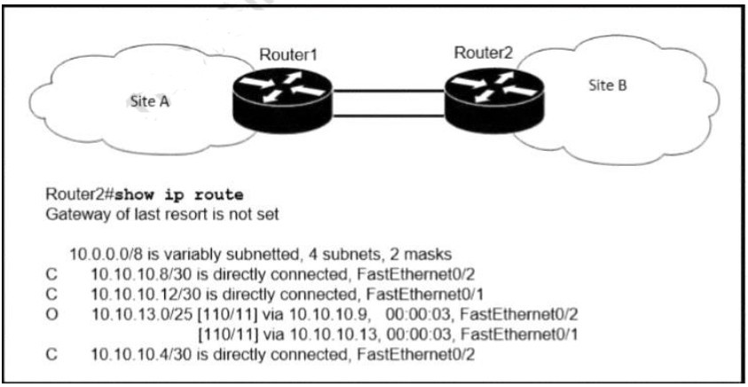

1. It load-balances traffic out of Fa0/1 and Fa0/2.
2. It is unreachable and discards the traffic.
3. It sends packets out of interface Fa0/2.
4. It sends packets out of interface Fa0/1. Answer: B

Q357

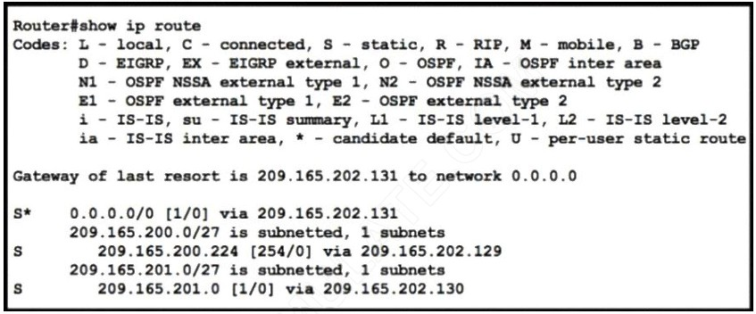Refer to the exhibit. Which command configures a floating static route to provide a backup to the primary link?

A. ip route 0.0.0.0 0.0.0.0 209.165.202.131

B. ip route 209.165.201.0 255.255.255.224 209.165.202.130

C. ip route 0.0.0.0 0.0.0.0 209.165.200.224

D. ip route 209.165.200.224 255.255.255.224 209.165.202.129 254

Answer: D

Q358

What is a practice that protects a network from VLAN hopping attacks?

1. Enable dynamic ARP inspection
2. Configure an ACL to prevent traffic from changing VLANs
3. Change native VLAN to an unused VLAN ID
4. Implement port security on internet-facing VLANs Answer: C

Q359

Which technology can prevent client devices from arbitrarily connecting to the network without state remediation?

A. 802.1x

B. IP Source Guard

C. MAC Authentication Bypass

D. 802.11n

Answer: A Q360

What facilitates a Telnet connection between devices by entering the device name?

1. SNMP
2. DNS lookup
3. syslog
4. NTP Answer: B Q361

How does the dynamically-learned MAC address feature function?

1. The CAM table is empty until ingress traffic arrives at each port
2. Switches dynamically learn MAC addresses of each connecting CAM table.
3. The ports are restricted and learn up to a maximum of 10 dynamically-learned addresses
4. It requires a minimum number of secure MAC addresses to be filled dynamically Answer: A

Q362

When implementing a router as a DHCP server, which two features must be configured? (Choose two)

1. relay agent information
2. database agent
3. address pool
4. smart-relay
5. manual bindings Answer: BC

Q363

Which command must be entered to configure a DHCP relay?

1. ip helper-address
2. ip address dhcp
3. ip dhcp pool
4. ip dhcp relay Answer: A

Q364

Where does a switch maintain DHCP snooping information?

1. in the MAC address table
2. in the CAM table
3. in the binding database
4. in the frame forwarding database Answer: C

Which type of security program is violated when a group of employees enters a building using the ID badge of only one person?

1. intrusion detection
2. user awareness
3. physical access control
4. network authorization Answer: C

Q366

A network administrator needs to aggregate 4 ports into a single logical link which must negotiate layer 2 connectivity to ports on another switch What must be configured when using active mode on both sides of the connection?

1. 802.1q trunks
2. Cisco vPC
3. LLDP
4. LACP Answer: D

Q367

In which situation is private IPv4 addressing appropriate for a new subnet on the network of an organization?

1. There is limited unique address space, and traffic on the new subnet will stay local within the organization.
2. The network has multiple endpoint listeners, and it is desired to limit the number of broadcasts.
3. Traffic on the subnet must traverse a site-to-site VPN to an outside organization.
4. The ISP requires the new subnet to be advertised to the internet for web services. Answer: A

Q368

Aside from discarding, which two states does the switch port transition through while using RSTP (802.1w)? (Choose two)

1. listening
2. blocking
3. forwarding
4. learning
5. speaking Answer: C D

Which state does the switch port move to when PortFast is enabled?

1. forwarding
2. listening
3. blocking
4. learning Answer: A

Q370

Refer to the exhibit. An access list is created to deny Telnet access from host PC-1 to RTR-1 and allow access from all other hosts A Telnet attempt from PC-2 gives this message:” Connection refused by remote host” Without allowing Telnet access from PC-1, which action must be taken to permit the traffic?

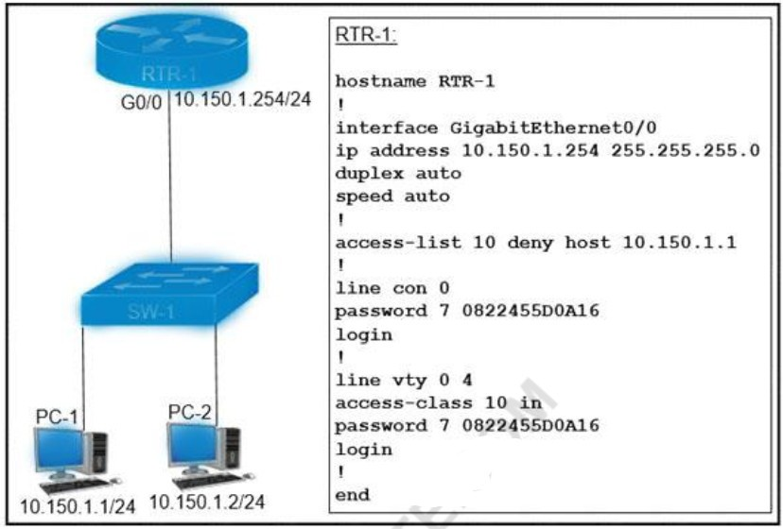

1. Add the access-list 10 permit any command to the configuration
2. Remove the access-class 10 in command from line vty 0.4.
3. Add the ip access-group 10 out command to interface g0/0.
4. Remove the password command from line vty 0 4. Answer: A

Q371

What is a role of wireless controllers in an enterprise network?

1. centralize the management of access points in an enterprise network
2. support standalone or controller-based architectures
3. serve as the first line of defense in an enterprise network
4. provide secure user logins to devices on the network. Answer: A

Q372

What is the effect when loopback interfaces and the configured router ID are absent during the OSPF Process configuration?

1. No router ID is set, and the OSPF protocol does not run.
2. The highest up/up physical interface IP address is selected as the router ID.
3. The lowest IP address is incremented by 1 and selected as the router ID.
4. The router ID 0.0.0.0 is selected and placed in the OSPF process. Answer: B

Q373

What is recommended for the wireless infrastructure design of an organization?

1. group access points together to increase throughput on a given channel
2. configure the first three access points are configured to use Channels 1, 6, and 11
3. include a least two access points on nonoverlapping channels to support load balancing
4. assign physically adjacent access points to the same Wi-Fi channel Answer: B

Q374

Which 802.11 frame type is indicated by a probe response after a client sends a probe request?

1. action
2. management
3. control
4. data Answer: B

Q375

How do servers connect to the network in a virtual environment?

1. wireless to an access point that is physically connected to the network
2. a cable connected to a physical switch on the network
3. a virtual switch that links to an access point that is physically connected to the network
4. a software switch on a hypervisor that is physically connected to the network Answer: D

Q376

Which CRUD operation corresponds to the HTTP GET method?

1. read
2. update
3. create
4. delete Answer: A

Explanation: GET: This method retrieves the information identified by the request URI. In the context of the RESTful web services, this method is used to retrieve resources. This is the method used for read operations (the R in CRUD).

https://hub.packtpub.com/crud-operations-rest/

Q377

With REST API, which standard HTTP header tells a server which media type is expected by the client?

1. Accept-Encoding: gzip. deflate
2. Accept-Patch: text/example; charset=utf-8
3. Content-Type: application/json; charset=utf-8
4. Accept: application/json Answer: D

Explanation: Accept header is a way for a client to specify the media type of the response content it is expecting and Content-type is a way to specify the media type of request being sent from the client to the server.

Q378

Which device tracks the state of active connections in order to make a decision to forward a packet through?

1. wireless access point
2. firewall
3. wireless LAN controller
4. router Answer: C

Q379

Refer to the exhibit. PC1 is trying to ping PC3 for the first time and sends out an ARP to S1. Which action is taken by S1?

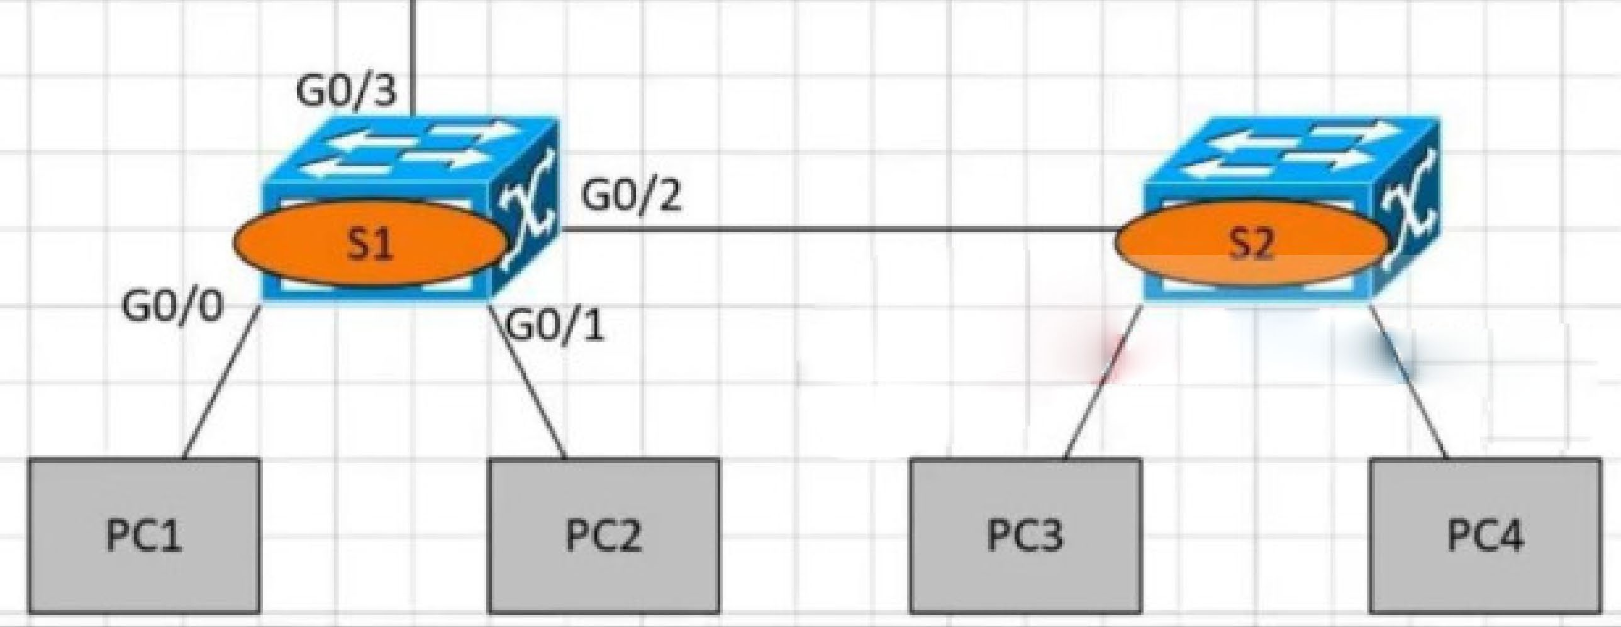

1. It forwards it out G0/3 only
2. It is flooded out every port except G0/0.
3. It drops the frame.
4. It forwards it out interface G0/2 only. Answer: B

Q380

Refer to the exhibit. A network administrator has been tasked with securing VTY access to a router. Which access-list entry accomplishes this task?

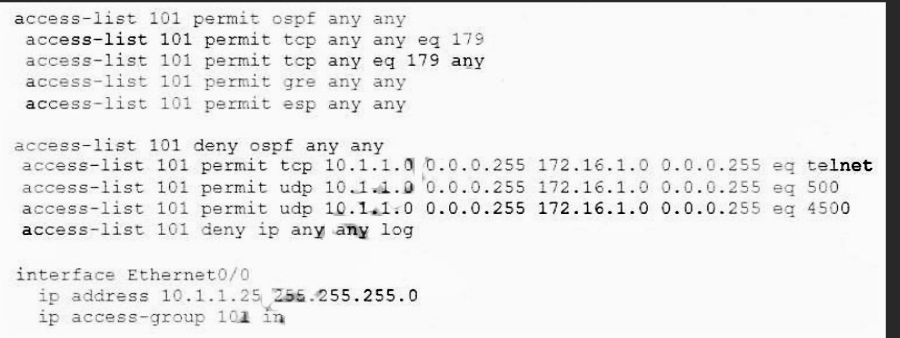

A. access-list 101 permit tcp 10.1.10 0.0.0.255 172.16.10 0.0.0.255 eq ssh

B. access-list 101 permit tcp 10.11.0 0.0.0.255 172.16.10 0.0.0.255 eq scp

C. access-list 101 permit tcp 10.11.0 0.0.0.255 172.16.10 0.0.0.255 eq telnet

D. access-list 101 permit tcp 10.1.10 0.0.0.255 172.16.10 0.0.0.255 eq https Answer: A

Q381

A network administrator must enable DHCP services between two sites. What must be configured for the router to pass DHCPDISCOVER messages on to the server?

1. a DHCP Relay Agent
2. DHCP Binding
3. a DHCP Pool
4. DHCP Snooping

Answer: A

Q382

Which device controls the forwarding of authentication requests for users when connecting to the network using a lightweight access point?

1. TACACS server
2. wireless access point
3. RADIUS server
4. wireless LAN controller Answer: D

Q383

Refer to the exhibit. What is the result if Gig1/11 receives an STP BPDU? CCNA 200-301 Dumps Full Questions - Exam Study Guide & Free 308

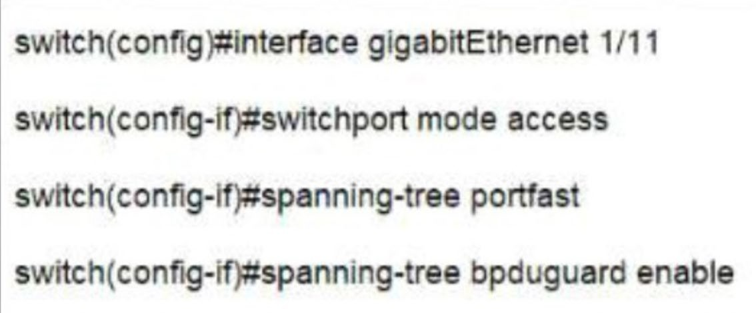

1. The port transitions to STP blocking
2. The port transitions to the root port
3. The port immediately transitions to STP forwarding.
4. The port goes into error-disable state Answer: D

Q384

Which configuration is needed to generate an RSA key for SSH on a router?

1. Configure the version of SSH
2. Configure VTY access.
3. Create a user with a password.
4. Assign a DNS domain name Answer: D

Q385

What is the maximum bandwidth of a T1 point-to-point connection?

1. 1.544 Mbps
2. 2.048 Mbps
3. 34.368 Mbps
4. 43.7 Mbps Answer: A

Q386

An engineer must configure traffic for a VLAN that is untagged by the switch as it crosses a trunk link. Which command should be used?

1. switchport trunk allowed vlan 10
2. switchport trunk native vlan 10
3. switchport mode trunk
4. switchport trunk encapsulation dot1q Answer: B

Q387

How does a Cisco Unified Wireless network respond to Wi-Fi channel overlap?

1. It alternates automatically between 2.4 GHz and 5 GHz on adjacent access points
2. It allows the administrator to assign channels on a per-device or per-interface basis.
3. It segregates devices from different manufacturers onto different channels.
4. It analyzes client load and background noise and dynamically assigns a channel. Answer: A

Q388

What does a switch use to build its MAC address table?

1. VTP
2. DTP
3. egress traffic
4. ingress traffic Answer: D

Q389

Which network plane is centralized and manages routing decisions?

1. policy plane
2. management plane
3. control plane
4. data plane Answer: C

Q390

What does a router do when configured with the default DNS lookup settings, and a URL is entered on the CLI?

1. initiates a ping request to the URL
2. prompts the user to specify the desired IP address
3. continuously attempts to resolve the URL until the command is cancelled
4. sends a broadcast message in an attempt to resolve the URL Answer: D

Q391

What is a DNS lookup operation?

1. DNS server pings the destination to verify that it is available
2. serves requests over destination port 53
3. DNS server forwards the client to an alternate IP address when the primary IP is down
4. responds to a request for IP address to domain name resolution to the DNS server Answer: D

Q392

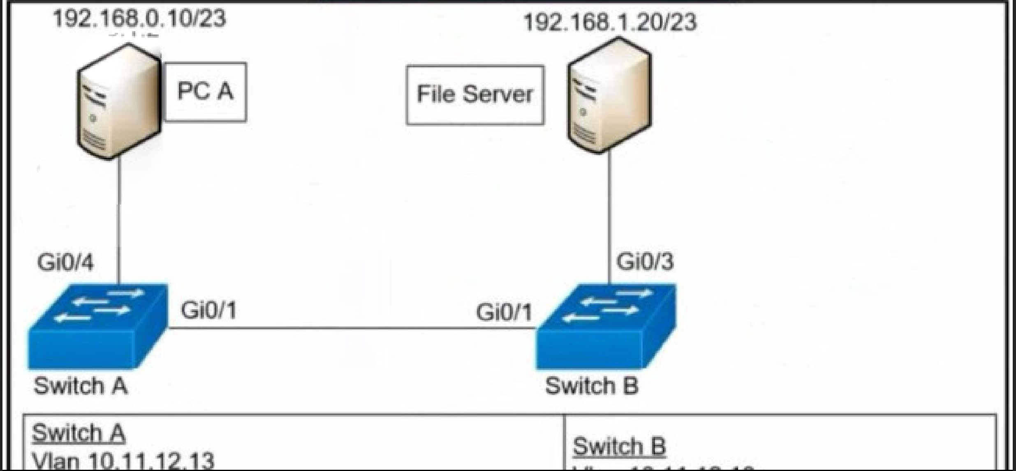Refer to the exhibit. A network engineer must configured communication between PC A and the File Server. To prevent interruption for any other communications, which command must be configured?

1. Switch trunk allowed vlan 12
2. Switchport trunk allowed vlan none
3. Switchport trunk allowed vlan add 13
4. Switchport trunk allowed vlan remove 10-11 Answer: C

Q393

What is a characteristic of a SOHO network?

* + A. connects each switch to every other switch in the network
  + B. enables multiple users to share a single broadband connection
  + C. provides high throughput access for 1000 or more users
  + D. includes at least three tiers of devices to provide load balancing and redundancy Answer: B

Q394

Which resource is able to be shared among virtual machines deployed on the same physical server?

* + A. disk
  + B. applications
  + C. VM configuration file
  + D. operating system Answer: A

Q395

Which implementation provides the strongest encryption combination for the wireless environment?

* + A. WPA2 + AES
  + B. WPA + AES
  + C. WEP
  + D. WPA + TKIP Answer: A

Q396

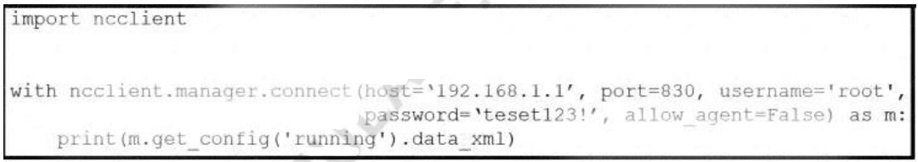Refer to the exhibit. After running the code in the exhibit, which step reduces the amount of data that the NETCONF server returns to the NETCONF client, to only the interface’s configuration?

* + A. Use the Ixml library to parse the data returned by the NETCONF server for the interface’s configuration.
  + B. Create an XML filter as a string and pass it to get_config() method as an argument.
  + C. Create a JSON filter as a string and pass it to the get_config() method as an argument.
  + D. Use the JSON library to parse the data returned by the NETCONF server for the interface’s configuration.

Answer: D Q397

What is an appropriate use for private IPv4 addressing?

* + A. on the public-facing interface of a firewall
  + B. to allow hosts inside to communicate in both directions with hosts outside the

organization

* + C. on internal hosts that stream data solely to external resources
  + D. on hosts that communicates only with other internal hosts Answer: D

Q398

What are two functions of an SDN controller? (Choose two)

* + A. Layer 2 forwarding
  + B. coordinating VTNs
  + C. tracking hosts
  + D. managing the topology
  + E. protecting against DDoS attacks Answer: B D

Q399

If a switch port receives a new frame while it is actively transmitting a previous frame, how does it process the frames?

* + A. The new frame is delivered first, the previous frame is dropped, and a retransmission request is sent.
  + B. The previous frame is delivered, the new frame is dropped, and a retransmission request is sent.
  + C. The new frame is placed in a queue for transmission after the previous frame.
  + D. The two frames are processed and delivered at the same time. Answer: C

Q400

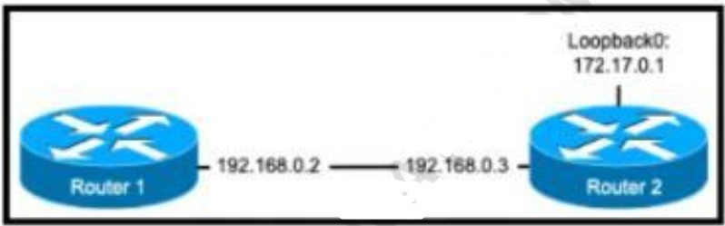Refer to the exhibit. The ntp server 192.168.0.3 command has been configured on router 1 to make it an NTP client of router 2. Which command must be configured on router 2 so that it operates in server-only mode and relies only on its internal clock?

* + A. Router2(config)#ntp passive
  + B. Router2(config)#ntp server 172.17.0.1
  + C. Router2(config)#ntp master 4
  + D. Router2(config)#ntp server 192.168.0.2 Answer: C

Q401

Which WAN topology provides a combination of simplicity quality, and availability?

* + A. partial mesh
  + B. full mesh
  + C. point-to-point
  + D. hub-and-spoke Answer: C

Q402

Why does a switch flood a frame to all ports?

* + A. The frame has zero destination MAC addresses.
  + B. The source MAC address of the frame is unknown
  + C. The source and destination MAC addresses of the frame are the same
  + D. The destination MAC address of the frame is unknown. Answer: D

Q403

When DHCP is configured on a router, which command must be entered so the default gateway is automatically distributed?

* + A. default-router
  + B. default-gateway
  + C. ip helper-address
  + D. dns-server Answer: A

Q404

What is a network appliance that checks the state of a packet to determine whether the packet is legitimate?

* + A. Layer 2 switch
  + B. load balancer
  + C. firewall
  + D. LAN controller Answer: C

Q405

How is the native VLAN secured in a network?

* + A. separate from other VLANs within the administrative domain
  + B. give it a value in the private VLAN range
  + C. assign it as VLAN 1
  + D. configure it as a different VLAN ID on each end of the link Answer: A

Q406

Which command on a port enters the forwarding state immediately when a PC is connected to it?

* + A. switch(config)#spanning-tree portfast default
  + B. switch(config)#spanning-tree portfast bpduguard default
  + C. switch(config-if)#spanning-tree portfast trunk
  + D. switch(config-if)#no spanning-tree portfast Answer: C

Q407

Refer to Exhibit. Which configuration must be applied to the router that configures PAT to translate all addresses in VLAN 200 while allowing devices on VLAN 100 to use their own IP

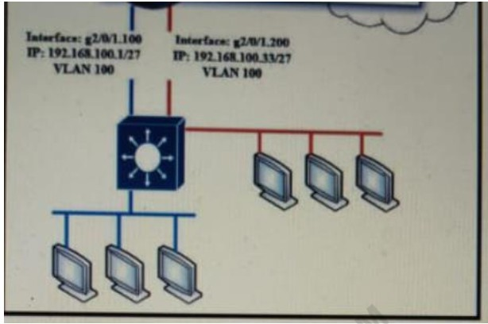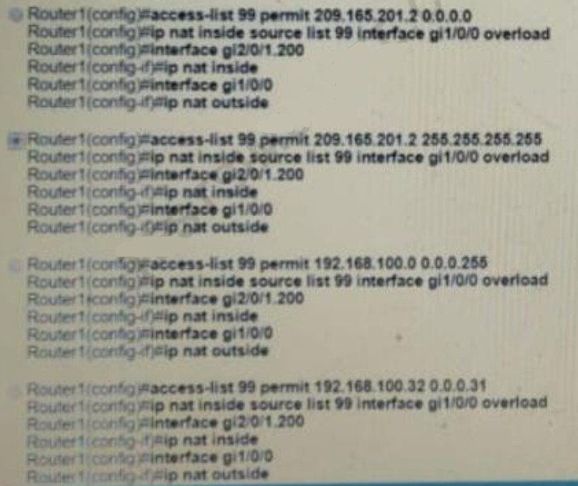addresses?

* + A. Option A
  + B. Option B
  + C. Option C
  + D. Option D Answer: D

Q408

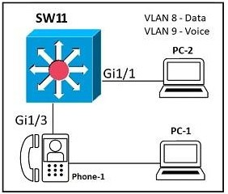Refer to the exhibit. An administrator must configure interfaces Gi1/1 and Gi1/3 on switch SW11 PC-1 and PC-2 must be placed in the Data VLAN and Phone-1 must be placed in the Voice VLAN Which configuration meets these requirements?

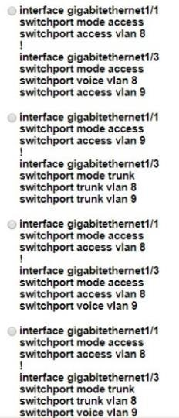

* + A. Option A
  + B. Option B
  + C. Option C
  + D. Option D Answer: C

Q409

Refer to the exhibit. Which switch becomes the root of the spanning tree for VLAN 110?

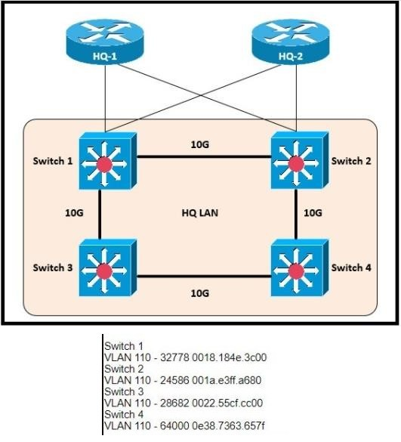

* + A. Switch 1
  + B. Switch 2
  + C. Switch 3
  + D. Switch 4 Answer: B

Q410

What is a benefit of VRRP?

* + A. It provides traffic load balancing to destinations that are more than two hops from the source.
  + B. It provides the default gateway redundancy on a LAN using two or more routers.
  + C. It allows neighbors to share routing table information between each other.
  + D. It prevents loops in a Layer 2 LAN by forwarding all traffic to a root bridge, which then makes the final forwarding decision.

Answer: B Q411

Which protocol does an IPv4 host use to obtain a dynamically assigned IP address?

* + A. ARP
  + B. DHCP
  + C. CDP
  + D. DNS Answer: B Q412

Refer to the exhibit. An access list is required to permit traffic from any host on interface G0/0 and deny traffic from interface G/0/1. Which access list must be applied?

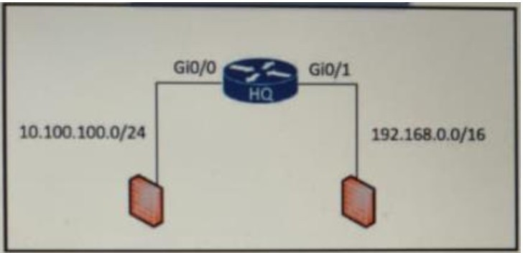

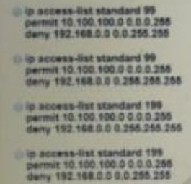

* + A. Option A
  + B. Option B
  + C. Option C
  + D. Option D Answer: A

Q413

How does a switch process a frame received on Fa0/1 with the destination MAC address of 0e38.7363.657b when the table is missing the address?

* + A. lt drops the frame immediately.
  + B. It forwards the frame back out of interface Fa0/1.
  + C. It floods the frame to all interfaces except Fa0/1.
  + D. It holds the frame until the MAC address timer expires and then drops the frame. Answer: C

Q414

Which condition must be met before an NMS handles an SNMP trap from an agent?

* + A. The NMS software must be loaded with the MIB associated with the trap.
  + B. The NMS must be configured on the same router as the SNMP agent
  + C. The NMS must receive a trap and an inform message from the SNMP agent within a configured interval
  + D. The NMS must receive the same trap from two different SNMP agents to verify that it is reliable.

Answer: A Q415

What is the purpose of a southbound API in a control based networking architecture?

* + A. Facilities communication between the controller and the applications
  + B. Facilities communication between the controller and the networking hardware
  + C. allows application developers to interact with the network
  + D. integrates a controller with other automation and orchestration tools. Answer: B

Explanation: The Southbound Interface

In a controller-based network architecture, the controller needs to communicate to the networking devices. In most network drawings and architecture drawings, those network devices typically sit below the controller, as shown in Figure 16-5. There is an interface between the controller and those devices, and given its location at the bottom part of drawings, the interface came to be known as the southbound interface, or SBI, as labeled in Figure 16-5.

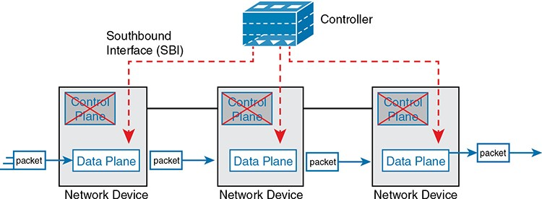

FIGURE 16-5 Centralized Control Plane and a Distributed Data Plane Q416

Which switch technology establishes a network connection immediately when it is plugged in?

* + A. PortFast
  + B. BPDU guard
  + C. UplinkFast
  + D. BackboneFast Answer: C

Q417

What causes a port to be placed in the err-disabled state?

* + A. latency
  + B. port security violation
  + C. shutdown command issued on the port
  + D. nothing plugged into the port Answer: B

Explanation: This mode is the default violation mode; when in this mode, the switch will automatically force the switchport into an error disabled (err-disable) state when a violation occurs. While in this state, the switchport forwards no traffic. The switchport can be brought out of this error disabled state by issuing the errdisable recovery cause CLI command or by disabling and reenabling the switchport.

1. An engineer needs to add an old switch back into a network. To prevent the switch from corrupting the VLAN database which action must be taken?
   1. Add the switch in the VTP domain with a lower revision number
   2. Add the switch with DTP set to dynamic desirable
   3. Add the switch in the VTP domain with a higher revision number
   4. Add the switch with DTP set to desirable Answer: A
2. Which JSON data type is an unordered set of attribute- value pairs?
   1. array
   2. string
   3. object
   4. Boolean Answer: C
3. What occurs when overlapping Wi-Fi channels are implemented?
   1. The wireless network becomes vulnerable to unauthorized access.
   2. Wireless devices are unable to distinguish between different SSIDs
   3. Users experience poor wireless network performance.
   4. Network communications are open to eavesdropping. Answer: C
4. Which technology allows for multiple operating systems to be run on a single host computer?
   1. virtual routing and forwarding
   2. network port ID visualization
   3. virtual device contexts
   4. server visualization Answer: D
5. Which two QoS tools provides congestion management? (Choose two)
   1. CAR
   2. CBWFQ
   3. PQ
   4. PBR
   5. FRTS Answer: B C

Explanation: Type of queuing methods are available:* First-In-First-Out (FIFO)* Priority Queuing (PQ)* Custom Queuing (CQ)* Weighted Fair Queuing (WFQ)* Class-Based Weighted Fair Queuing (CBWFQ)* LowLatency Queuing (LLQ)

1. Refer to the exhibit. An administrator must turn off the Cisco Discovery Protocol on the port configured with address last usable address in the 10.0.0.0/30 subnet. Which command set meets the requirement?